**Result**

**1 Data Analysis**

**1.1 Measurement Metrics and Activity Classification**

**Weekly averages (per person)** were calculated by dividing total clicks by the product of user count and number of weeks in each period, providing normalized metrics for comparison across different time frames.

To understand engagement patterns, resources were classified based on their utilization frequency. **High-activity resources** were defined as those generating more than two interactions per person per week during the intervention period (weeks 2-3), while **low-activity resources** had two or fewer interactions per person per week.

**1.2 Aera Analysis (Percentage Change in Different Periods across the Semester)**

In this study, we analyzed four distinct time periods to assess the impact of interventions on digital learning resource usage. The pre-intervention period encompassed weeks 0-1, establishing baseline engagement patterns before any interventions were implemented. During the intervention period of weeks 2-3, students received their assigned support strategies (SI, SoL, or control activities). The immediate post-intervention period spanned weeks 4-6, capturing short-term effects, while the sustained post-intervention period extended from weeks 7-16, allowing assessment of long-term impact. To quantify changes in resource usage across these periods, percentage changes were calculated using the formula ((New average - Original average) / Original average) × 100, where averages represent weekly interactions per person normalized by dividing total interactions by the product of user count and number of weeks in each period.

1.2 Cumulative Analysis (**Resource-Specific Engagement Patterns)**

For the temporal analysis, the semester was segmented into specific periods relative to examinations. Each examination period included a three-week preparation window preceding the exam date, allowing for the observation of resource utilization patterns during critical academic periods. The analysis normalized all usage metrics by the number of students in each group to ensure fair comparisons across groups of different sizes.

The resource interaction analysis proceeded at two levels. At the individual resource level, the analysis tracked student interactions with specific learning materials, such as practice quizzes, chapter quizzes, and extended curriculum materials. Each resource was analyzed independently to maintain granular insight into usage patterns. The cumulative usage analysis employed time-series visualization techniques to illustrate how different groups accumulated interactions with resources over time, with special attention to acceleration or deceleration of usage during exam preparation periods.

Statistical measures included the calculation of per-student interaction rates, active user counts during exam preparation windows, and total interaction volumes. These metrics were computed for each resource and group combination, allowing for comparative analysis across different intervention conditions. The analysis considered resources valid for detailed examination if they received at least 20 interactions during the semester, ensuring sufficient data for meaningful pattern detection.

The visualization approach emphasized clarity in temporal patterns through cumulative usage plots, with distinct color coding for each student group and clear demarcation of examination periods. Gray bands in the visualizations highlighted the three-week examination preparation windows, facilitating the identification of changes in resource utilization patterns during these critical periods.

(distinct count)

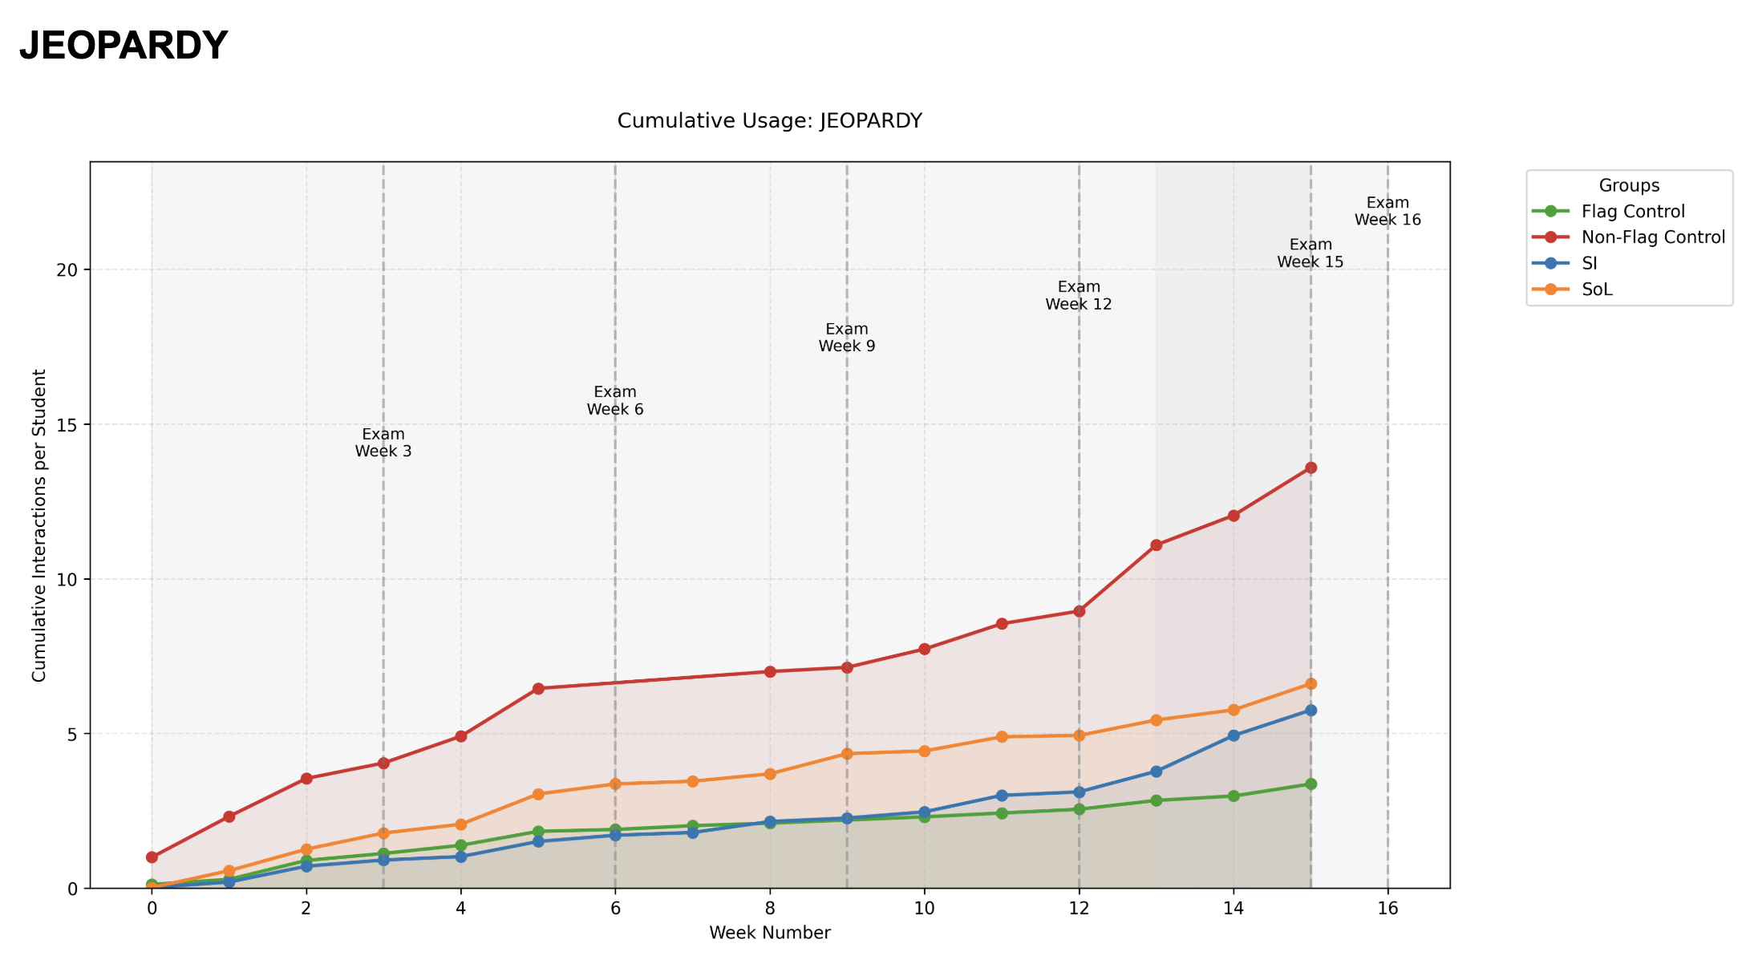For JEOPARDY resources, the non-flag control group showed consistently higher cumulative usage throughout the semester, reaching approximately 13 interactions per student by week 15. In contrast, the intervention groups (SI, SoL), and Flag Control demonstrated more moderate but steady engagement, with SoL students accumulating around 6 interactions per student, followed by SI students with 5 interactions, and Flag Control students with 3 interactions by the end of the semester.

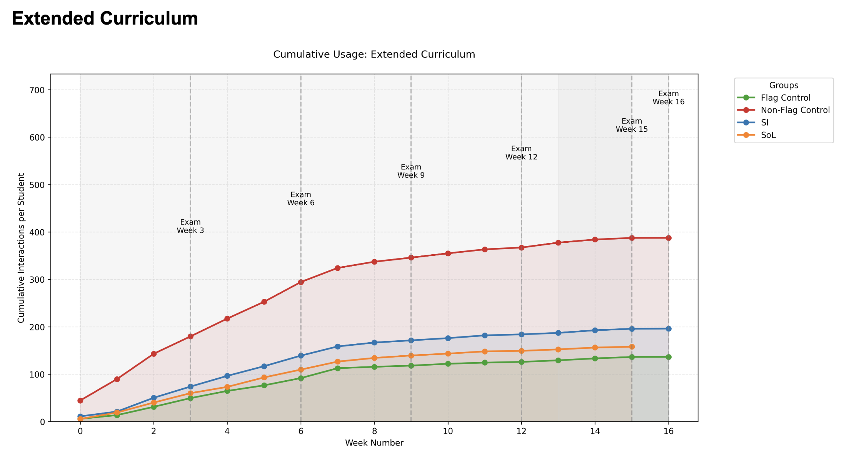The Extended Curriculum usage patterns present a more pronounced intervention effect. The non-flag control group exhibited substantially higher engagement, accumulating nearly 400 interactions per student over the semester. However, the accumulation rate notably slowed after week 6, suggesting a potential saturation point. The intervention groups showed more controlled and consistent engagement patterns, with SI students reaching approximately 200 cumulative interactions, while SoL and Flag Control groups maintained similar trajectories, ending at about 150 interactions per student. This pattern suggests that the intervention may have promoted more strategic and focused resource utilization among these groups.

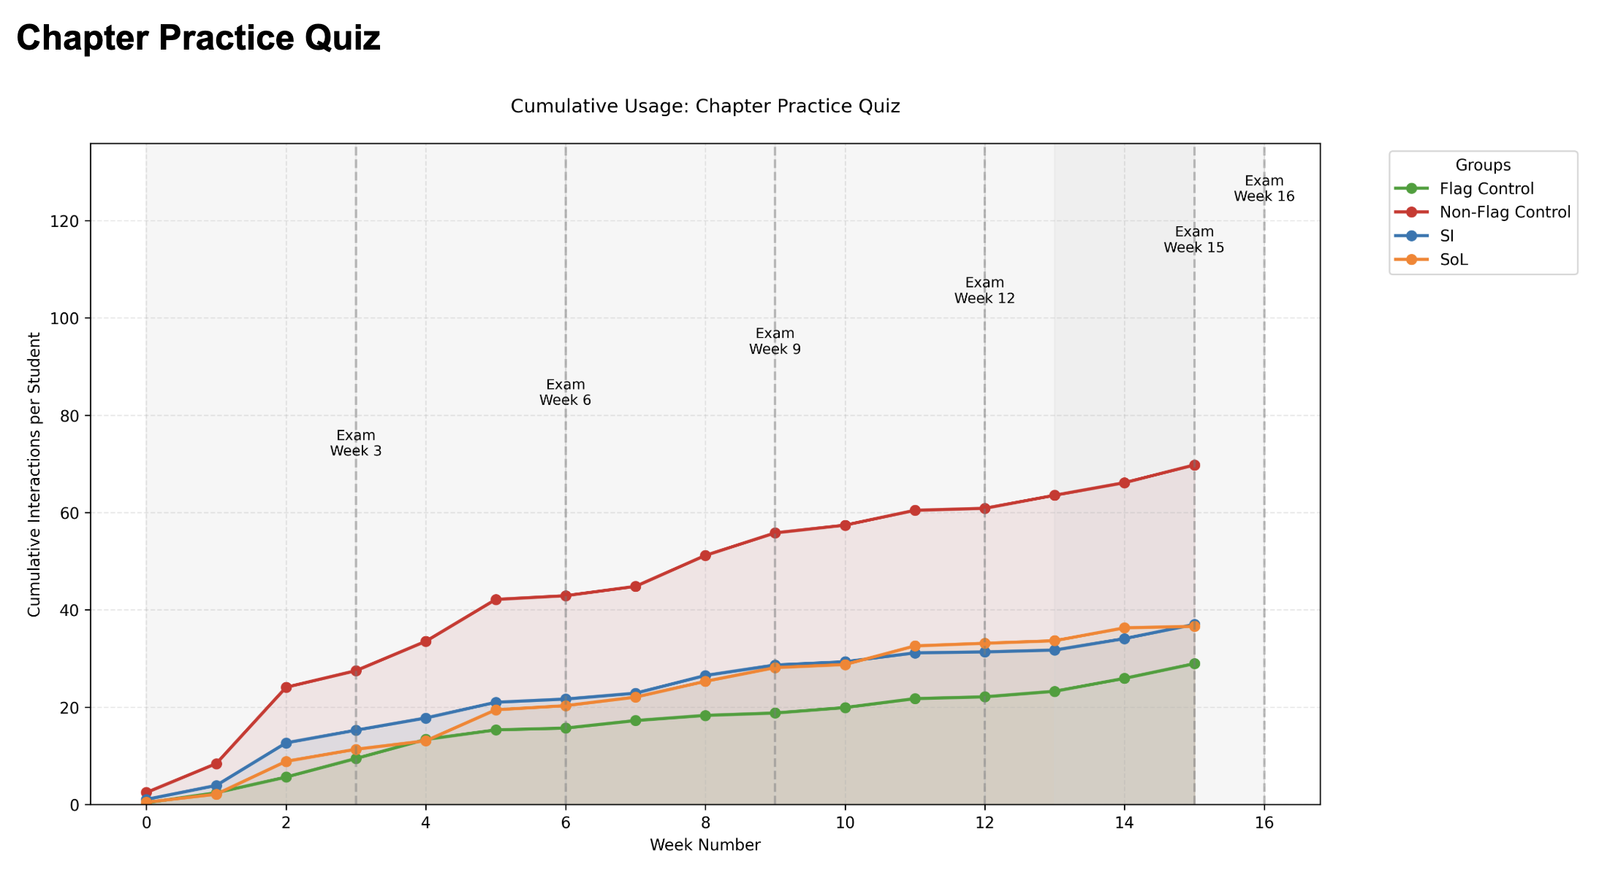Chapter Practice Quizzes: Non-Flag Control group (red) shows the highest cumulative usage, reaching about 70 interactions per student; SoL and SI groups showed similar trajectories, reaching about 35-40 interactions per student, while the Flag Control group maintained the lowest engagement level at around 30 interactions per student.

The intervention's impact is particularly evident in the early weeks (weeks 2-4), where all groups exhibited their steepest increase in cumulative interactions. The Non-Flag Control group showed the most dramatic initial response, with a sharp rise from weeks 2-6 that gradually leveled off. The SI and SoL groups demonstrated moderate but consistent growth during this period, while the Flag Control group showed the most modest increase.

During the post-intervention period (weeks 4-6), the growth rate slowed across all groups, though the relative differences established during the intervention period largely persisted. The long-term effect (weeks 6-15) shows sustained engagement patterns with gradual increases, suggesting the intervention created lasting behavioral changes. The timing of exams (marked at weeks 3, 6, 9, 12, and 15) appears to coincide with subtle increases in usage across all groups, indicating that assessment periods motivated additional practice quiz engagement regardless of intervention group.

**1.3 Regression Analysis**

To examine the relationship between digital learning behaviors and academic performance, we conducted multiple linear regression analyses across four time periods: pre-intervention, intervention, post-immediate intervention, and post-long intervention. The dependent variable was final exam performance. Independent variables included engagement metrics for Lab Practice Quizzes, JEOPARDY activities, Chapter Practice Quizzes, and Extended Curriculum resources. All interaction rates were log-transformed to address potential non-normality in the data distribution.

The Zero-Inflated Negative Binomial (ZINB) model was selected as the most appropriate analytical approach for analyzing the intervention effects on student click behavior. This choice was primarily driven by two key characteristics of the observed data. First, the data exhibited substantial zero-inflation across all intervention periods, with the proportion of zero counts ranging from 80.5% during the intervention period to 90.9% in the long-post period. These excessive zeros likely arise from two distinct processes: students who never engaged with the material (structural zeros) and students who were engaged but happened not to click during certain days (sampling zeros). Second, the data showed significant overdispersion, with variance-to-mean ratios ranging from 1.22 to 55.67 across periods, violating the equidispersion assumption of simpler count models. The ZINB model addresses both these features by combining a logistic regression component to model the probability of structural zeros with a negative binomial component to model the count process, including sampling zeros and non-zero counts. This dual modeling approach allows for more accurate estimation of intervention effects by separately considering factors that influence whether students engage at all and factors that influence the intensity of engagement when they do participate.

Table: Students Click Data Distribution (By Period/Student)

|  |  |  |  |  |  |  |  |  |  |  |
| --- | --- | --- | --- | --- | --- | --- | --- | --- | --- | --- |
| Resource | period | n_  Student(non-zero) | n_  weeks | total_  counts | M_count | variance | dispersion | zero_  prop | min_  count | max_  count |
| Extended Curriculum | During-intervention | 161 | 2 | 322 | 25.18 | 1211.67 | 48.13 | 0.36 | 0 | 174 |
| Immediate-post | 161 | 3 | 483 | 20.61 | 1147.47 | 55.66 | 0.41 | 0 | 277 |
| Long-term-post | 161 | 10 | 1610 | 5.73 | 252.75 | 44.08 | 0.63 | 0 | 308 |
| Pre-intervention | 161 | 2 | 322 | 14.18 | 723.25 | 50.99 | 0.36 | 0 | 222 |
| Getting Started | During-intervention | 63 | 2 | 126 | 0.13 | 0.17 | 1.23 | 0.89 | 0 | 2 |
| Immediate-post | 63 | 3 | 189 | 0.03 | 0.04 | 1.38 | 0.98 | 0 | 2 |
| Long-term-post | 63 | 10 | 630 | 0.01 | 0.01 | 1.39 | 0.99 | 0 | 2 |
| Pre-intervention | 63 | 2 | 126 | 0.98 | 2.34 | 2.40 | 0.56 | 0 | 8 |
| Introduction | During-intervention | 89 | 2 | 178 | 1.88 | 17.87 | 9.52 | 0.64 | 0 | 30 |
| Immediate-post | 89 | 3 | 267 | 1.45 | 11.53 | 7.98 | 0.70 | 0 | 24 |
| Long-term-post | 89 | 10 | 890 | 0.70 | 5.35 | 7.68 | 0.83 | 0 | 22 |
| Pre-intervention | 89 | 2 | 178 | 2.12 | 20.86 | 9.85 | 0.59 | 0 | 32 |
| Chapter Practice Quiz | During-intervention | 118 | 2 | 236 | 7.92 | 224.31 | 28.34 | 0.50 | 0 | 104 |
| Immediate-post | 118 | 3 | 354 | 4.18 | 92.33 | 22.07 | 0.66 | 0 | 67 |
| Long-term-post | 118 | 10 | 1180 | 2.46 | 51.70 | 21.06 | 0.78 | 0 | 80 |
| Pre-intervention | 118 | 2 | 236 | 2.71 | 34.80 | 12.85 | 0.69 | 0 | 34 |
| Helpful Videos | During-intervention | 85 | 2 | 170 | 1.06 | 6.14 | 5.80 | 0.67 | 0 | 19 |
| Immediate-post | 85 | 3 | 255 | 0.76 | 4.46 | 5.84 | 0.77 | 0 | 16 |
| Long-term-post | 85 | 10 | 850 | 0.38 | 3.27 | 8.49 | 0.89 | 0 | 32 |
| Pre-intervention | 85 | 2 | 170 | 0.57 | 1.70 | 2.98 | 0.76 | 0 | 9 |
| Lab Practice Quiz | During-intervention | 106 | 2 | 212 | 2.83 | 80.27 | 28.36 | 0.71 | 0 | 77 |
| Immediate-post | 106 | 3 | 318 | 10.70 | 375.05 | 35.06 | 0.41 | 0 | 155 |
| Long-term-post | 106 | 10 | 1060 | 3.49 | 94.90 | 27.20 | 0.73 | 0 | 113 |
| Pre-intervention | 106 | 2 | 212 | 0.21 | 1.29 | 6.23 | 0.95 | 0 | 11 |
| Chapter Outline | During-intervention | 76 | 2 | 152 | 1.07 | 9.35 | 8.77 | 0.77 | 0 | 24 |
| Immediate-post | 76 | 3 | 228 | 0.85 | 4.53 | 5.35 | 0.79 | 0 | 14 |
| Long-term-post | 76 | 10 | 760 | 0.53 | 4.71 | 8.88 | 0.88 | 0 | 38 |
| Pre-intervention | 76 | 2 | 152 | 1.26 | 14.17 | 11.27 | 0.72 | 0 | 34 |
| JEOPARDY | During-intervention | 70 | 2 | 140 | 1.19 | 6.82 | 5.72 | 0.73 | 0 | 14 |
| Immediate-post | 70 | 3 | 210 | 0.99 | 6.55 | 6.61 | 0.80 | 0 | 15 |
| Long-term-post | 70 | 10 | 700 | 0.81 | 11.44 | 14.10 | 0.88 | 0 | 36 |
| Pre-intervention | 70 | 2 | 140 | 0.73 | 2.80 | 3.85 | 0.77 | 0 | 9 |
| SmartBook | During-intervention | 72 | 2 | 144 | 1.03 | 6.49 | 6.31 | 0.76 | 0 | 17 |
| Immediate-post | 72 | 3 | 216 | 0.88 | 12.90 | 14.59 | 0.81 | 0 | 44 |
| Long-term-post | 72 | 10 | 720 | 0.34 | 1.79 | 5.21 | 0.91 | 0 | 13 |
| Pre-intervention | 72 | 2 | 144 | 1.64 | 12.83 | 7.83 | 0.71 | 0 | 21 |
| Base Art Images | During-intervention | 72 | 2 | 144 | 0.88 | 4.82 | 5.46 | 0.74 | 0 | 17 |
| Immediate-post | 72 | 3 | 216 | 0.90 | 5.05 | 5.62 | 0.78 | 0 | 15 |
| Long-term-post | 72 | 10 | 720 | 0.31 | 1.60 | 5.16 | 0.91 | 0 | 16 |
| Pre-intervention | 72 | 2 | 144 | 1.19 | 8.36 | 7.04 | 0.70 | 0 | 19 |
| Chapter Outcomes | During-intervention | 54 | 2 | 108 | 0.73 | 4.22 | 5.76 | 0.80 | 0 | 16 |
| Immediate-post | 54 | 3 | 162 | 0.48 | 2.47 | 5.14 | 0.86 | 0 | 12 |
| Long-term-post | 54 | 10 | 540 | 0.29 | 2.14 | 7.32 | 0.92 | 0 | 21 |
| Pre-intervention | 54 | 2 | 108 | 0.82 | 4.18 | 5.08 | 0.79 | 0 | 12 |

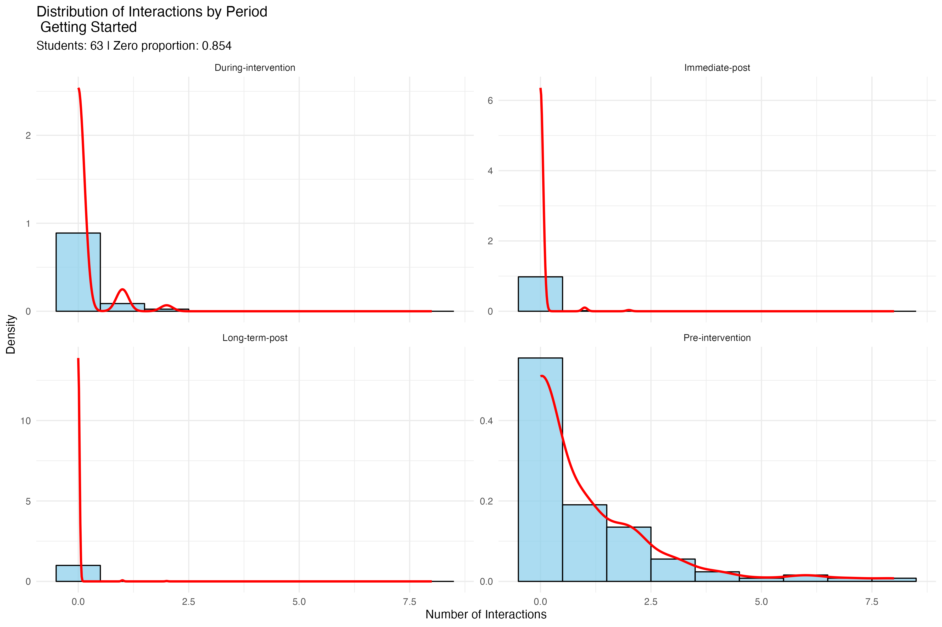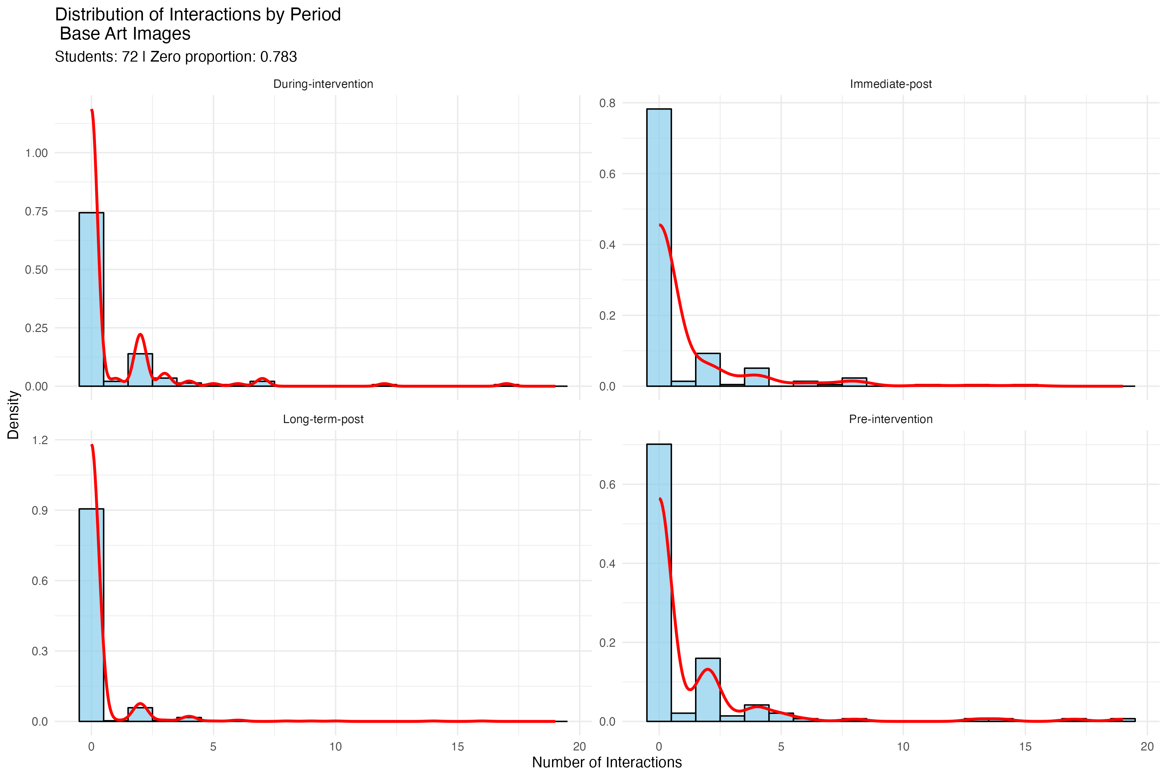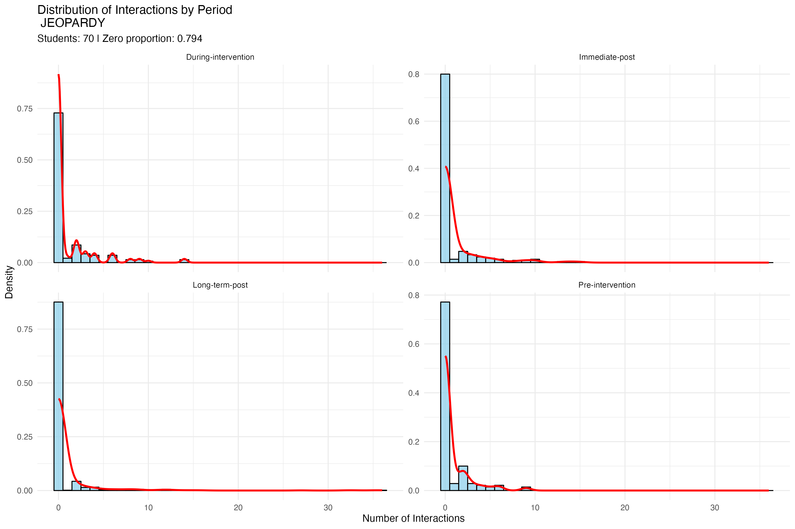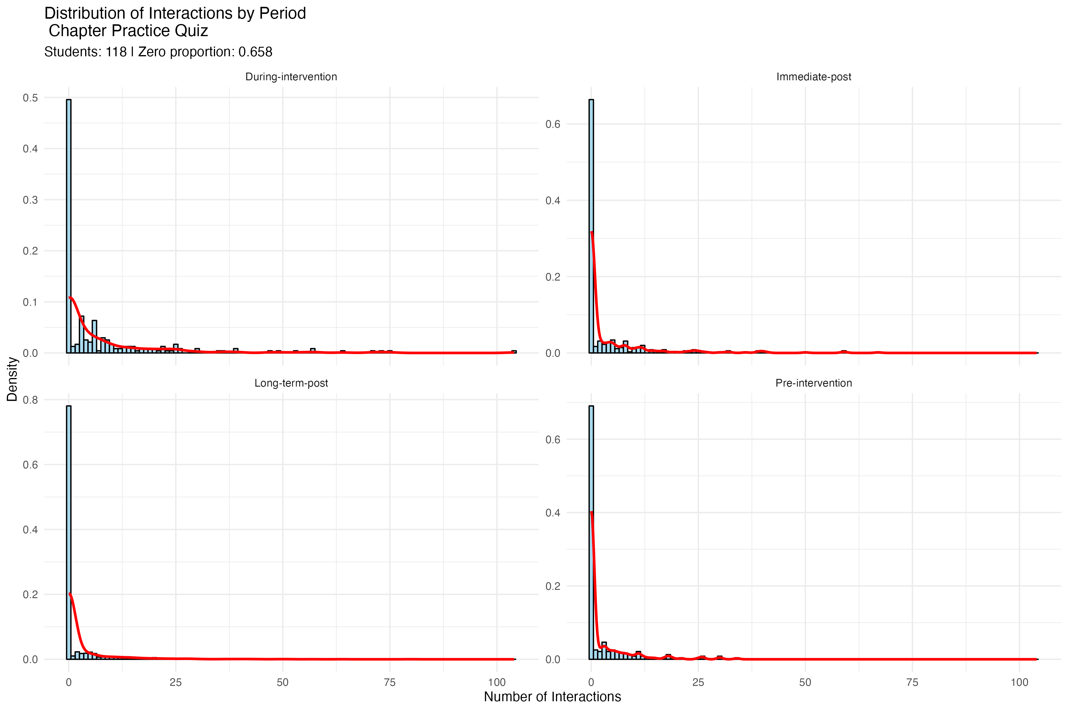

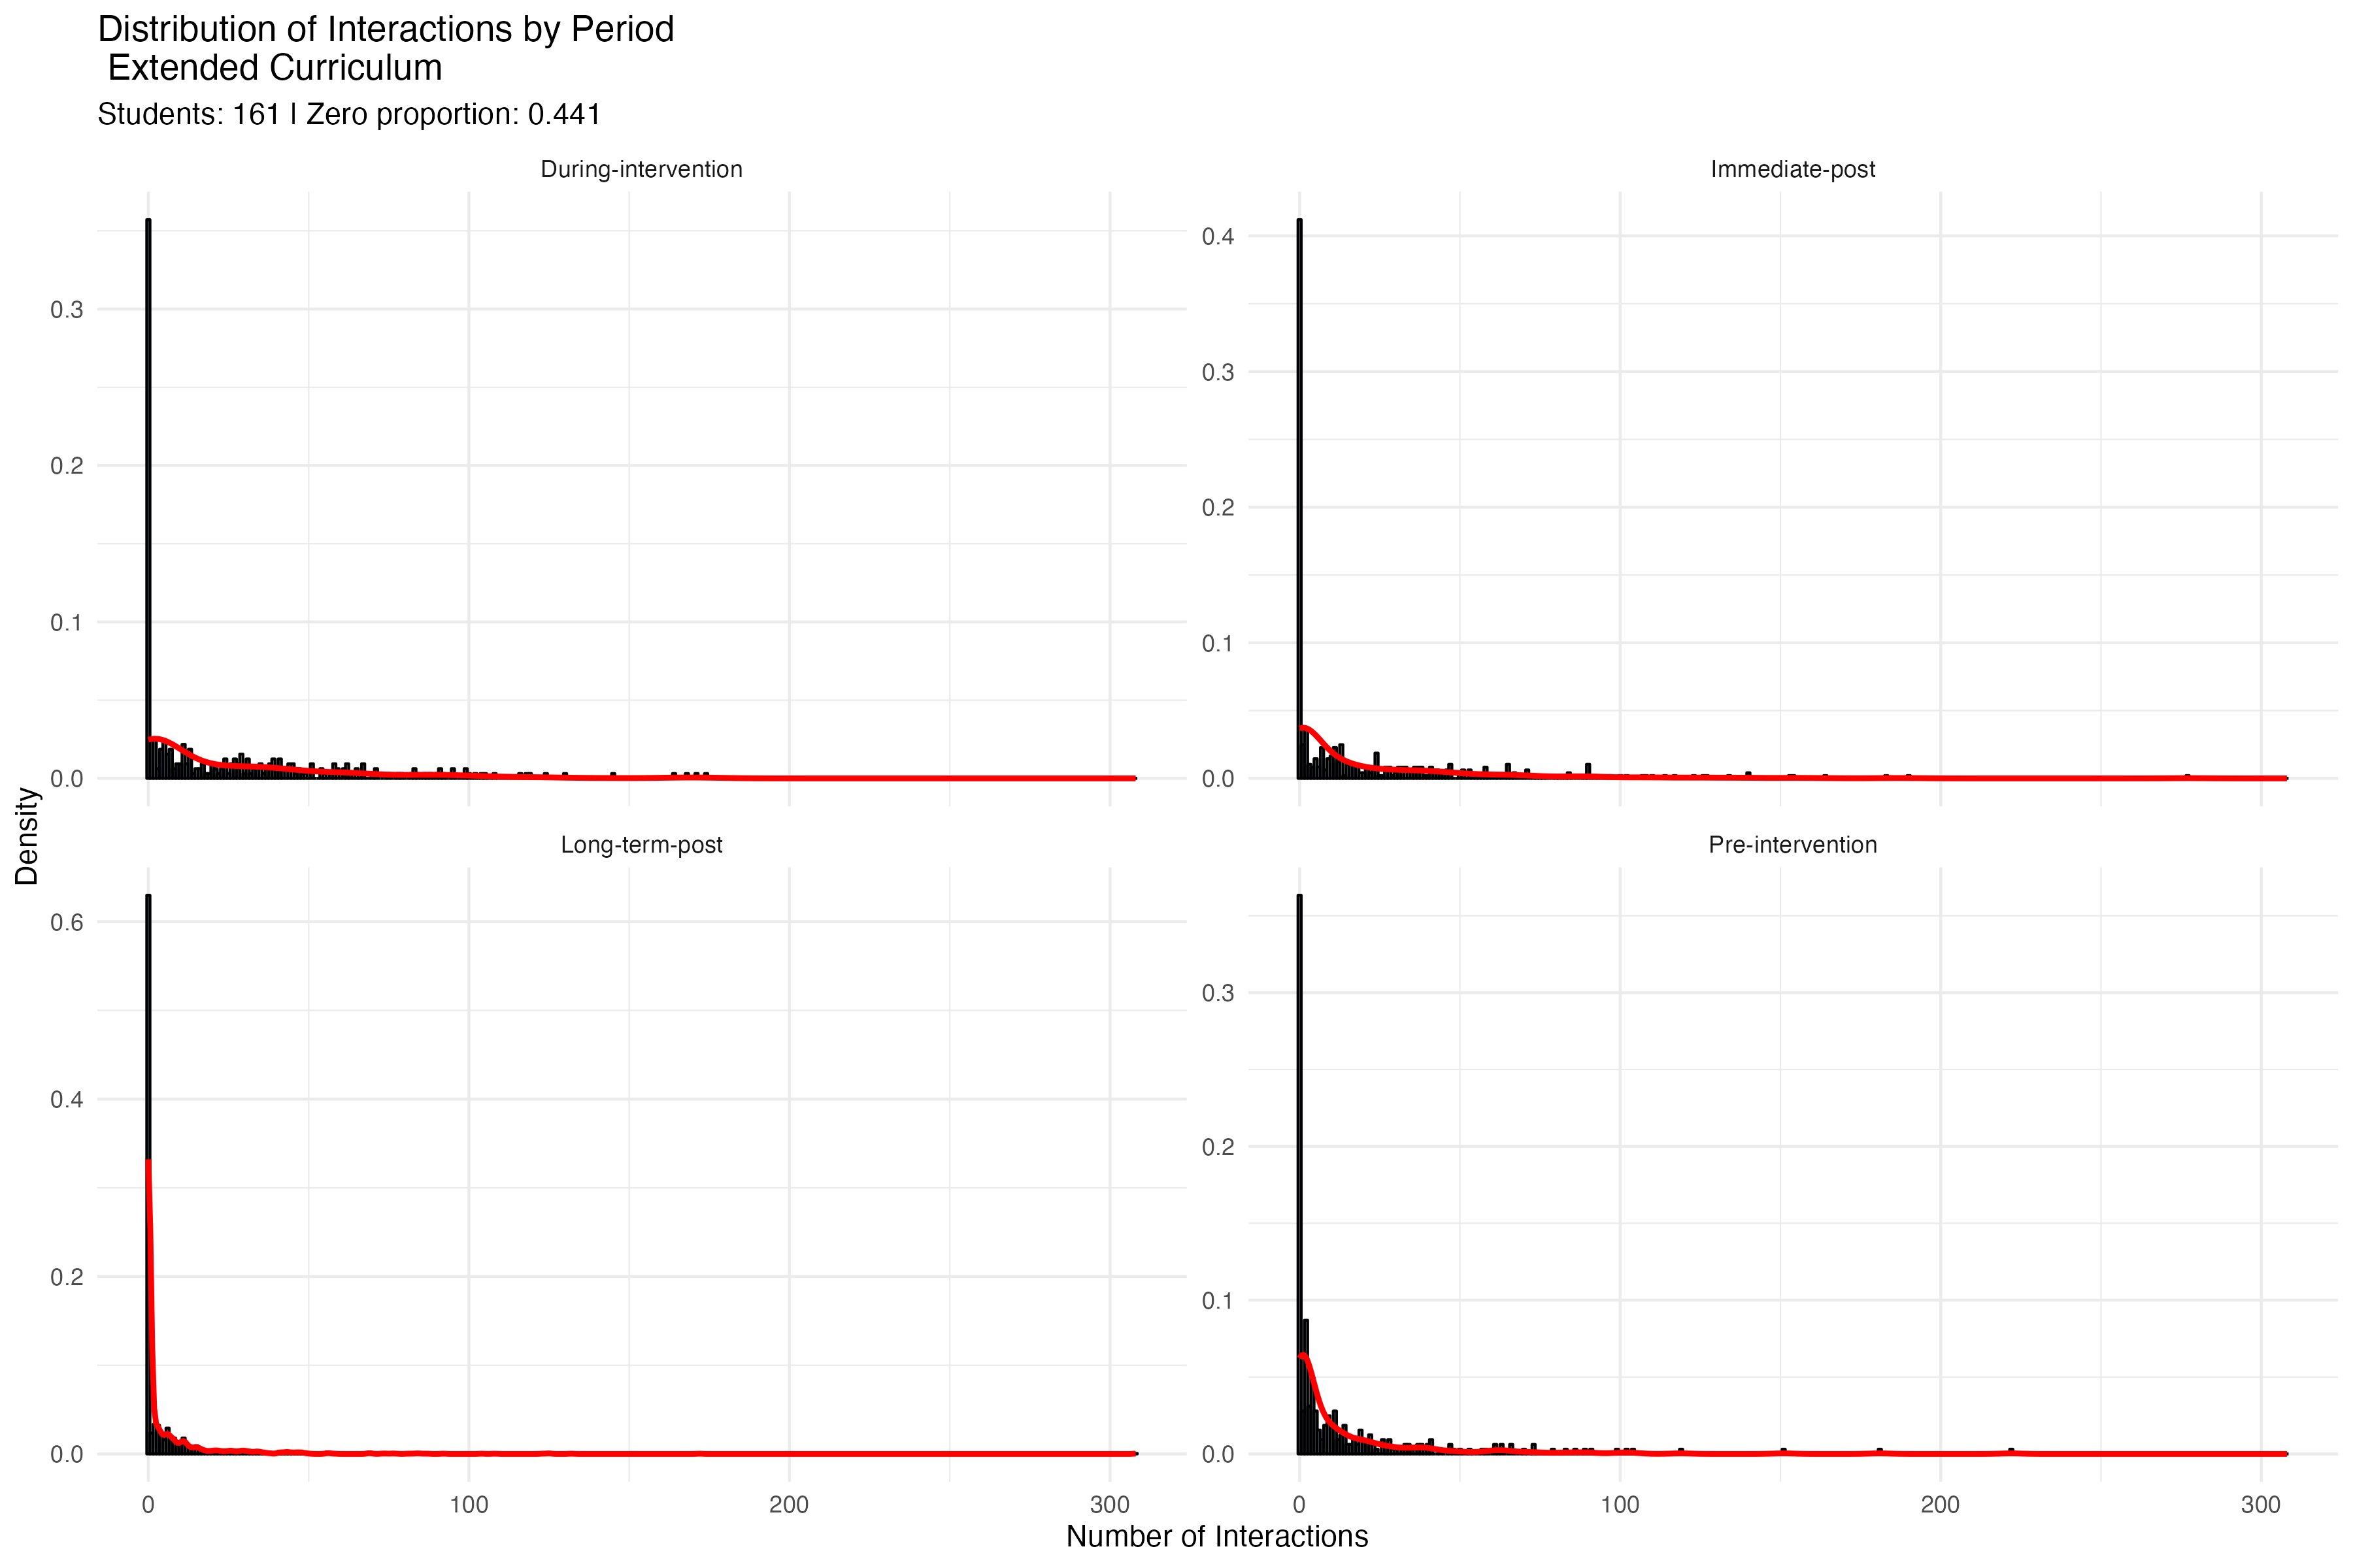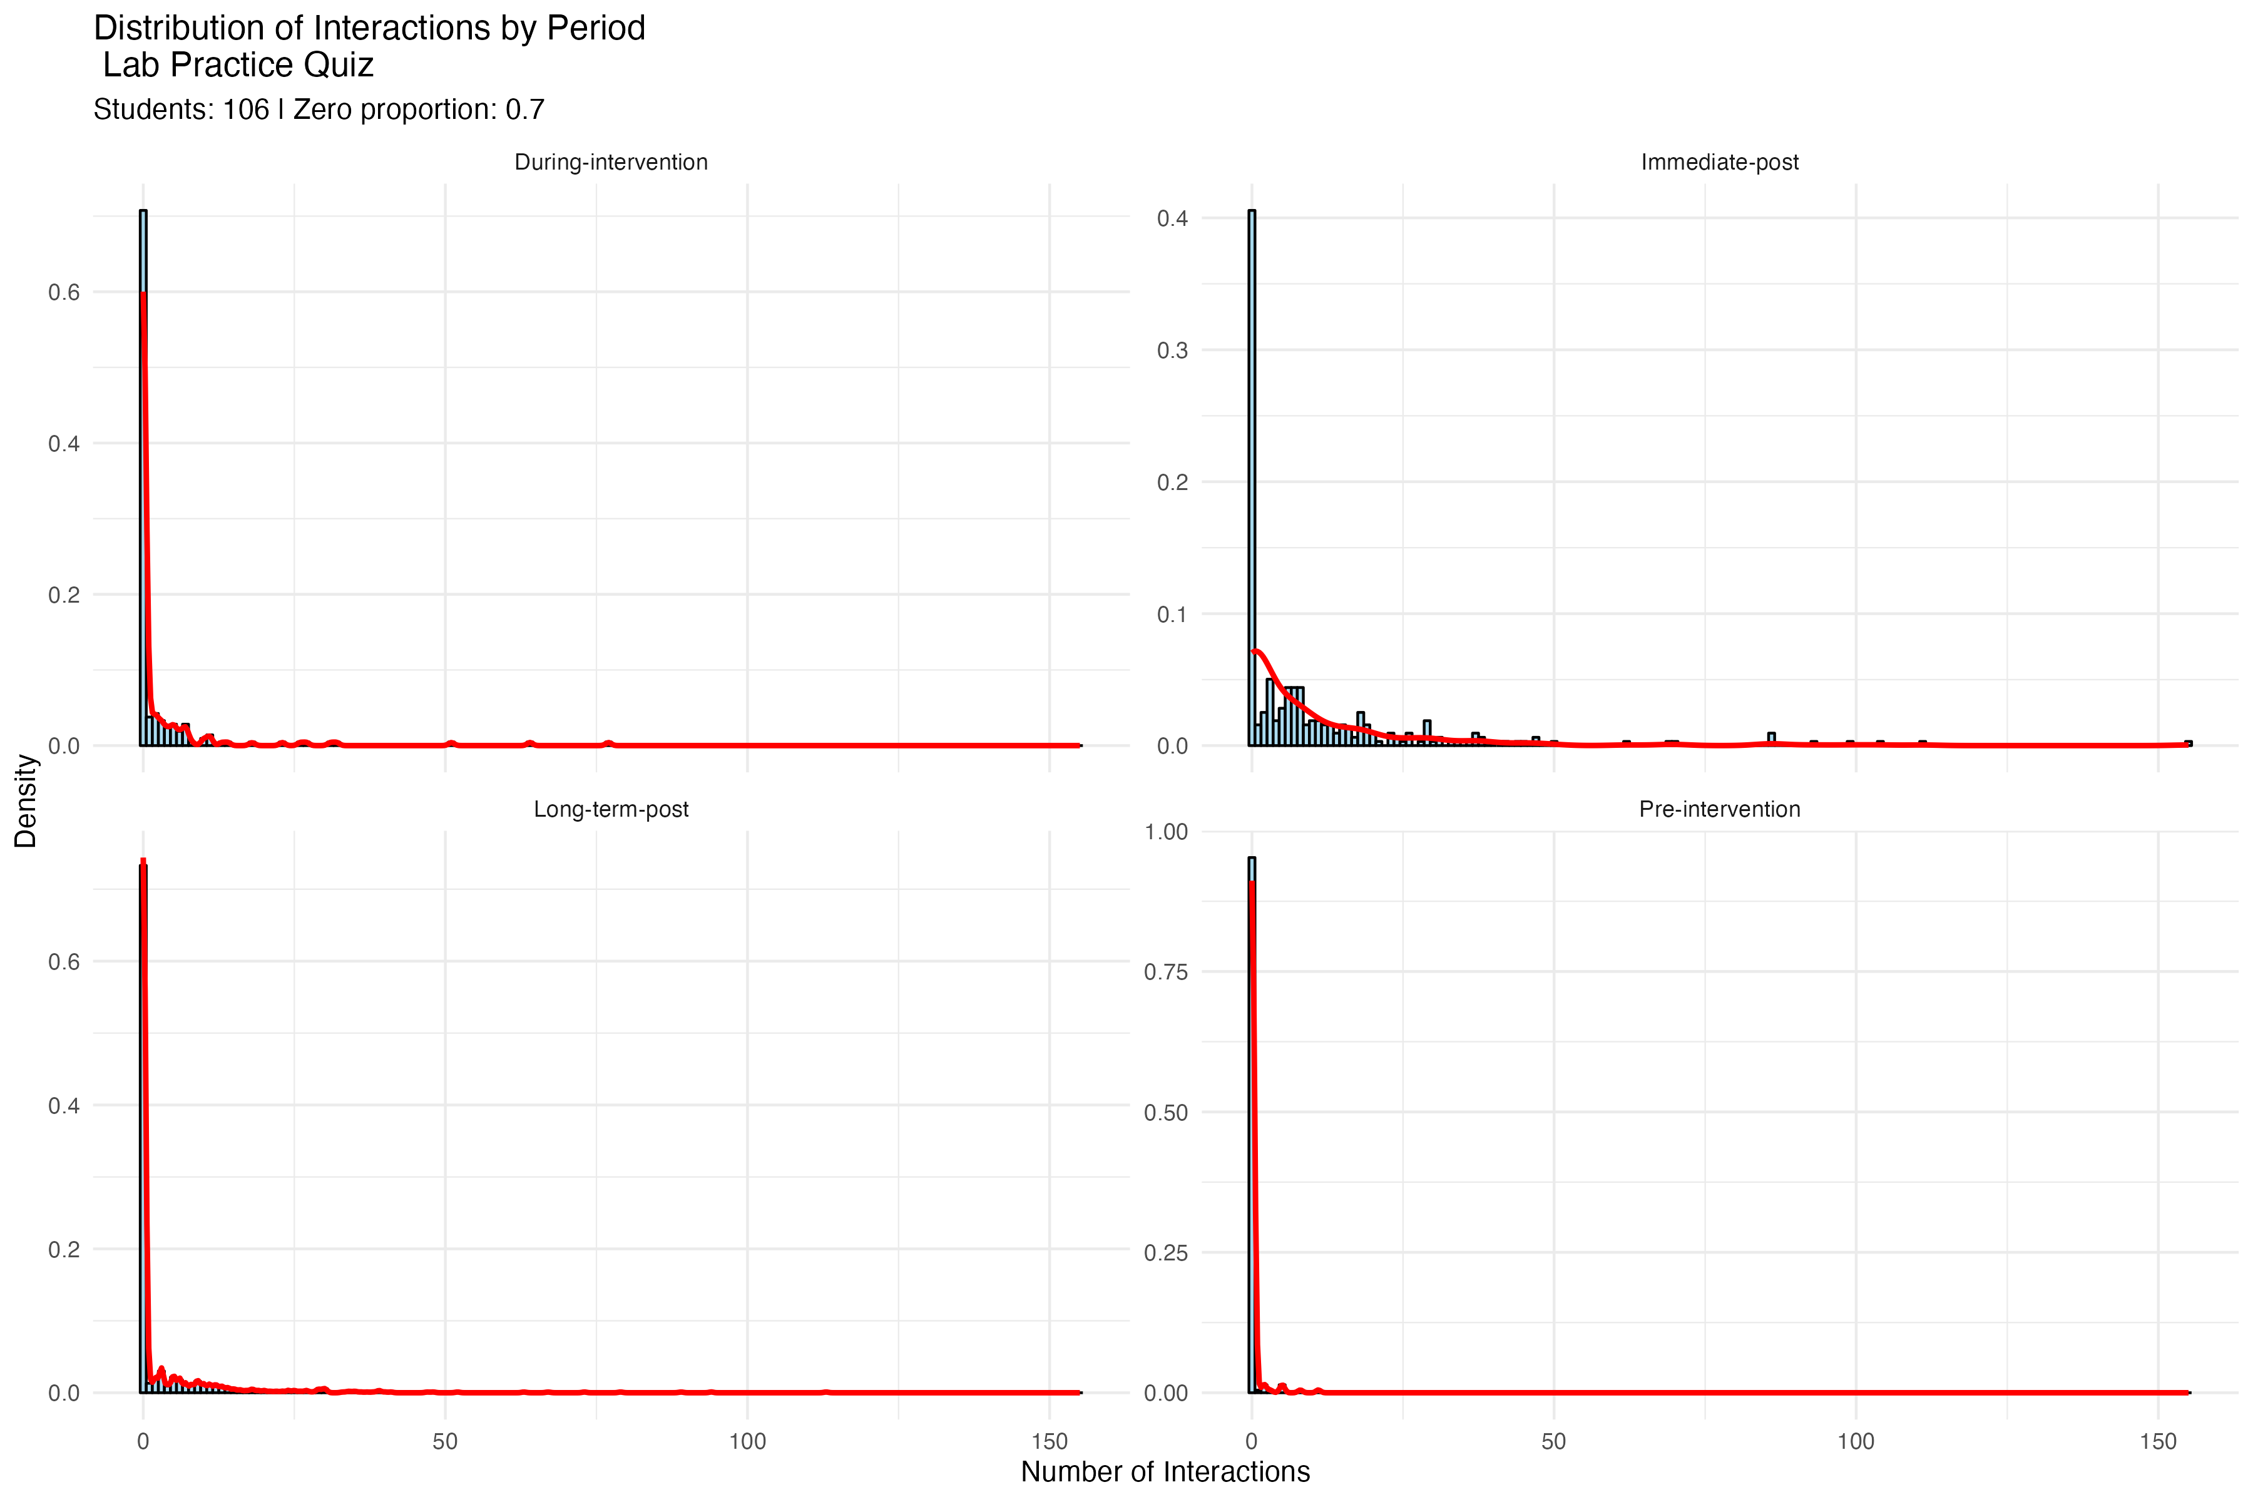

Multiple Regression Analysis for ZINB Models

The analysis was conducted separately for each type of digital resource in each period, comparing three intervention groups (SI, SoL, and Non-Flag Control) against the Flag Control group as the reference category.

To ensure robust statistical inference, we implemented a bootstrap procedure with 2000 resamples, using the percentile method to construct 90% confidence intervals for the group differences. The analysis was stratified across four distinct time periods: pre-intervention, during-intervention, immediate post-intervention, and long-term post-intervention. This temporal stratification allowed us to examine both the immediate and sustained effects of the interventions.

The model parameters were estimated using maximum likelihood estimation with robust standard errors. To address convergence issues, we employed an increased maximum iteration limit of 500 in the model fitting process. Significance levels were denoted using conventional markers ( *p < .10,* ***p < .05,*** p < .01), and parallel processing was utilized to expedite the bootstrap computations. The results were visualized using error bar plots showing the estimated differences between groups, with bootstrap confidence intervals providing a measure of statistical uncertainty.

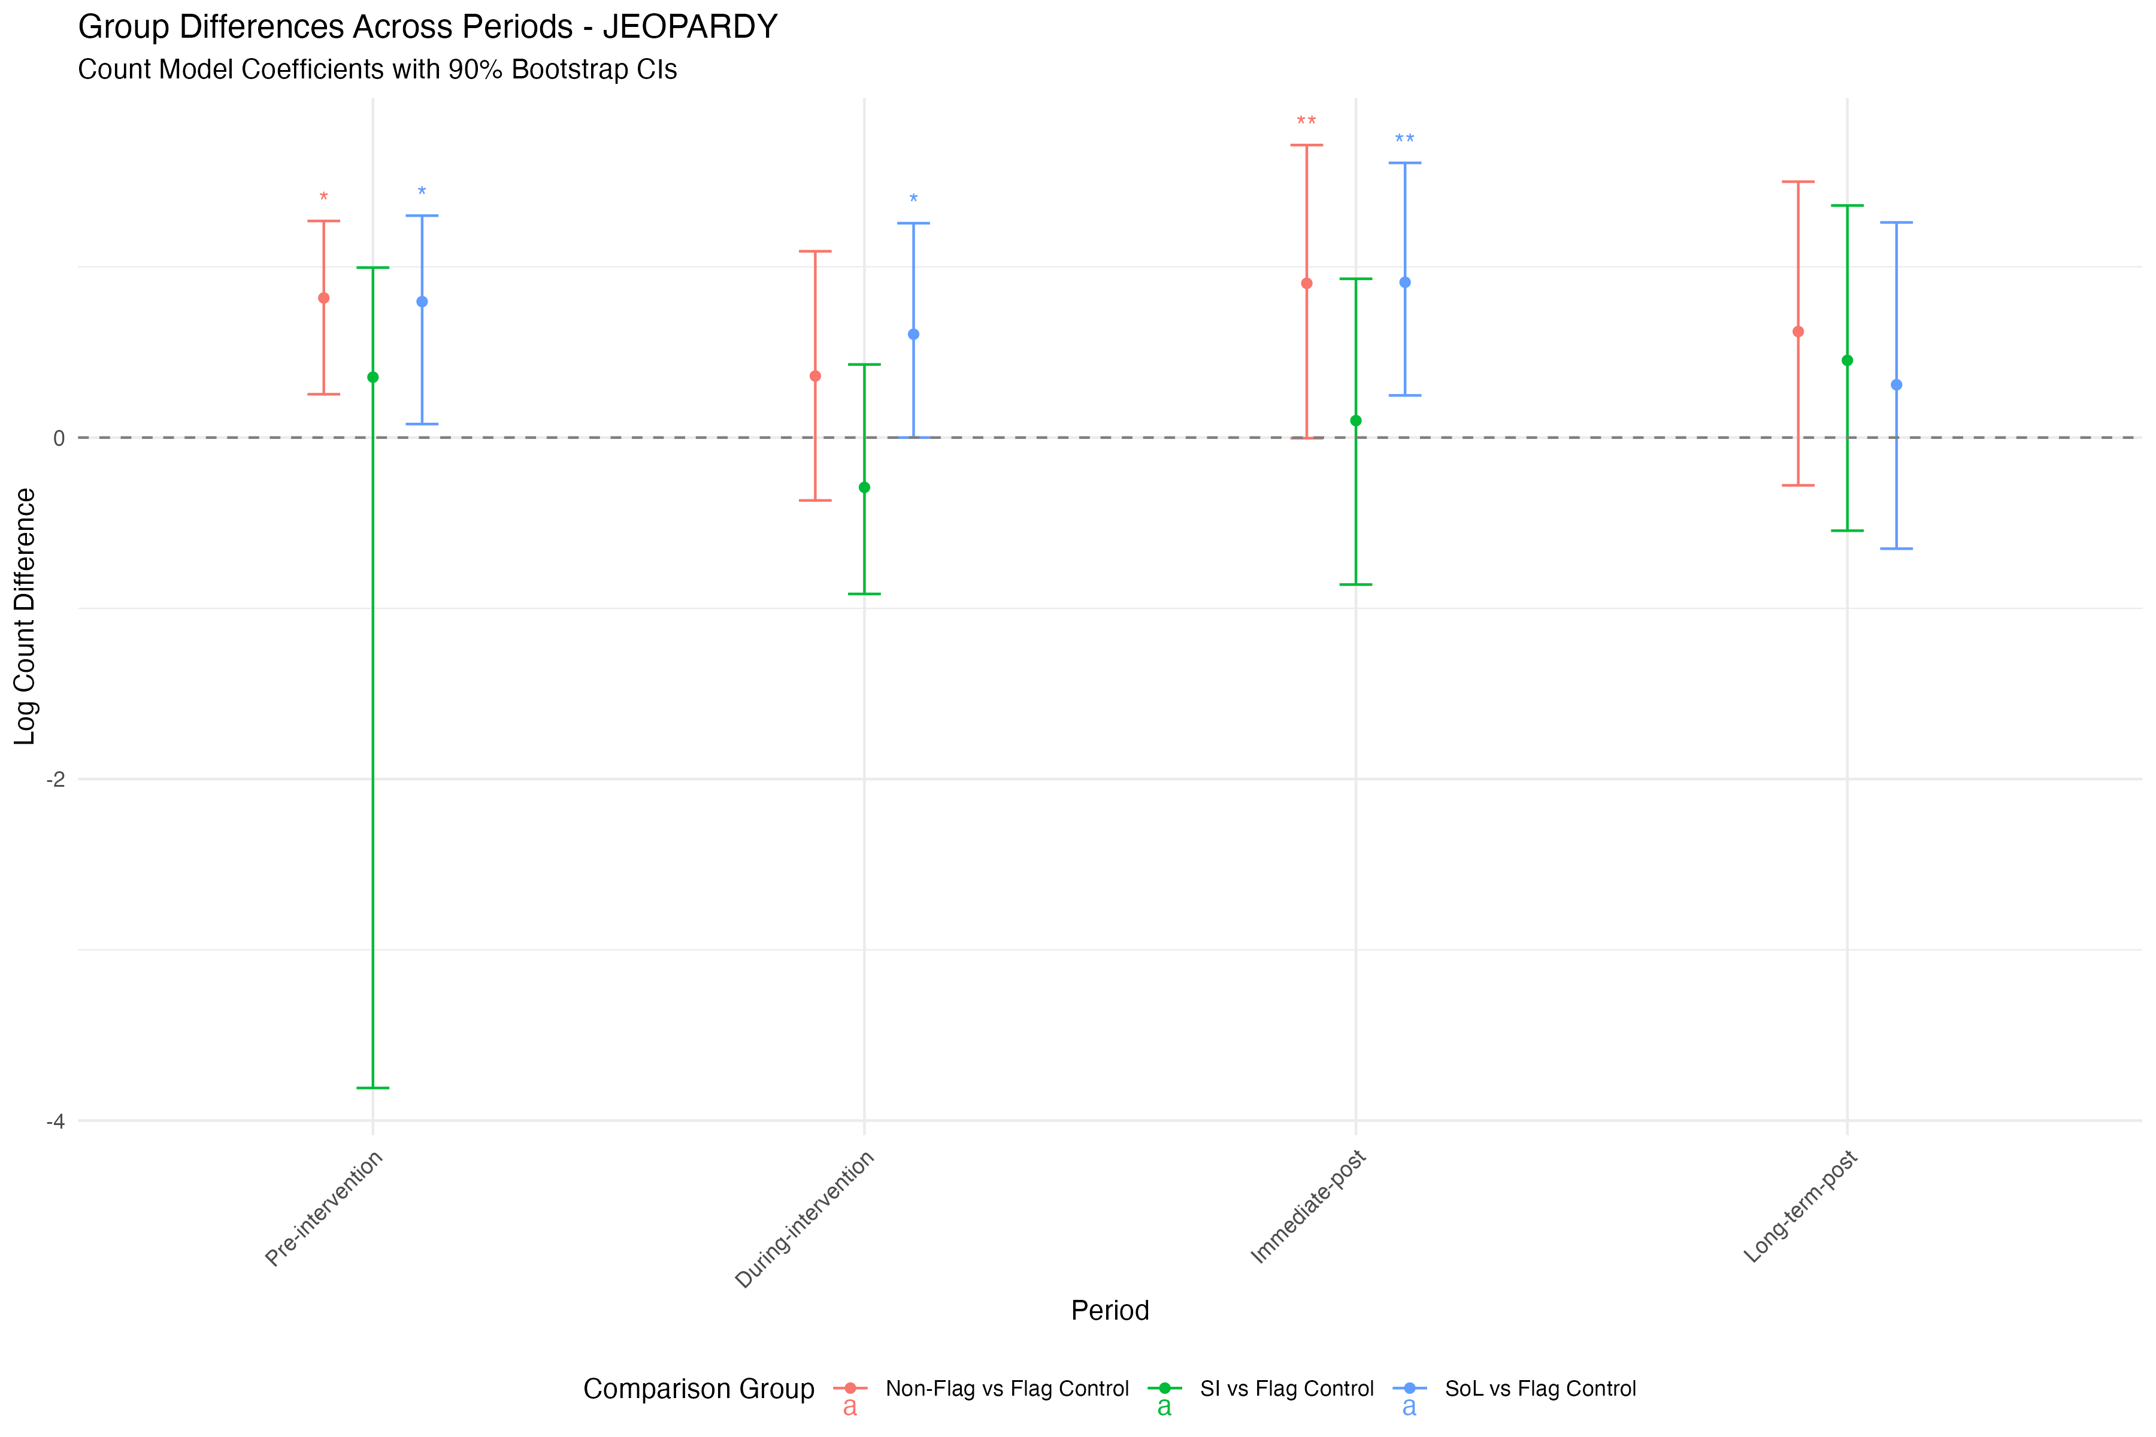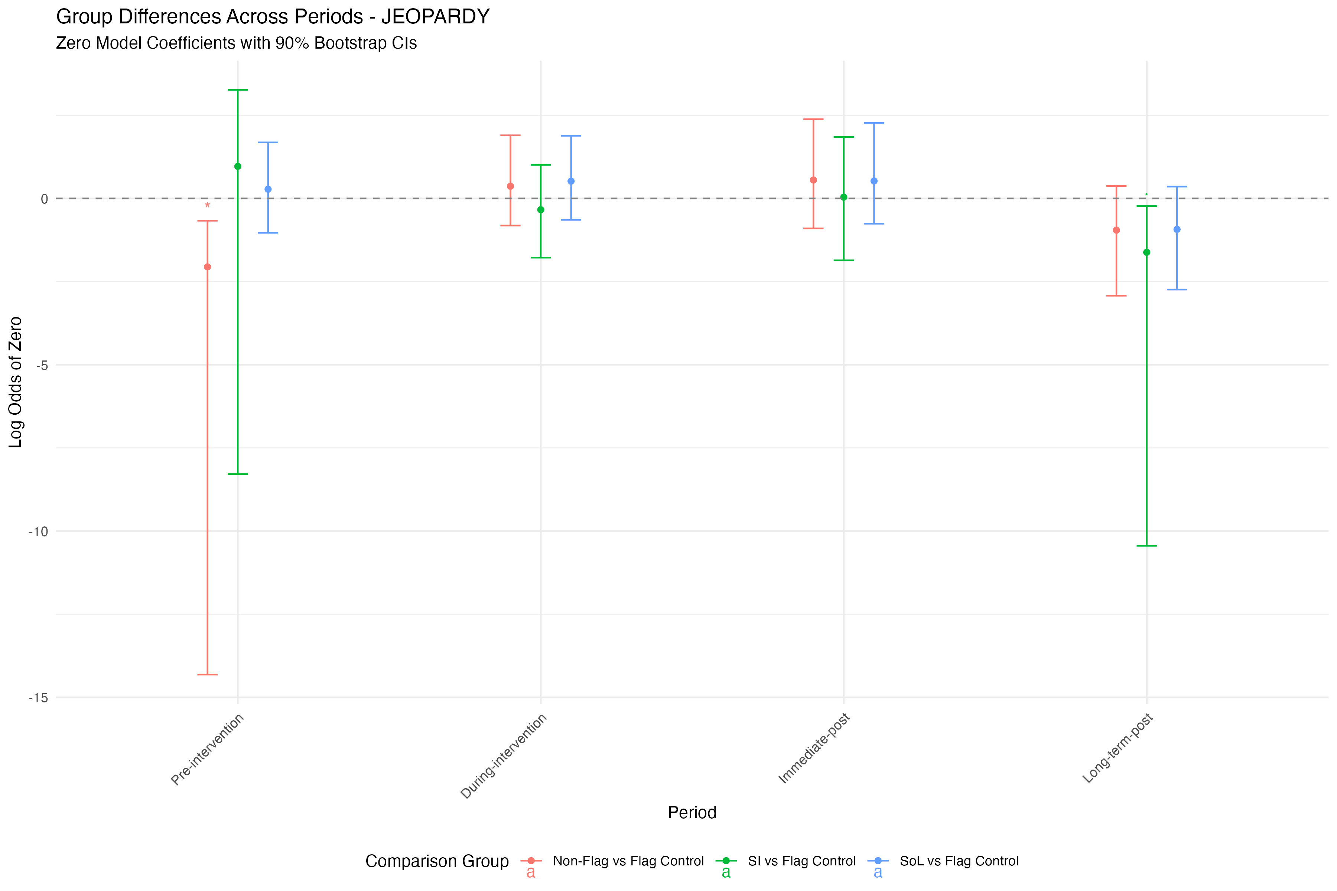

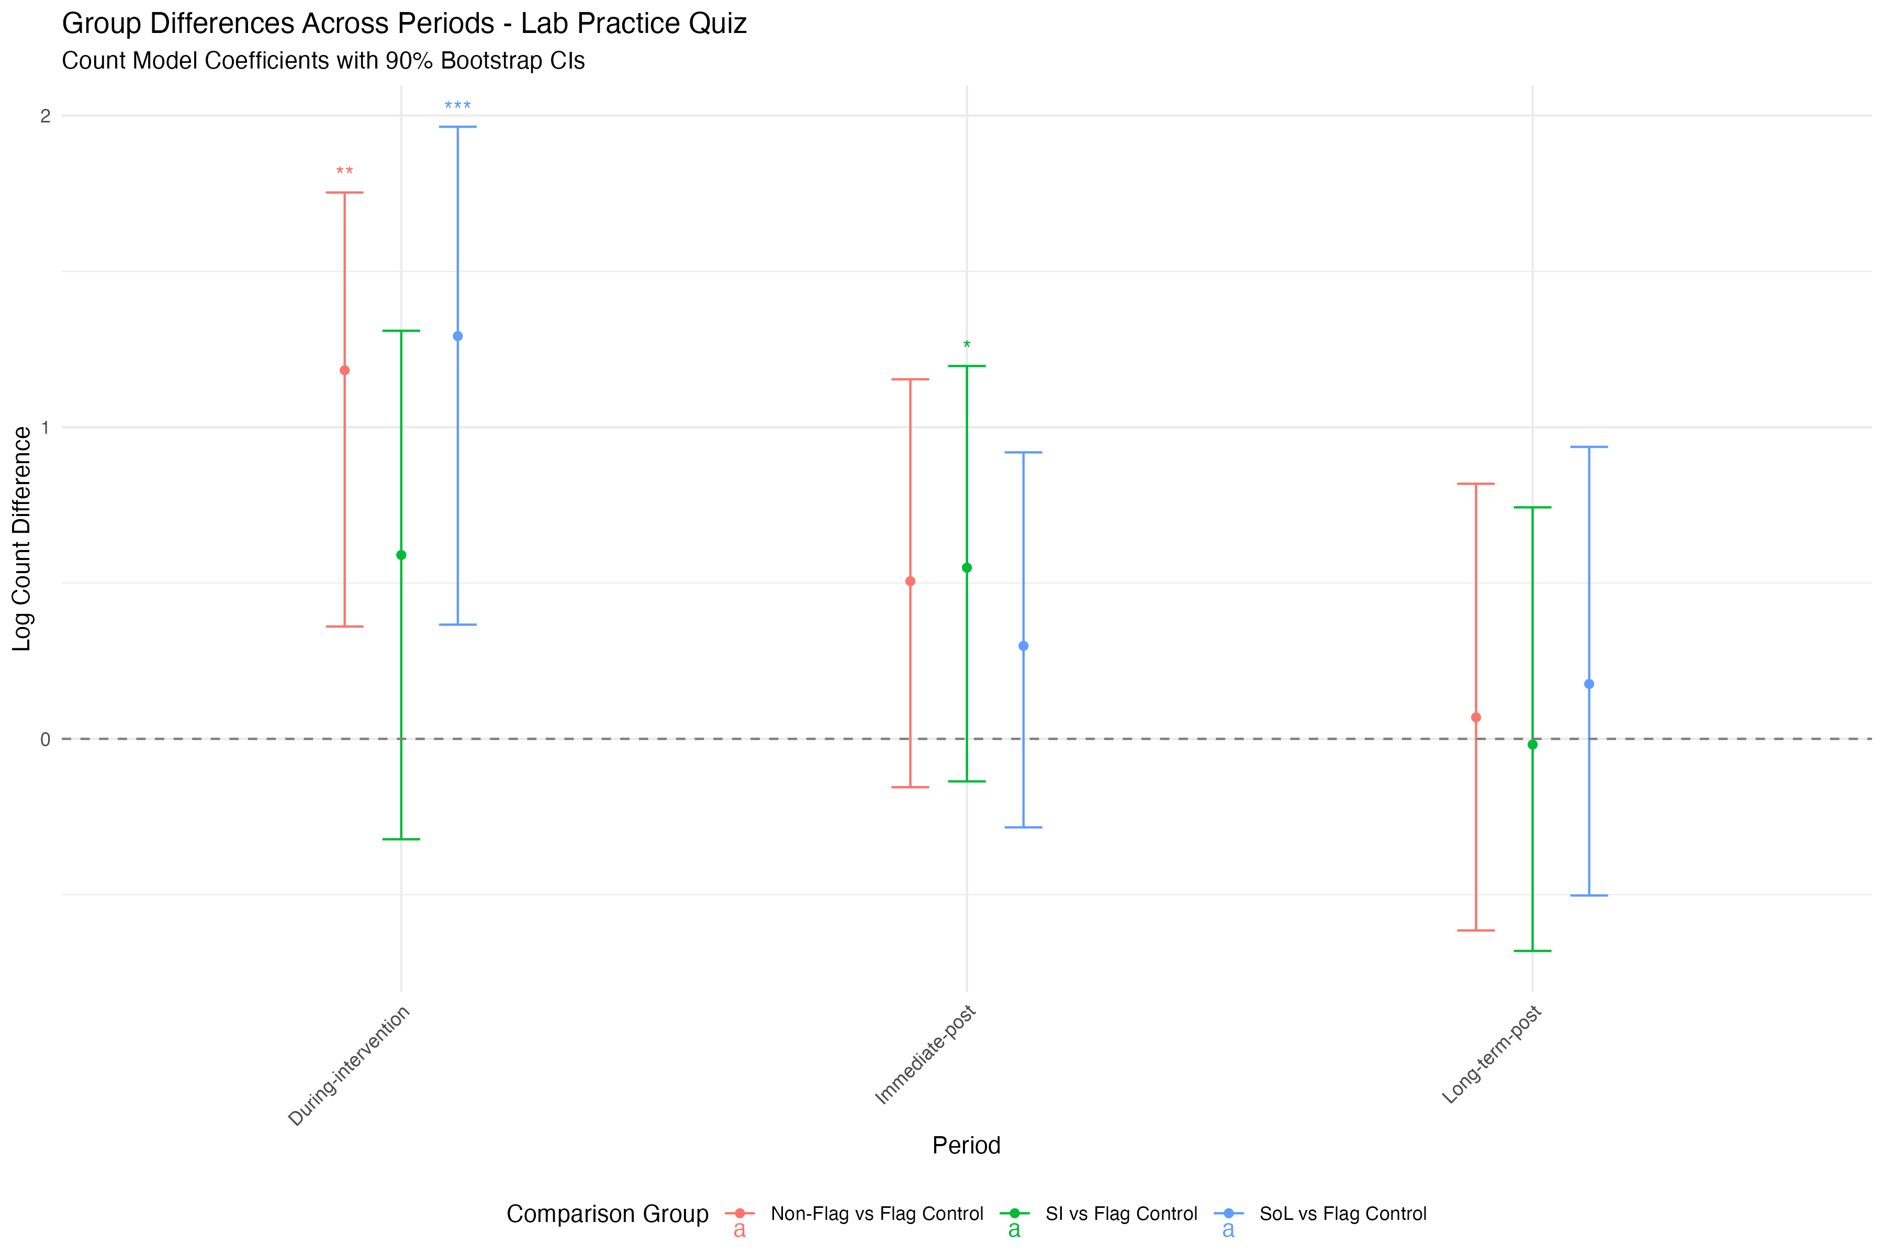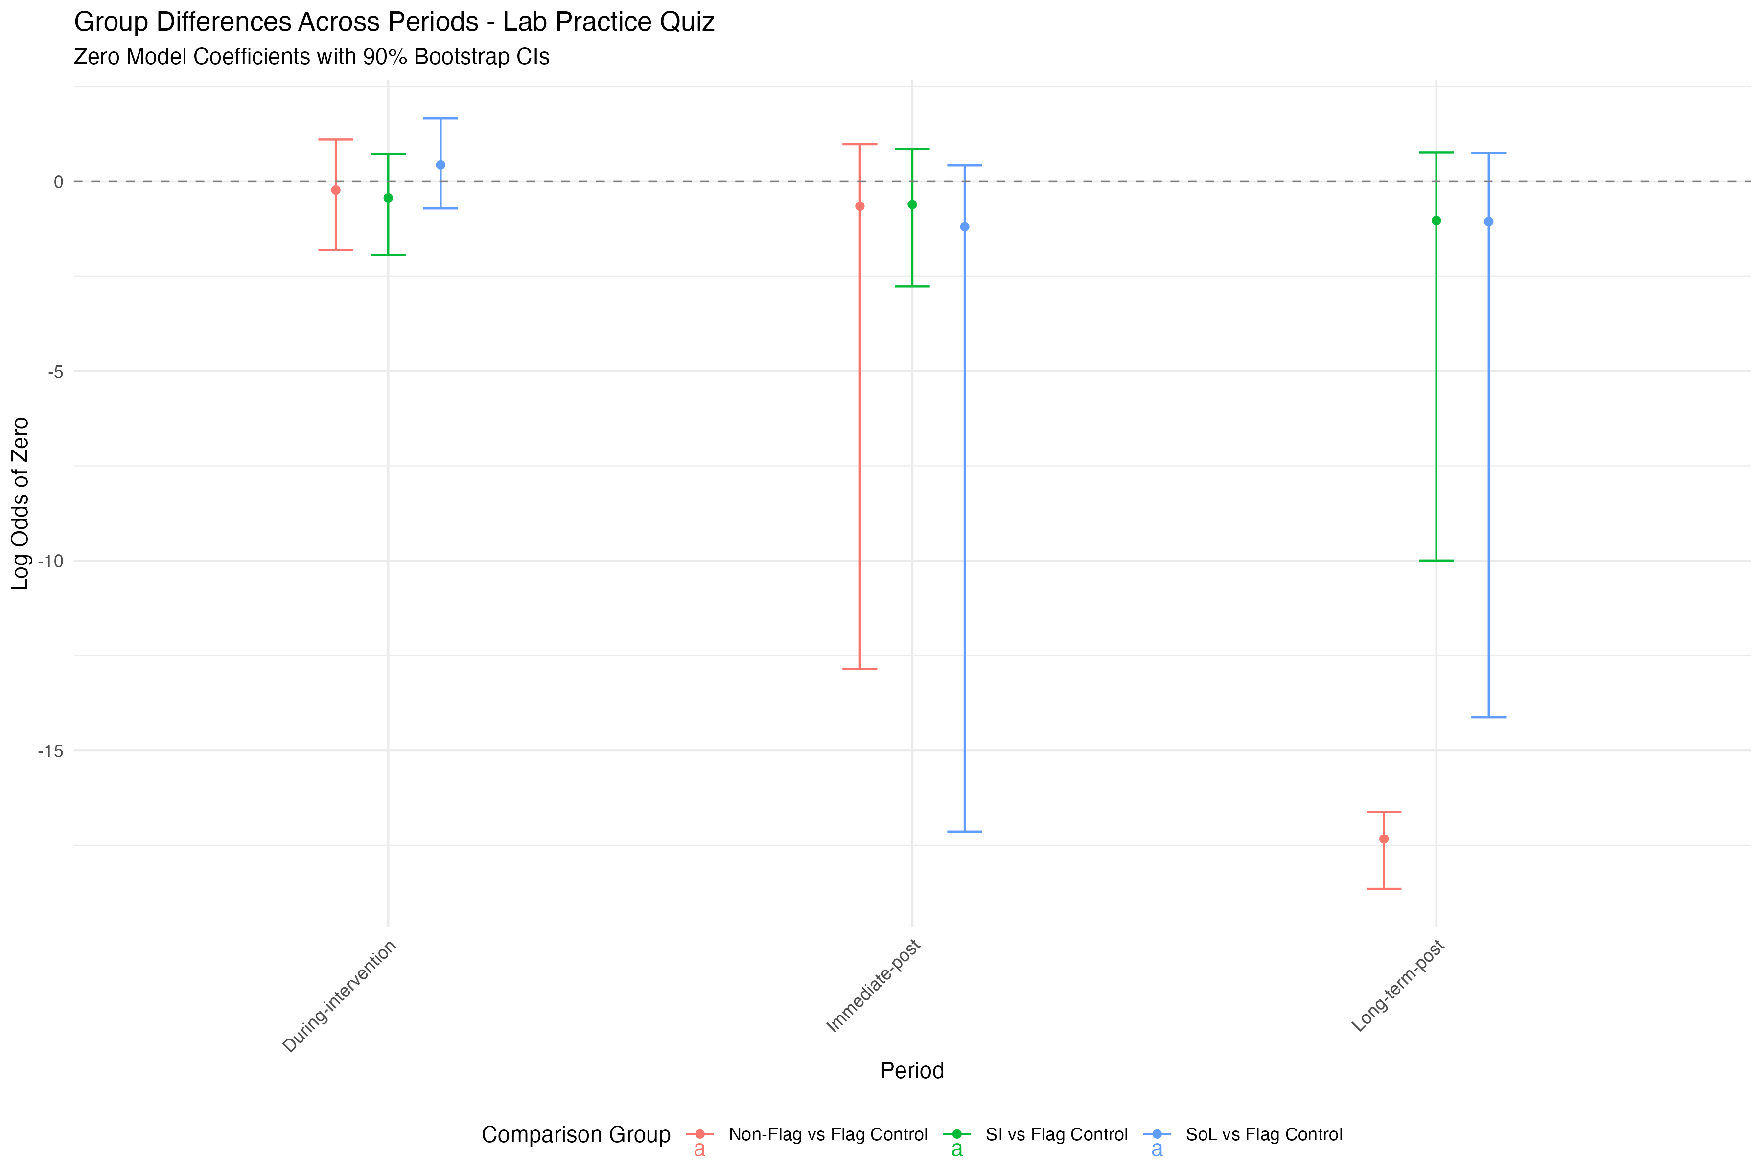

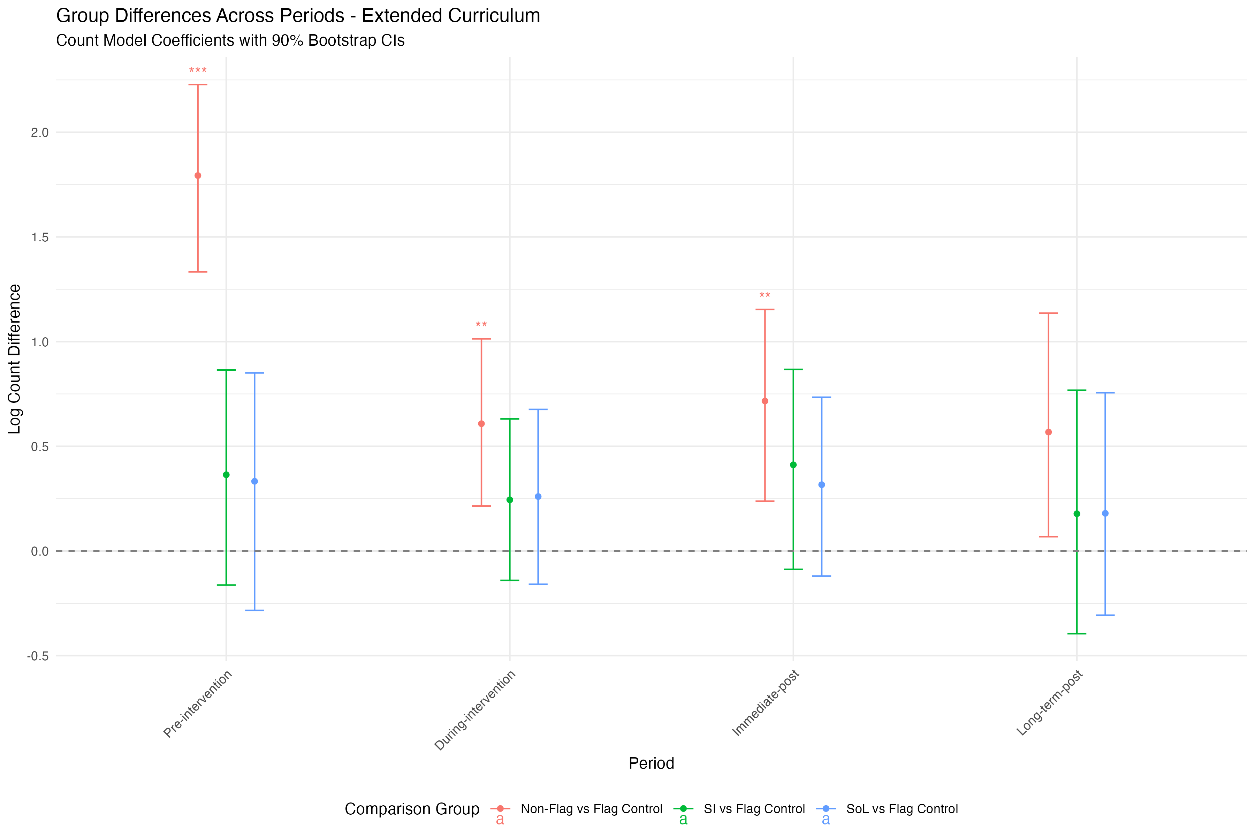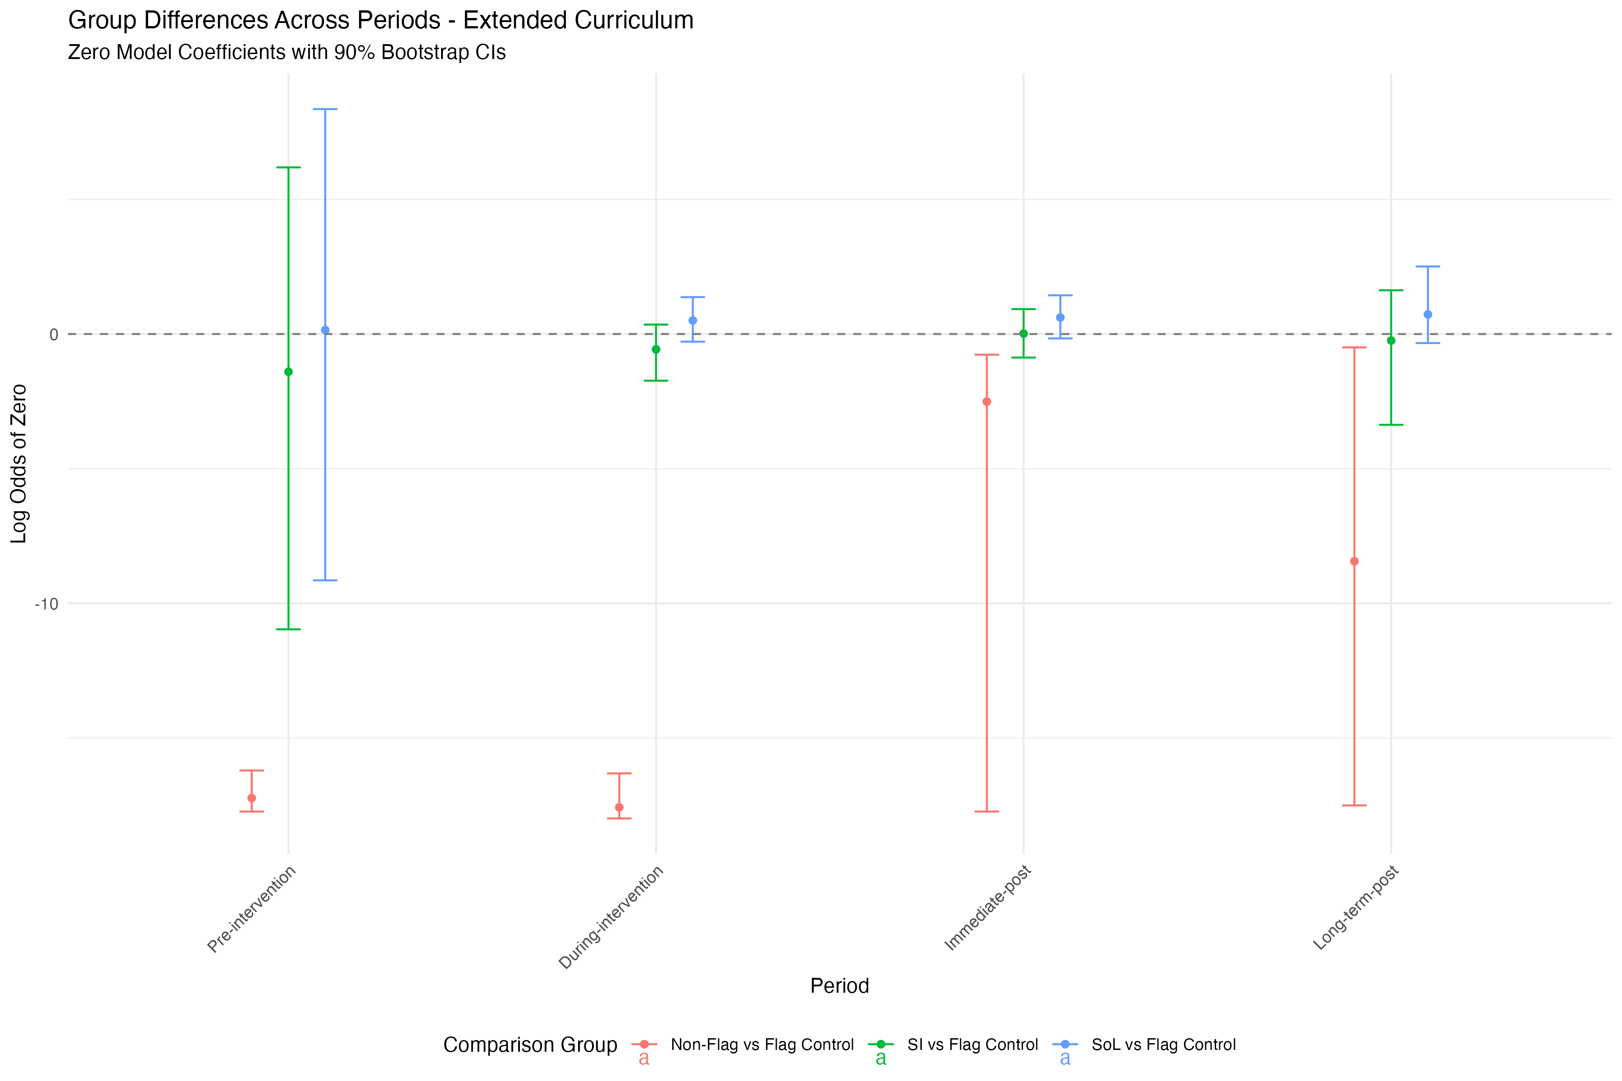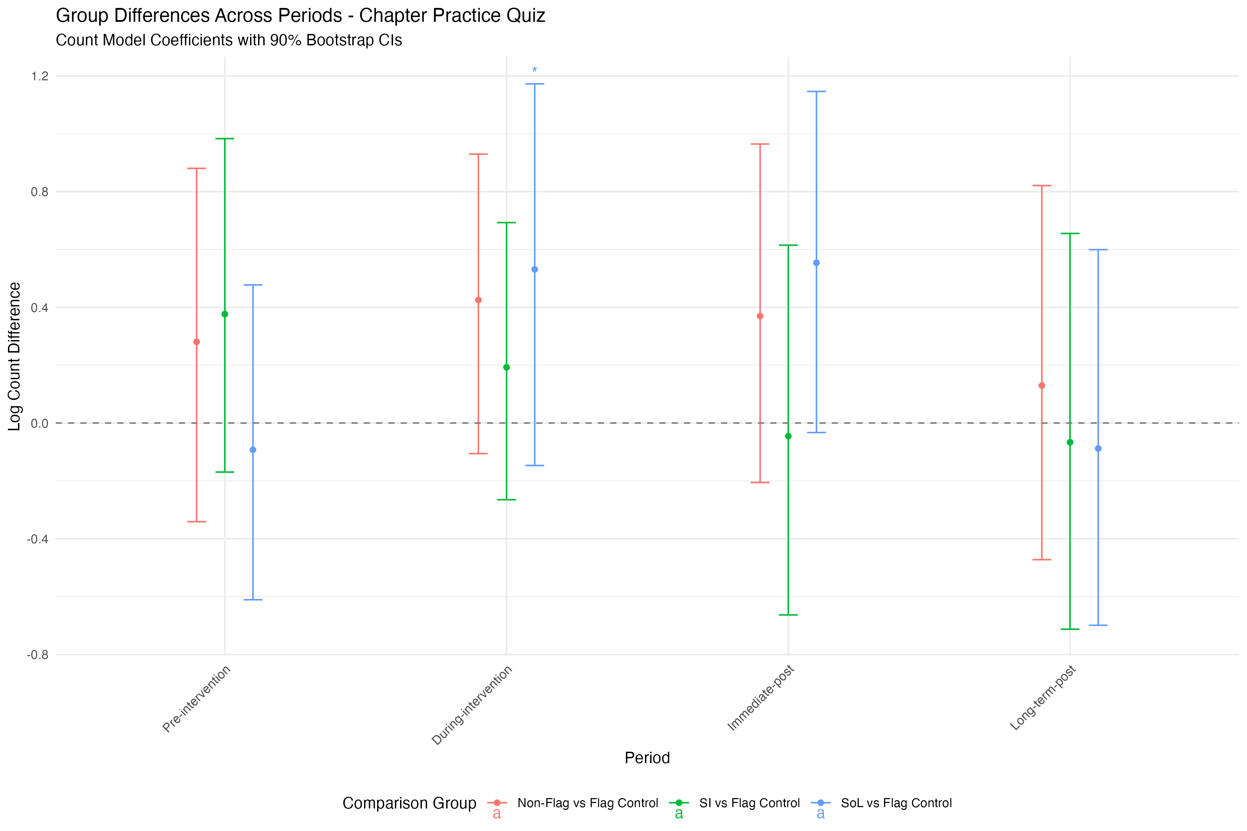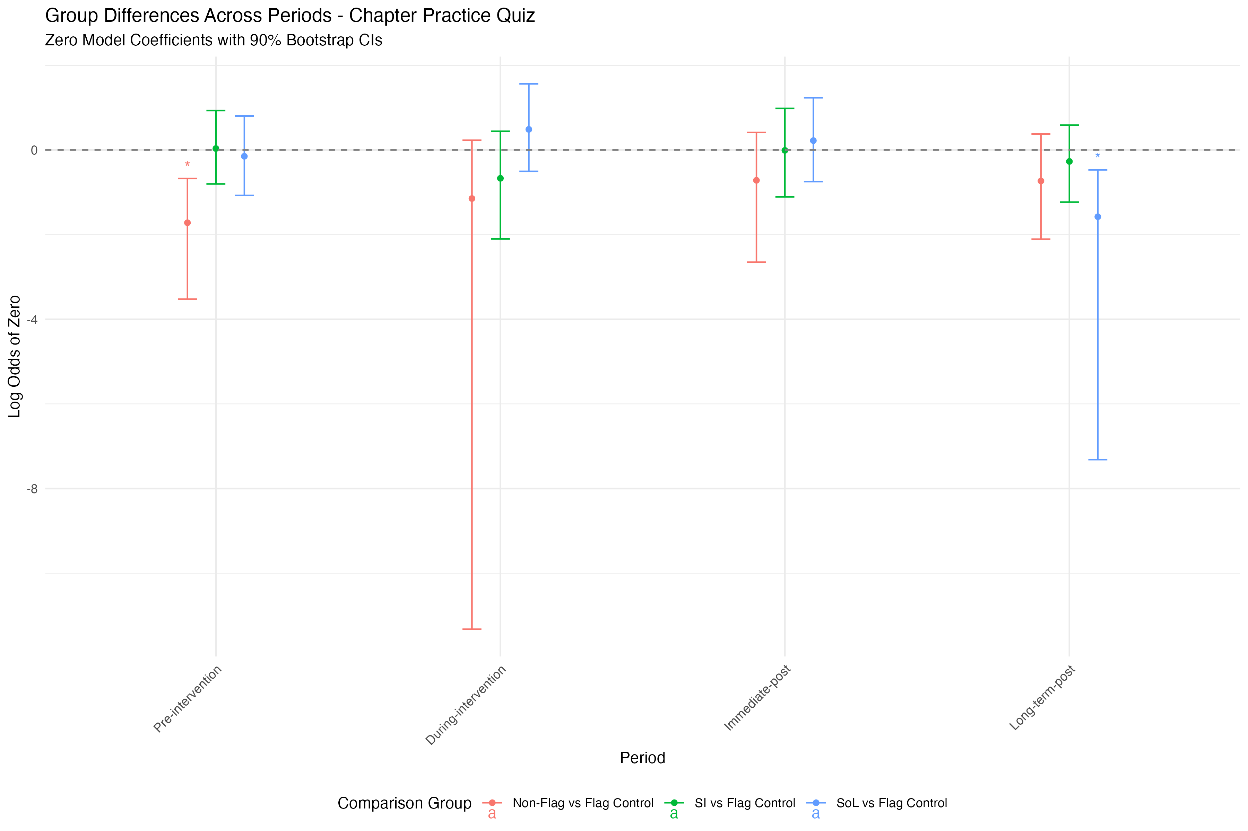

1.4 Multiple Mediation

A regularized multiple parallel mediation analysis was conducted using LASSO penalization to identify significant mediation pathways (Serang,Jacobucci, & Grimm), 2017. The model included six potential mediators: JEOPARDY and Chapter Practice Quiz usage measured at three time points (during intervention, immediate post, and long-term post). LASSO regularization was applied with a lambda grid search from 0.4 to 0.01, using BIC for model selection. The optimal lambda value was selected through cross-validation to prevent overfitting.

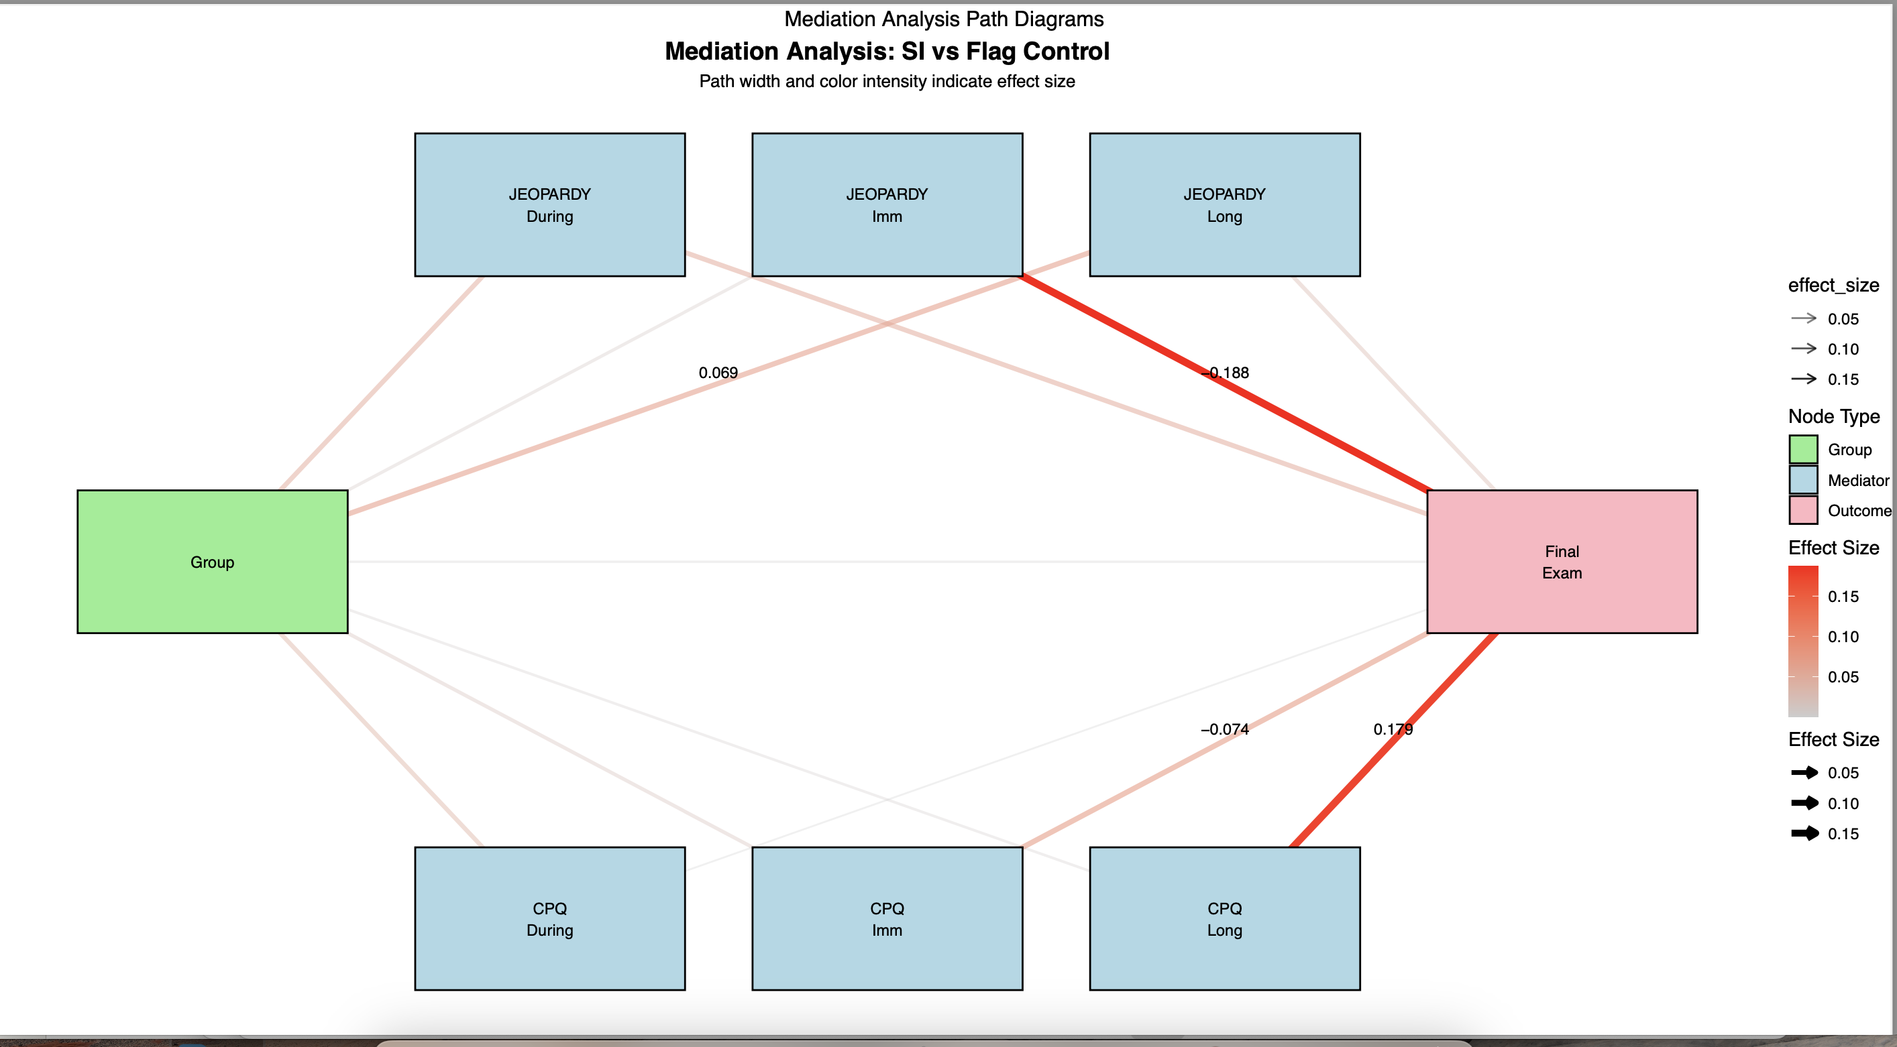

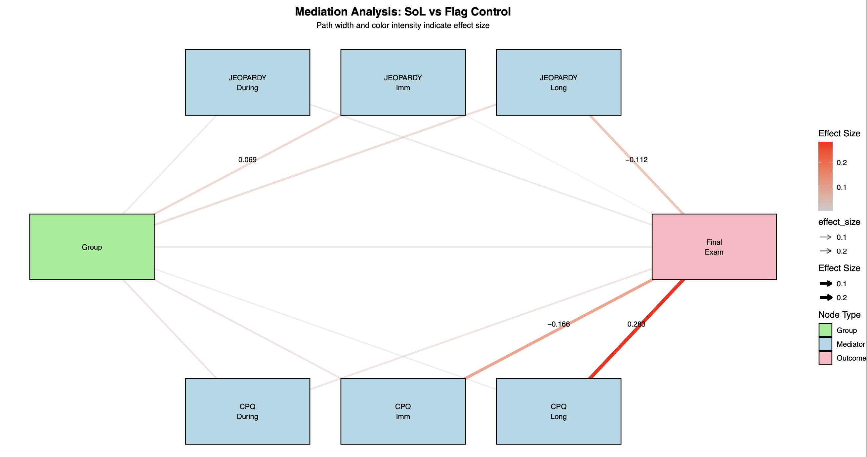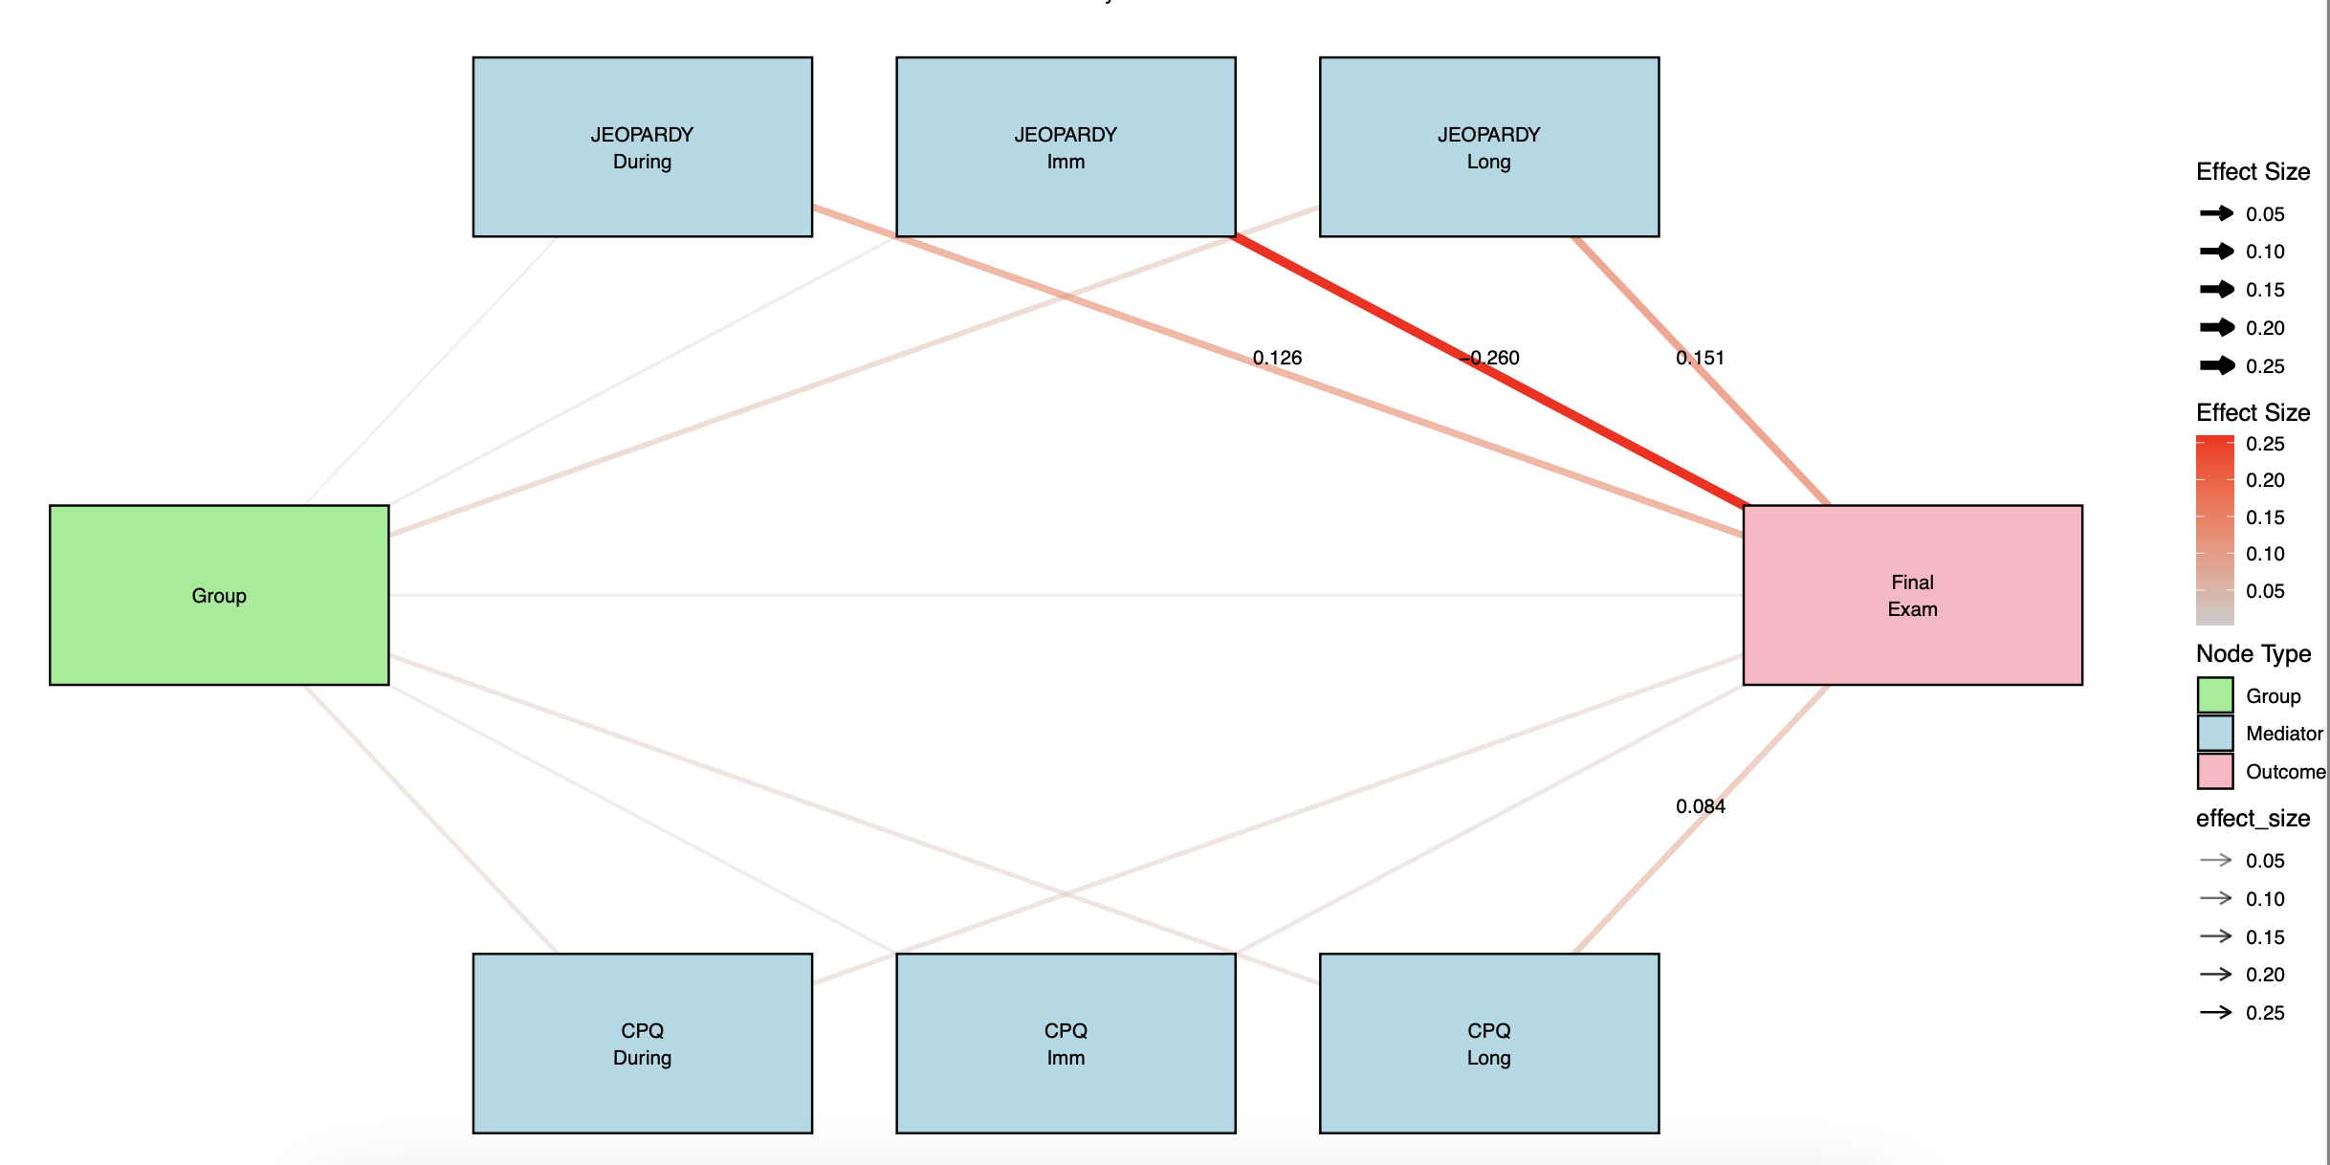

**1.4 Mediation Analysis**

The study also employed mediation analysis to examine how interventions (SI, SoL, and Flag Control) influenced final exam performance through digital learning behaviors.

**2 Descriptive Analyses**

**2.1 Intervention Period Clicks Analysis**

During the intervention period (weeks 2-3), the Practice Quiz emerged as the most frequently accessed resource with Non-Flag Control students showing approximately 9.5 interactions per person per week, while SI and SoL groups showed moderate engagement levels around 5-6 interactions. The Extended Curriculum demonstrated consistently high usage across groups, with Non-Flag Control students averaging 45 interactions per person per week, followed by SI (26 interactions), SoL (20 interactions), and Flag Control (18 interactions) groups. These baseline measurements established clear engagement hierarchies among intervention groups.

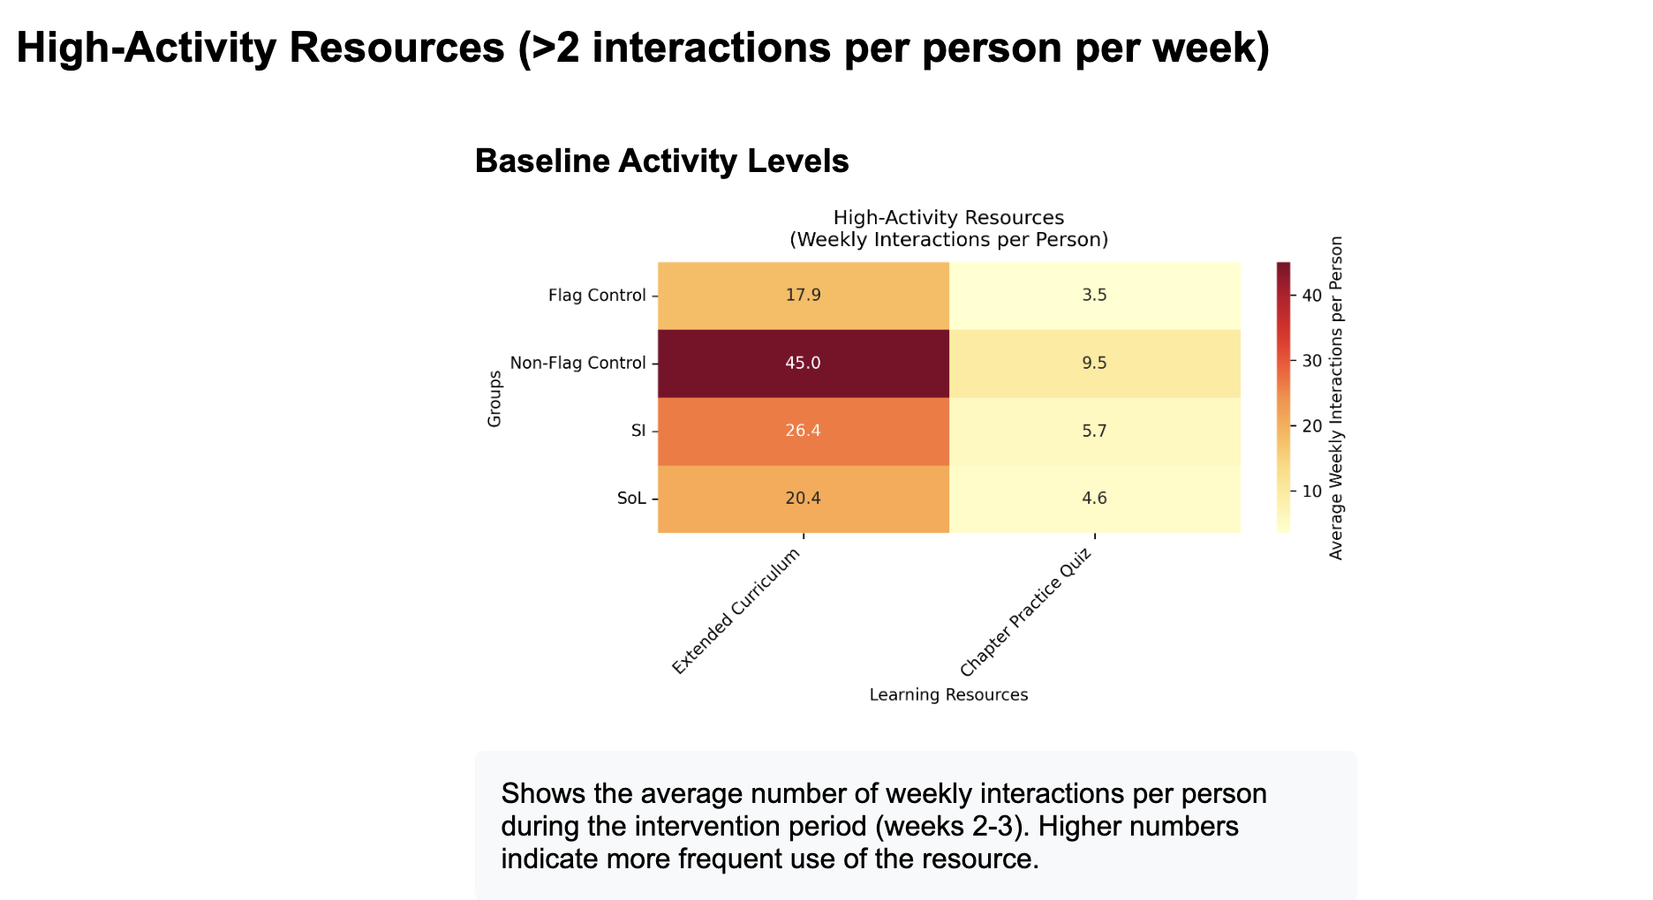

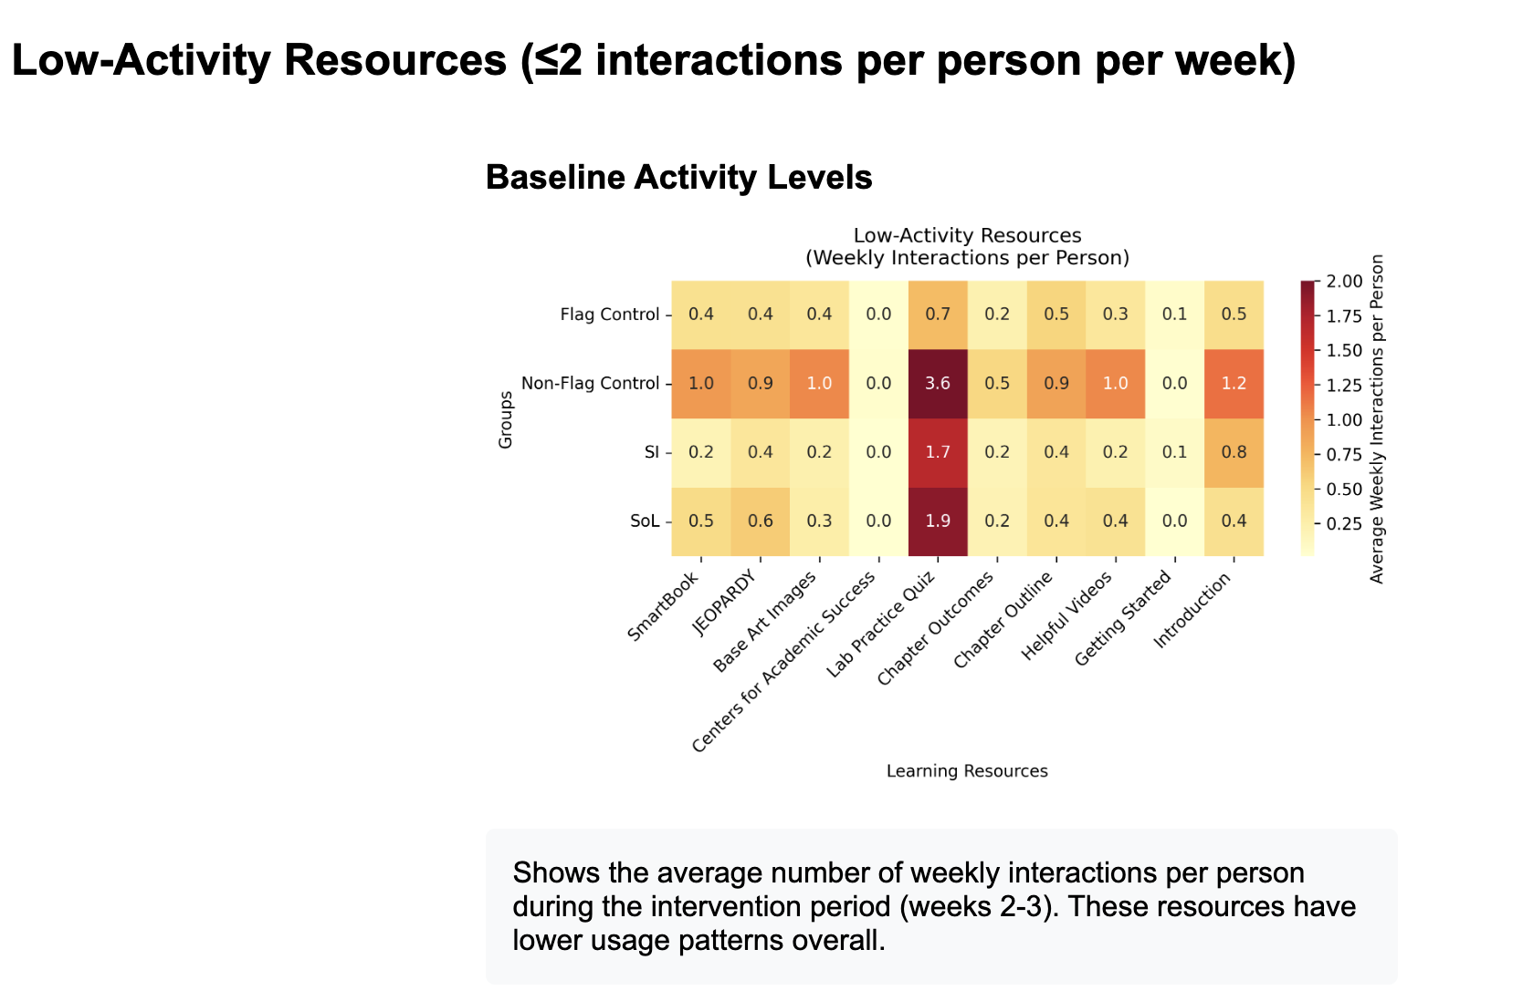

**2.2 Temporal Engagement Dynamics (Pre – Post Contrast)**

The analysis of high-activity resources revealed distinct patterns between immediate and long-term usage. In the immediate post-intervention period (weeks 0-1 vs 4-6), Flag Control and SI groups showed substantial increases in Extended Curriculum usage (107.0% and 105.7% respectively), while the SoL group demonstrated strong growth in Chapter Practice Quiz engagement (183.2%). Conversely, the Non-Flag Control group exhibited a decline in Extended Curriculum usage (-14.8%). The long-term comparison (weeks 0-1 vs 7-16) showed a general decline across all groups in Extended Curriculum usage, ranging from -34.4% (Flag Control) to -79.2% (Non-Flag Control), though the SoL group maintained relatively stronger Chapter Practice Quiz engagement (54.6% increase).

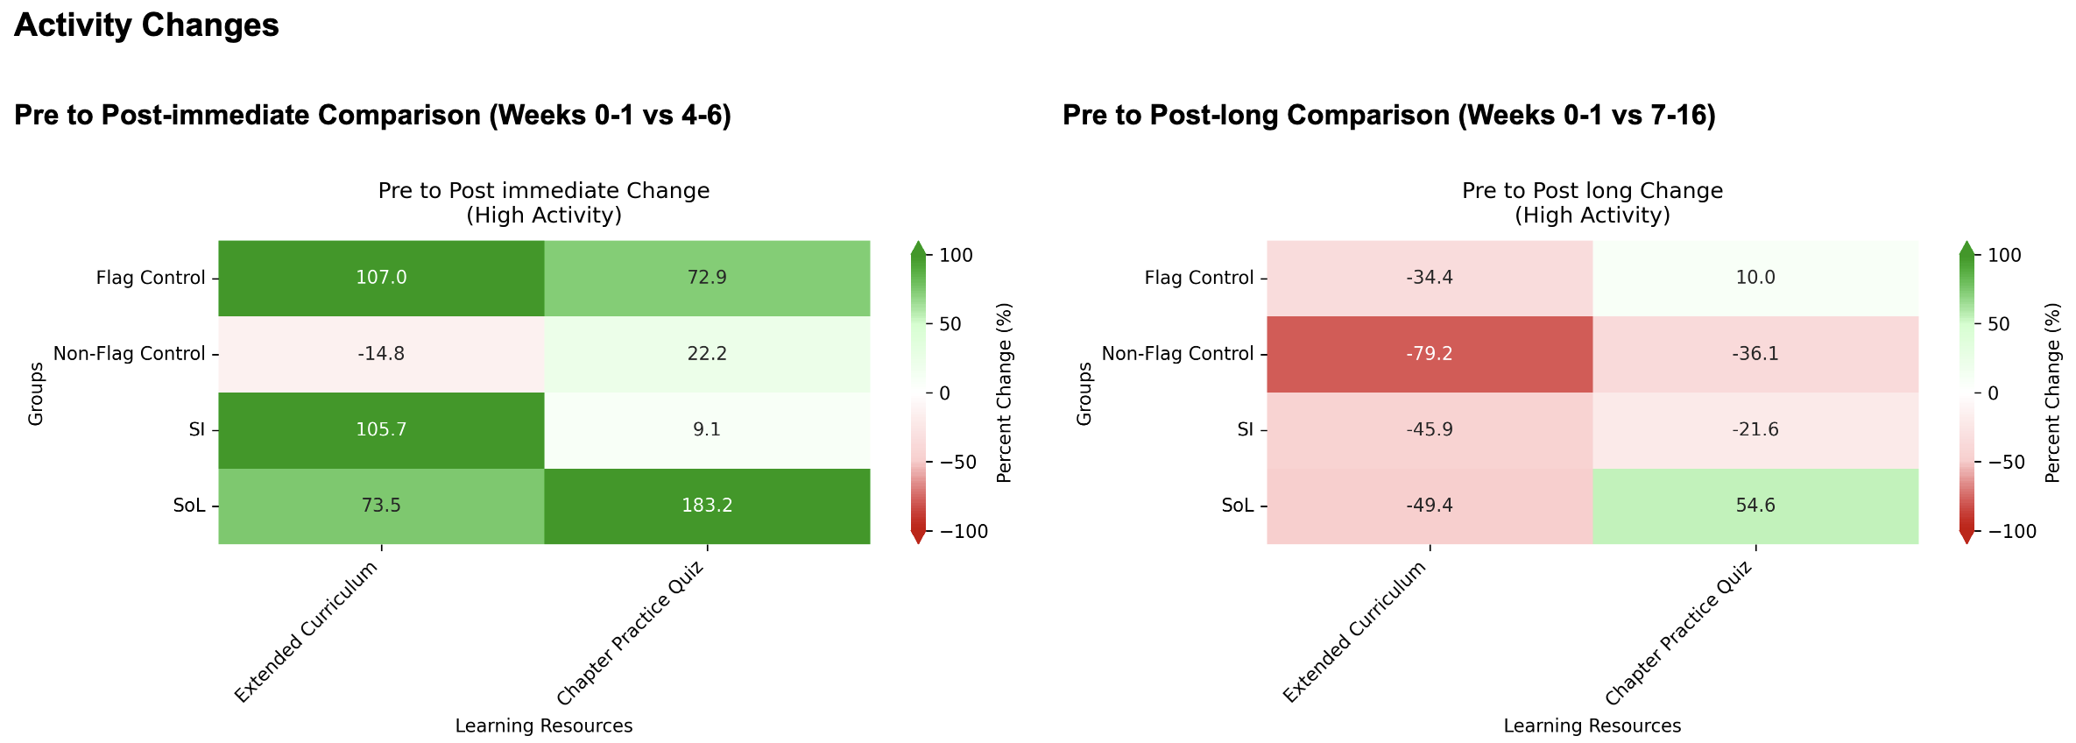

Analysis of specific resources in area graphs revealed distinctive usage characteristics. For example, JEOPARDY engagement demonstrated increasing trends in later weeks (6-15), particularly for SI and Non-Flag Control groups. SmartBook usage was notably front-loaded, with Non-Flag Control students showing high initial engagement (3.5 interactions) that rapidly decreased, while other groups maintained lower but more consistent usage patterns throughout the semester.

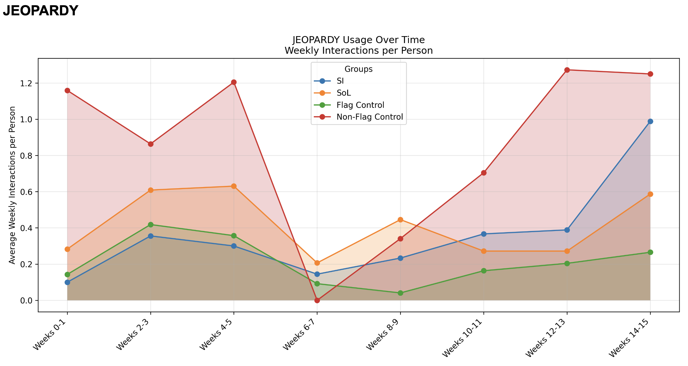

The Lab Practice Quiz utilization revealed distinct temporal patterns and group differences in student engagement. During weeks 4-7, engagement peaked across all groups, with Non-Flag Control students showing the highest usage at 10 interactions per person per week, followed by SI group at 9 interactions, while SoL and Flag Control groups maintained moderate levels between 5-6 interactions. This peak period suggests intensive quiz preparation activities across all groups, with Non-Flag Control and SI groups demonstrating particularly strong engagement.

The data exhibited a cyclical pattern with three main peaks (weeks 4-5, 6-7, and 10-11), followed by progressive decreases in engagement. While Non-Flag Control students showed consistently higher initial peaks, the SI group maintained more sustained engagement mid-semester, notably during weeks 10-11 where they temporarily exceeded Non-Flag Control usage. By weeks 14-15, all groups converged to similar lower levels of 1-2 interactions per person per week, indicating a natural decline in quiz preparation intensity.

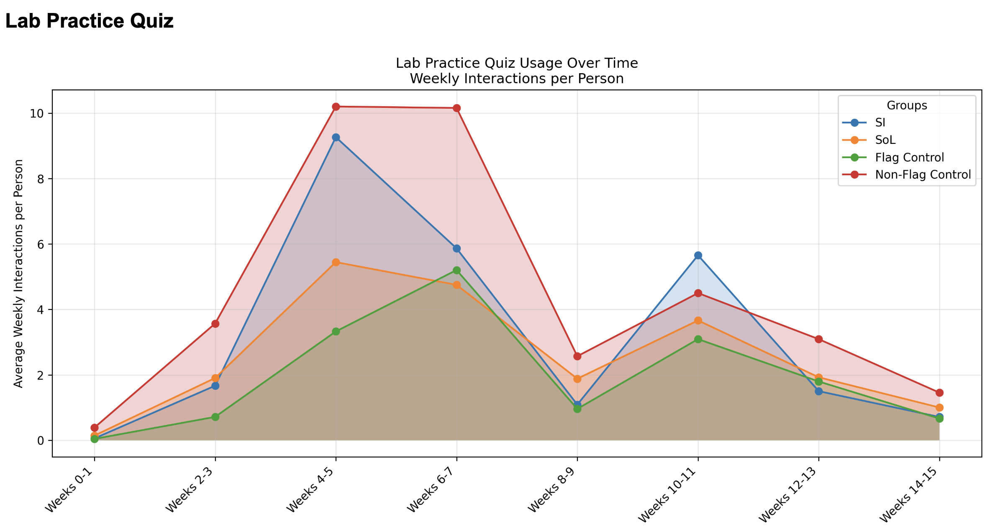

**3. Predictive Power of Digital Traces Clicks**

**3.1 Pre-Intervention Period**

The pre-intervention model showed very weak predictive power to the final exam scores (R² = 0.017, adjusted R² = -0.012) and was not statistically significant (F = 0.599, p = 0.664).

**3.2 Intervention Period**

During the intervention phase, the model continued to show minimal predictive capability (R² = 0.016, adjusted R² = -0.014) and remained non-significant (F = 0.537, p = 0.709).

**3.3 Post-Immediate Period**

The post-immediate period showed the strongest, though still modest, predictive relationship (R² = 0.065, adjusted R² = 0.037, F = 2.330, p = 0.059). During this period: Chapter Practice Quiz engagement emerged as the only significant predictor of academic performance (β = 5.063, p = 0.007); JEOPARDY showed a negative, though non-significant, relationship with performance (β = -4.395, p = 0.174); Strong correlations persisted between Lab Practice Quiz and Extended Curriculum usage (r = 0.86)

|  |  |  |  |  |  |
| --- | --- | --- | --- | --- | --- |
| Variable | Coefficient | SE | T | P | VIF |
|  | 73.808 | 1.884 | 39.166 | 0.000 | N/A |
| Lab Practice Quiz_post_immediate | 2.569 | 1.815 | 1.416 | 0.159 | 3.94 |
| JEOPARDY_post_immediate | -4.395 | 3.218 | -1.366 | 0.174 | 1.53 |
| Chapter Practice Quiz_post_immediate | 5.063 | 1.863 | 2.717 | **0.007** | 2.45 |
| Extended Curriculum_post_immediate | -2.814 | 1.747 | -1.611 | 0.110 | 6.00 |

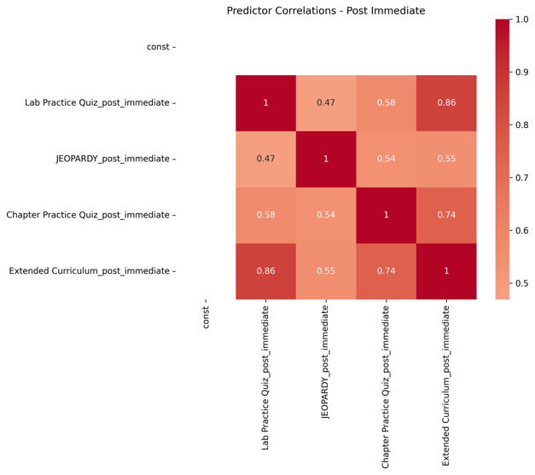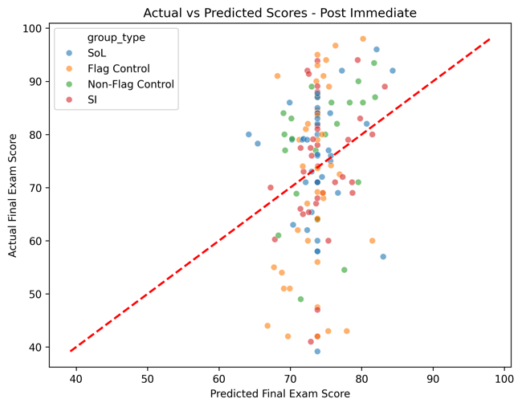

**3.4 Post-Long Period**

The sustained effects model maintained similar predictive power to the post-immediate period (R² = 0.063, adjusted R² = 0.035, F = 2.252, p = 0.067) but none of the digital trace showed significant predictive power to the final exams. The correlation patterns remained relatively stable, with moderate to strong relationships between most digital behaviors (r = 0.32 to 0.79).

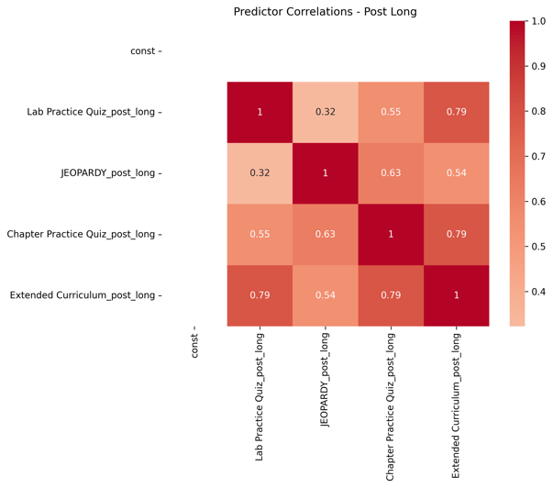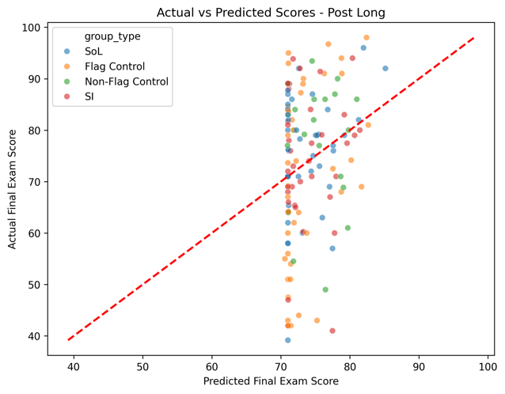

**4 Mediation Analysis**

Mediation analyses revealed none significant indirect pathways through which the interventions influenced final exam performance, may be due to the limited sample sizes in the mediation analysis. But there are some potential mediators such as Chapter Practice Quizzes.

**Supplemental Instruction (SI) Effects**

The SI intervention showed a significant positive effect on Chapter Practice Quiz engagement (a = 0.603, p = 0.021), though the relationship between quiz engagement and final exam performance was marginally significant (b = 2.919, p = 0.104). The total effect of SI on final exam performance was substantial (total effect = 3.847), with an indirect effect through quiz engagement of 1.761 (p = 0.175).

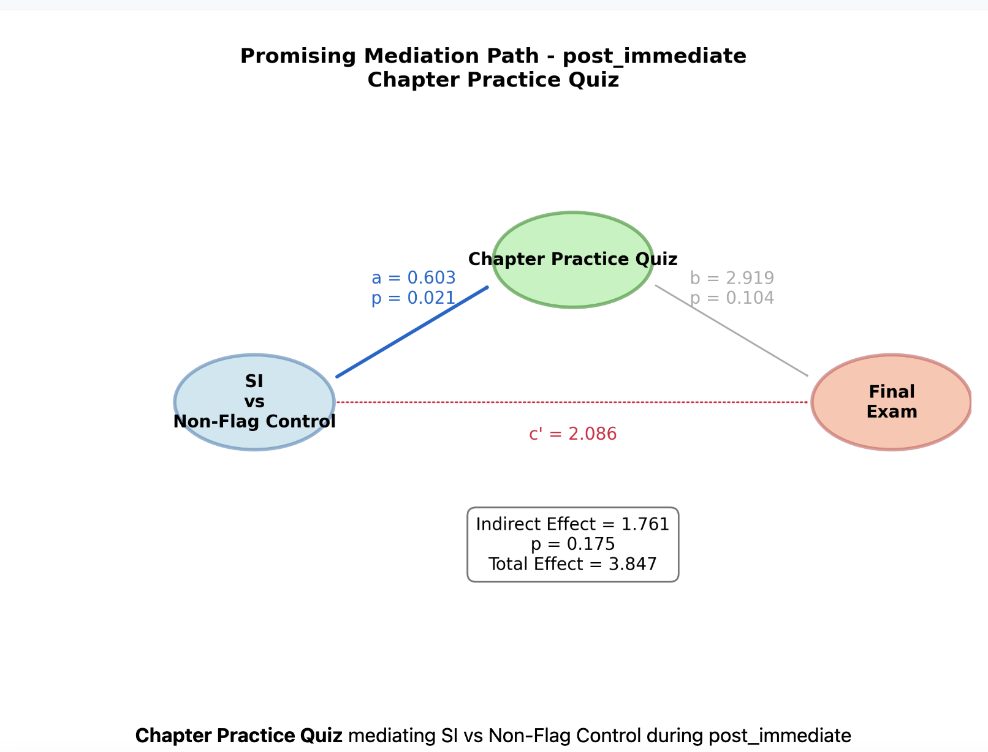

**Science of Learning (SoL) Effects**

Students receiving the SoL intervention demonstrated significantly increased engagement with Chapter Practice Quizzes (a = 0.577, p = 0.046), with a trending positive relationship to final exam performance (b = 2.750, p = 0.061). The total effect was moderate (1.832), with an indirect effect of 1.585 (p = 0.163).

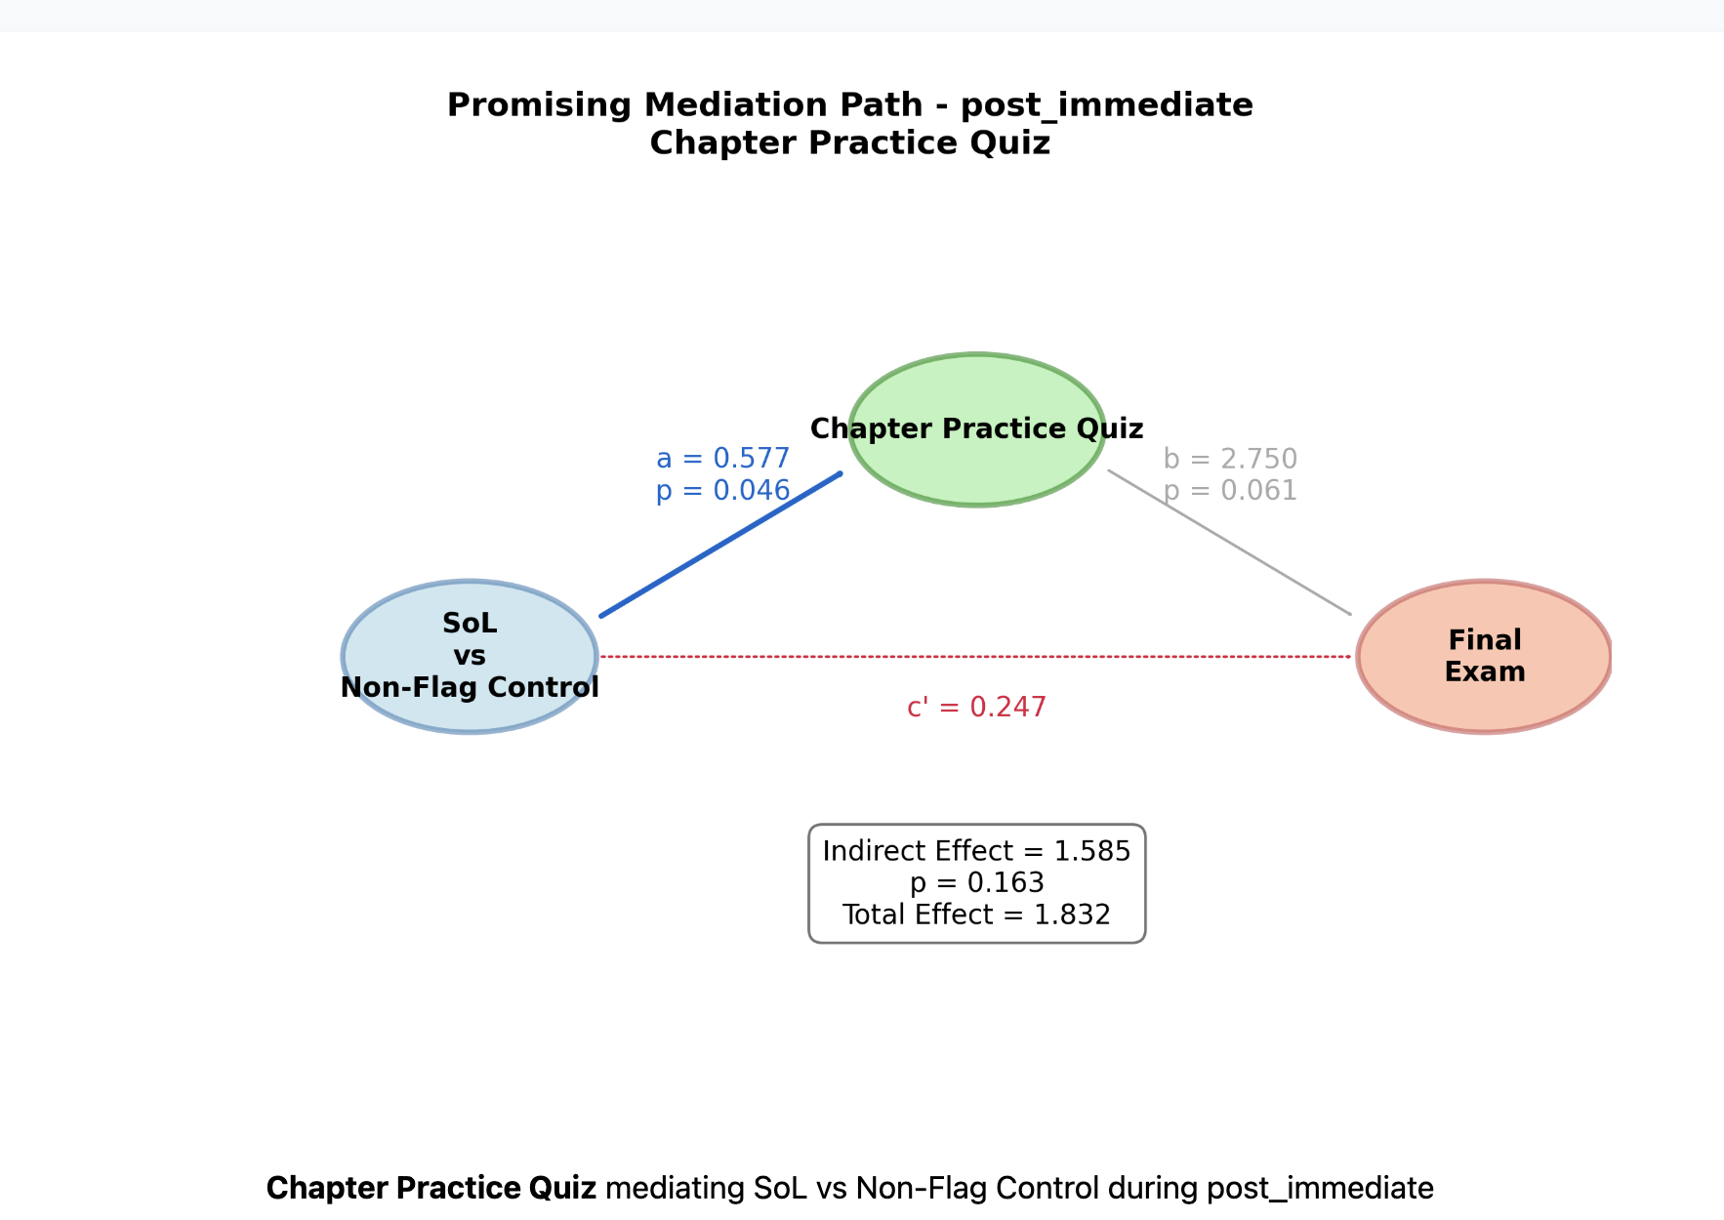

The SoL intervention also showed strong positive effects on Extended Curriculum engagement (a = 1.239, p = 0.005), though its relationship with final exam performance was marginally significant (b = 1.642, p = 0.090). The total effect remained consistent at 1.832, with an indirect effect of 2.035 (p = 0.139).

Long-term Effects Analysis of the post-long period revealed that Flag Control students showed different engagement patterns compared to Non-Flag Control students, with a significant relationship between Chapter Practice Quiz engagement and final exam performance (b = 5.410, p = 0.031). The total effect was notably large (6.468), with an indirect effect of 2.272 (p = 0.142).

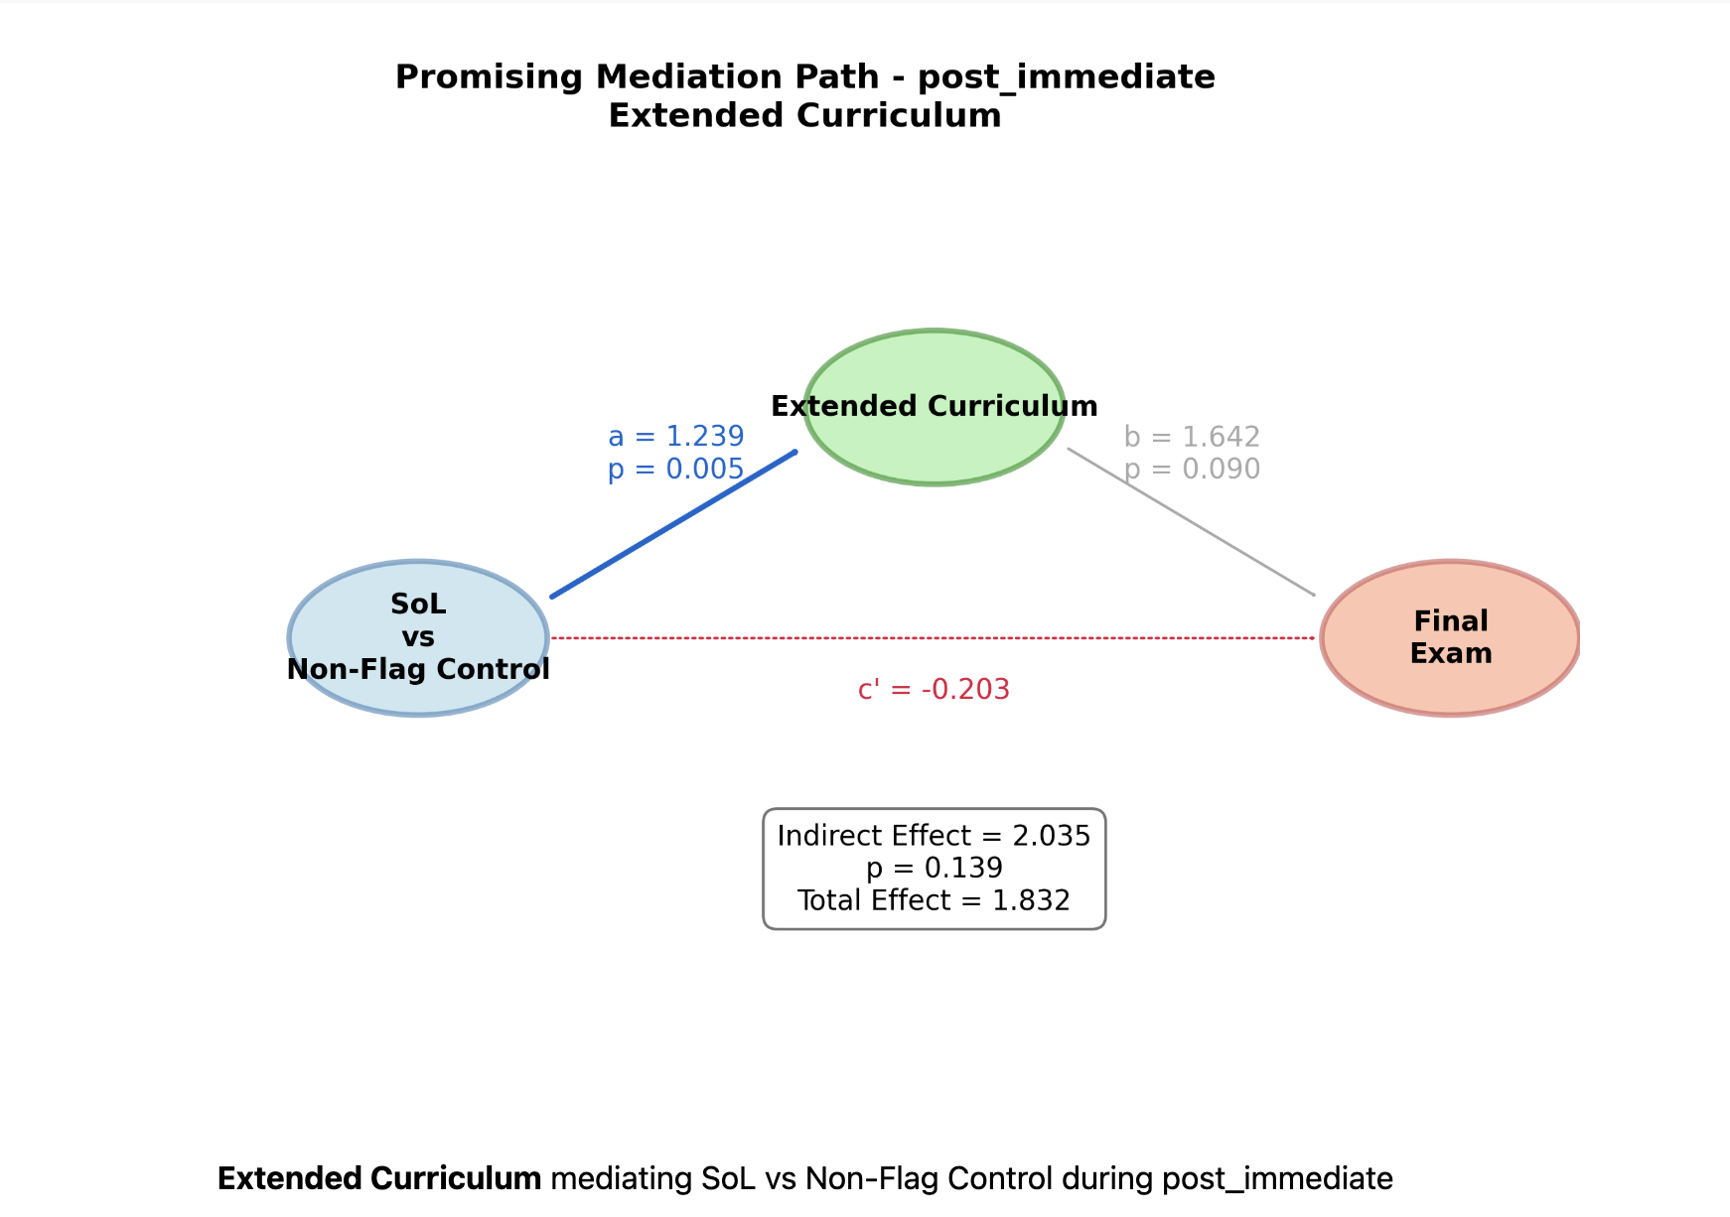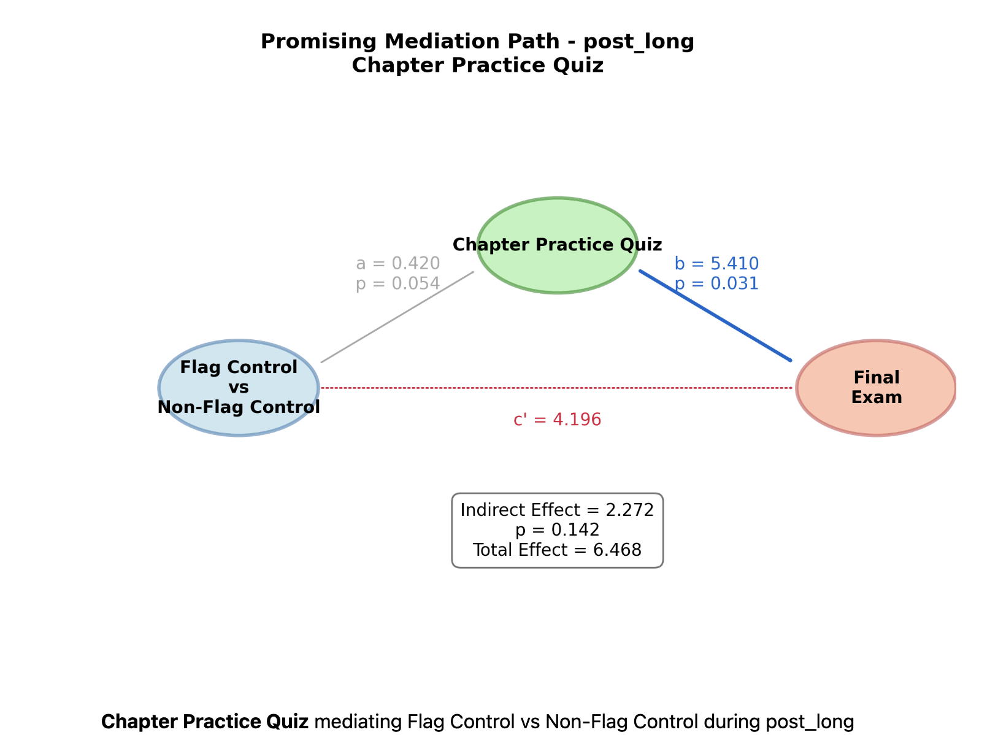

These results suggest that both SI and SoL interventions effectively increased student engagement with digital learning resources, particularly Chapter Practice Quizzes, which in turn showed promising relationships with final exam performance.

**Summary of the Result Section**

Based on the comprehensive analysis of digital learning behaviors and intervention effects, several key patterns emerged across the study periods. During the intervention period, Practice Quiz and Extended Curriculum emerged as the most frequently accessed resources, with Non-Flag Control students showing notably higher engagement levels compared to other groups. The temporal analysis revealed distinct immediate and long-term effects of interventions. Immediately post-intervention, Flag Control and SI groups demonstrated substantial increases in Extended Curriculum usage, while the SoL group showed strong growth in Chapter Practice Quiz engagement. However, long-term analysis indicated a general decline in Extended Curriculum usage across all groups, though the SoL group maintained relatively stronger Chapter Practice Quiz engagement.

Resource-specific patterns showed that JEOPARDY engagement increased in later weeks, particularly for SI and Non-Flag Control groups. Lab Practice Quiz utilization exhibited cyclical patterns with three main peaks, showing highest engagement from Non-Flag Control students, followed closely by the SI group.

The predictive analysis revealed that digital traces had the strongest relationship with academic performance during the post-immediate period, with Chapter Practice Quiz engagement emerging as the only significant predictor. While mediation analyses showed no statistically significant indirect pathways, both SI and SoL interventions demonstrated promising effects on increasing student engagement with digital learning resources, particularly through Chapter Practice Quizzes. The SI intervention significantly increased Chapter Practice Quiz engagement, while the SoL intervention showed positive effects on both Chapter Practice Quiz and Extended Curriculum engagement. These findings suggest that targeted interventions can effectively promote digital learning resource utilization, though their impact on academic performance may require further investigation with larger sample sizes.

**Detailed SMART Operations Analysis of Learning Materials**

**SMART Operations Definitions (Winne)**

- 1. **Search**: Directing attention to particular information

- Sample traces: Opening successive bookmarks; Using a search tool

- 2. **Monitor**: Comparing information presentations in terms of standards

- Sample traces: Highlighting text (information highlighted meets a standard); Selecting a particular website to review

- 3. **Assemble**: Relating items of information

- Sample traces: Tagging; Assigning two bookmarks to a titled folder

- 4. **Rehearse**: Maintaining or re-instating information in working memory

- Sample traces: Reviewing a note; Copying, then pasting

- 5. **Translate**: Transforming the representation of information

- Sample traces: Paraphrasing; Describing a graph, equation, or diagram in words

|  |  |  |  |  |  |  |  |
| --- | --- | --- | --- | --- | --- | --- | --- |
| **Digital Trace** | **Instructor Description** | **Winne Framework** | **Search** | **Monitor** | **Assemble** | **Rehearse** | **Translate** |
| SmartBook | "This is a general resource that includes the e-text" | Students can bookmark content, highlight text, review materials, and navigate through chapters | **1 (Students must navigate through text to locate specific content)** | **1 (System provides feedback and allows content highlighting for importance)** | 0 (Content is pre-organized) | **1 (Allows review and reinstating of information)** | 0 (Standard text format) |
| JEOPARDY | "Collection of questions related to chapter topics" | Questions serve as monitoring tools with feedback and rehearsal opportunities | 0 (Questions directly provided) | **1 (Immediate feedback on understanding against standards)** | 0 (Questions pre-structured) | **1 (Practice reinforces memory through repetition)** | 0 (Standard Q&A format) |
| Base Art Images | "Collection of diagrams and images related to Chapter topics" | Visual resources that require translation to verbal descriptions and assembly with concepts | 0 (Images directly accessible) | **1 (Can compare understanding against standards)** | **1 (Can relate images to text concepts)** | **1 (Can review visual information)** | **1 (Must describe visual information verbally)** |
| Centers for Academic Success | "Canvas tab, students click on to access Centers for Academic Success page on CSN website" [ask for more data about the appointment] | Resource requiring search for specific support services | **1 (Must seek specific help resources)** | **1 (Helps identify areas needing support)** | 0 (Direct service access) | 0 (Access point only) | 0 (No transformation required) |
| McGraw-Hill Connect | "A link that connects to an online learning platform" | Platform requiring navigation and offering multiple learning tools | **1 (Must locate specific resources)** | **1 (Platform provides feedback)** | 0 (Platform access point) | **1 (Contains practice activities)** | 0 (Standard interface) |
| Biol 223 Extended Curriculum 21-22 | “The homelink in the Canvas“ | Navigation/Home page requiring navigation | **1(Students must actively navigate from this page to locate specific content they need )** | 0(Does not provide feedback or evaluation opportunities) | 0 (Serves as an access point rather than a tool for connecting concepts) | 0 (No review or practice functionality indicated; Not designed for copying/pasting or review activities) | 0 (Navigation function doesn't involve paraphrasing or format conversion) |
| Chapter X Practice Quiz | "Practice Quiz covering Chapter X topics in preparation for Exam X" | Assessment tool for monitoring understanding and rehearsal | 0 (Quiz directly provided) | **1 (Provides feedback on understanding)** | 0 (Questions pre-structured) | **1 (Practice reinforces learning)** | 0 (Standard quiz format) |
| Lab X Practice Quiz | "Practice Quiz covering Lab X topics in preparation for Lab quiz x" | Lab-specific assessment for monitoring and rehearsal | 0 (Quiz directly provided) | **1 (Feedback on lab knowledge)** | 0 (Pre-structured format) | **1 (Practice strengthens recall)** | 0 (Standard quiz format) |
| Chapter X Active Learning | "Worksheet to be completed by students; identifies Chapter X terms in preparation for Exam X" | Interactive tool requiring multiple operations | 0 (Terms provided) | **1 (Self-check understanding)** | **0 (Connect concepts)** | **1 (Active engagement with terms)** | **1 (Transform terms into own understanding)** |
| Chapter X Outcomes | "List of outcomes identifying what students should know and be able to do at the end of Chapter X" | Standards document for monitoring progress | 0 (Directly listed) | **1 (Provides standards for comparison)** | 0 (Pre-structured) | 0 (Reference only) | 0 (Standard format) |
| Chapter X Outline | "Outline covering Chapter X topics in preparation for Exam X" | Organizational tool supporting multiple operations | 0 (Content directly provided) | **1 (Framework for checking understanding)** | **1 (Shows relationships between concepts)** | **1 (Can review structure)** | **1 (Can restate in own words)** |
| Chapter X Helpful Videos | "Videos explaining Chapter X topics" | Multimedia resource requiring translation to other formats | 0 (Directly accessible) | **1 (Can compare understanding)** | 0 (Pre-structured content) | 0 (Passive viewing) | **0 (Must transform visual/audio to notes or own understanding)** |
| Getting Started | "Information page that tells students how to use this Canvas website" | Navigational resource requiring search | **1 (Must locate specific instructions)** | 0 (Information only) | 0 (Pre-structured) | 0 (Reference material) | 0 (Standard format) |
| Introduction | "Information page about the Canvas site" | Basic information requiring search | **1 (Must find relevant info)** | 0 (Information only) | 0 (Pre-structured) | 0 (Reference only) | 0 (Standard format) |

**Coding Rationale**

1. Search (1/0): Coded as 1 if students must actively locate or seek specific information

2. Monitor (1/0): Coded as 1 if resource allows comparison against standards or provides feedback

3. Assemble (1/0): Coded as 1 if students must relate multiple pieces of information

4. Rehearse (1/0): Coded as 1 if resource supports active review or practice

5. Translate (1/0): Coded as 1 if resource requires transformation between formats

**Notes**:

- Resources marked as "embedded" or with unclear descriptions were excluded

- Coding considers both instructor-intended use and theoretical framework

- Multiple operations can apply to single resources

- Classifications based on primary intended use cases from the instructor

- Actual student usage patterns may vary

**Learning Traces Aggregation Framework**

**1. Assessment & Practice (Quiz Group)**

Common Pattern: Monitor (1), Rehearse (1), minimal Search/Assemble/Translate

- JEOPARDY

- Chapter X Practice Quiz

- Lab X Practice Quiz

Rationale: These resources are directly focused on practice and feedback, with strong monitoring and rehearsal components.

**2. Active Learning**

Common Pattern: Monitor (1), Assemble (1), Rehearse (1), Translate (1)

- Chapter X Active Learning

- Base Art Images

- Chapter X Outline

Rationale: These resources require students to actively engage with content through multiple SMART operations, particularly assembly and translation.

**3. Platform & Navigation Resources**

Common Pattern: Search (1), Monitor (1), some Rehearse (1)

- SmartBook

- McGraw-Hill Connect

Rationale: These are primary access points requiring navigation and offering multiple tool options.

**4. Support & Help-Seeking Behaviors**

Common Pattern: Search (1), Monitor (1)

- Centers for Academic Success

- Chapter X **Helpful** Videos

Rationale: This as important for analyzing help-seeking behaviors.

**5. Reference & Information Resources**

Common Pattern: Search (1), minimal other operations

- Getting Started

- Introduction

-Biol 223 Extended Curriculum 21-22

Rationale: These are primarily informational resources requiring search but minimal other cognitive operations. Task definition & environmental

[1. Correlation 2. Mediation analysis]

*Digital Self-Regulation: Intervention Effects on SRL Behaviors in Community College STEM Education (1901words)*

**Abstract**

This study examines the impact of Supplemental Instruction and Science of Learning interventions on digital learning behaviors and academic performance in a community college Anatomy course. Analyzing semester-long Learning Management System data from 192 students, we investigated digital engagement patterns, predictive relationships between behaviors and performance, and the mediating role of digital behaviors in intervention effectiveness. Results revealed significant differences in engagement patterns among intervention groups, with interventions increasing active learning and Self-Quizzing over time. Digital behaviors, particularly Self-Quizzing, significantly predicted academic performance and mediated intervention effects. These findings show how digital self-regulated learning behaviors change due to interventions and how those changes affect academic performance.

**Digital Self-Regulation: Intervention Effects on SRL Behaviors in Community College STEM Education**

**Background**

The digitization of higher education and emergence of learning analytics has provided new opportunities to study STEM learning through the lens of complex theories like self-regulated learning (SRL; Winne, 2014, 2017). STEM courses are notoriously challenging for many students, particularly in community college settings. In response, educators have increasingly adopted active learning designs that provide rich digital resources at scale (Shekhar et al., 2020). While these designs offer potential benefits, they also require students to possess strong SRL skills to effectively navigate and utilize these complex learning environments.

Interventions designed to support learning in complex tasks have shown promise in developing learners' SRL skills (Theobald, 2021). These skills are crucial for students to take full advantage of the affordances offered by active learning designs. However, while such interventions have demonstrated effectiveness in university settings, their impact in community colleges, particularly in relation to digital learning behaviors, remains understudied (Varty, 2022).

We address this critical gap by examining the effects of two distinct interventions: referring students to course-specific Supplemental Instruction (SI) sessions that focus on course content and assigning students to Science of Learning (SoL) training that focuses on building learning skills. Specifically, we investigated these interventions' impacts on students' digital SRL behaviors and academic performance in a community college Anatomy and Physiology course. This research aims to shed light on how different types of support can influence students' digital learning strategies and outcomes in challenging STEM courses within the community college context.

**Theoretical Framework**

**Self-Regulated Learning**

SRL is an inherently constructive and self-directed process where learners set goals for their learning and then attempt to monitor, regulate, and control their cognition, motivation, and behavior, guided and constrained by their goals and the contextual features in the environment (Winne, 2001). Winne and Hadwin's (1998) information processing model of SRL and COPES (Conditions, Operations, Products, Evaluations, and Standards) framework guides our interpretation of digital traces in learning environments. Students' engagement with course materials reflects their understanding of task conditions, whereas interactions with self-assessment tools represent both cognitive operations and self-evaluation processes.

**Measuring Self-Regulated Learning**

Winne and Perry (2000) laid the groundwork for measuring SRL as an event, supporting the use of digital behavior patterns as indicators of SRL strategies. Their foundational work informs a view of learning as a series of information processing events, potentially captured by specific digital SRL behaviors (Greene & Azevedo, 2010).

More recently, Noroozi et al. (2019) demonstrated the effectiveness of using log data from online learning environments to infer and support SRL processes, particularly in collaborative settings. Their work highlights the potential of digital trace analysis in capturing both individual and group-level SRL behaviors.

The adaptive nature of SRL emphasized in this model can be observed through changes in digital behavior patterns over time. These changes may reflect students' adaptation of strategies based on their experiences and outcomes, as supported by Winne and Hadwin's (2013) findings on the evolution of SRL strategies in response to task demands and feedback.

**Learning Interventions**

Our study is grounded in the argument that skill training is most effective when it promotes surface learning, consolidation of knowledge about skills, and planful transfer of skills to practice settings. Hattie and Donoghue (2016) proposed a model that highlights three key phases of learning: surface learning, deep learning, and transfer. Surface learning involves the acquisition and consolidation of foundational knowledge and skills. Deep learning focuses on understanding and integrating this knowledge, whereas the transfer phase emphasizes applying learned skills in new contexts. Such transfer can be observed in students' digital behaviors via learning analytics (Winne, 2017). To analyze this transfer, we employ a comprehensive framework that integrates multiple theoretical perspectives.

**Summary**

Given these insights, there is a clear need for research that leverages authentic, semester-long digital trace data to uncover the self-regulatory processes underlying successful learning in digital environments. This approach could inform more effective strategies for supporting student success in challenging STEM courses at community colleges. Our study aims to address this need by analyzing how these processes can be influenced by targeted interventions, with a focus on promoting surface learning, consolidation of knowledge about skills, and planful transfer of skills to practice settings.

**Research Questions**

**RQ1**: How do patterns of digital engagement in online learning environments differ among various student groups (SI intervention, SoL intervention, Flagged control, and Non-Flagged control), considering both immediate (post-intervention) and sustained (3 weeks post-intervention to semester end) digital trace data?

**RQ2**: How do immediate and sustained digital engagement behaviors, particularly those related to SRL strategies, predict academic performance across multiple time points (Exam 3 and 5 and Final Score) for different student groups, and how does this predictive relationship differ across intervention groups?

**RQ3**: How do digital behaviors in the LMS mediate the relationship between intervention participation (SI or SoL) and academic performance over time, compared to Flagged and Non-Flagged students?

**Next Steps:**

**Focusing on the guiding readings hannie hardwin – guiding feature engineering, improving arguments, why do people train SRL SKILLS, what are the effects after**

**Gamified quiz, non-gamified quiz, assets resources,**

* Circular reasoning?
* Testing **multiple mediators** at the same time, testing their strength and contribution, and getting an estimate of the overall mediation effect. Develop a theoretical model that includes multiple potential mediators between interventions and the outcome (Cogliano et al., 2020).
* Conduct separate analyses for **each semester.** Focusing on the Science of Learning (SoL) interventions?
* **Difference-in-Differences Analysis:** What is the causal effect of the interventions on students' digital learning behaviors? Compare treatment (SI and SoL) groups to flag control groups
* **Person-level factors**: Cogliano, Kardash, & Bernacki (2018) found that retrieval practice eliminated performance differences based on prior topic knowledge. This suggests that SoL interventions might be particularly beneficial for students with lower prior knowledge.

**Method**

Participants were 192 undergraduates (78.1% female; age 18-55, *M* = 26.12, *SD* = 7.82) from an introductory Anatomy and Physiology course at a southwestern U.S. community college. The course included five non-cumulative exams and a cumulative final exam.

We used an AI algorithm (See Appendix) to classify students into two groups: those flagged as potentially benefiting from additional support (*n*=167, 87%) and those non-flagged (*n*=25, 13%). Flagged students were randomly assigned to receive Supplemental Instruction referrals (SI), complete digital Science of Learning (SoL; See Appendix) training, or control activities (Biology Tasks). Non-flagged students were assigned control activities.

Digital trace data from the LMS and academic performance data were collected throughout the semester. Immediate digital traces were collected post-intervention (Week 4-6), while sustained engagement traces were collected from Week 7-15, examining long-term intervention impacts (Table 1-3).

**Data Analysis and Results**

**RQ1:** ANOVA analysis revealed significant differences in digital engagement patterns among student groups (SI, SoL, Flagged control, Non-Flagged control) for both immediate and sustained periods.

Early semester (Figure 1): There were statistically significant group differences (*F (*3, 188) = 3.114, *p* = .028) in Self-Quizzing. Non-Flagged students (*M* = 76.86, *SD* = 78.76) engaged significantly more than Flagged students (*M* = 29.21, *SD* = 46.18, *p* = .021). SI (*M* = 47.33, *SD* = 80.50) and SoL (*M* = 35.39, *SD* = 56.65) groups showed higher engagement than Flagged controls. And Gamified Quiz engagement showed significant group differences (*F* (3, 188) = 3.076, *p* = .029). Non-Flagged students (*M* = 3.14, *SD* = 5.29) engaged significantly more than Flagged (*M* = 0.89, *SD* = 2.27, *p* = .038) and SI (*M* = 0.88, *SD* = 2.62, *p* = .041) groups.

Later semester (Figure 2): Significant differences persisted (*F* (3, 188) = 4.861, *p* = .003). Non-Flagged students (*M* = 158.64, *SD* = 133.41) showed significantly higher Self-Quizzing compared to Flagged (*M* = 60.96, *SD* = 84.45, *p* = .001), SI (*M* = 87.90, *SD* = 103.24, *p* = .040), and SoL (*M* = 77.51, *SD* = 103.76, *p* = .013) groups.

**RQ2**: We conducted multiple regression analyses for each group (All Students, SI, SoL, Flagged, and Non-Flagged) to examine the predictive power of digital behaviors on academic outcomes (Figure 2-3).

For the overall student population, Self-Quizzing emerged as a robust predictor of academic outcomes, positively predicting performance on Exam 3 (*β* = 3.546, *p* = .015) and Final Score (*β* = 3.899, *p* = .008). For the Flagged students, immediate Gamified Quiz engagement strongly predicted performance on Exam 5 (*β* = 9.504, *p* = .041) and Final Score (*β* = 10.360, *p* = .028). For the SoL group, Image engagement (*β* = -9.021, *p* = .006) and task definition activities (*β* = 8.444, *p* = .024) were significant predictors for Exam 5 performance. The negative coefficient for image engagement suggests that increased use of this feature was associated with lower exam scores for this group. For the SI group, no digital behaviors significantly predicted academic outcomes in the regression models. For the Non-Flagged group, Self-Quizzing was a significant predictor of Final Score (*β* = 9.135, *p* = .044).

**RQ3**: Mediation analyses revealed how digital SRL behaviors mediated the relationship between intervention conditions and academic performance. Self-Quizzing emerged as a critical mediator, particularly when comparing Non-Flagged to Flagged control conditions (Figure 4-8).

For Final Scores, the direct effect of the Non-Flagged vs Flagged condition was significant (*β* = 0.724, *p* < .001). Self-Quizzing partially mediated this effect, accounting for 27.58% of the total effect. After accounting for the mediator, the adjusted direct effect remained significant (*β* = 0.524, *p* < .001).

For the SI intervention compared to Flagged controls, the direct effect on Exam 5 scores was not significant (*β* = 0.092, *p* = .421). Self-Quizzing partially mediated this effect, accounting for 74.40% of the total effect. The adjusted direct effect remained non-significant (*β* = 0.024, *p* = .837).

For Final Scores, the direct effect of SI vs Flagged controls was not significant (*β* = 0.221, *p* = .052). Self-Quizzing partially mediated this effect, accounting for 50.54% of the total effect. The adjusted direct effect became non-significant (*β* = 0.109, *p* = .339).

The SoL intervention showed similar patterns. For Final Scores, the direct effect of SoL vs Flagged controls was not significant (*β* = 0.228, *p* = .045). Self-Quizzing partially mediated this effect, accounting for 37.82% of the total effect. The adjusted direct effect became non-significant (*β* = 0.142, *p* = .215).

Interestingly, the proportion of effects mediated by Self-Quizzing showed some variation across exams and interventions. For instance, in the SI vs Flagged comparison, the proportion mediated by Self-Quizzing increased from 24.46% for Exam 3 to 74.40% for Exam 5, and then settled at 50.54% for Final Scores.

Other SRL behaviors showed varying mediation effects. Gamified Quiz engagement consistently demonstrated positive mediation, particularly for the SI intervention on Exam 5 scores (28.73% mediation, *β* = 0.026, *p =* .423). Task definition engagement showed substantial mediation for Final Scores, especially when comparing Non-Flagged to Flagged students (64.95% mediation, *β* = 0.468, *p =* .084).

The SoL intervention revealed unexpected patterns for Exam 5 scores. The direct effect of SoL vs Flagged controls was significant (*β* = 0.337, *p =* .003). However, active learning strategies (*β* = -0.035, *p =* .599) and image engagement (*β* = -0.055, *p =* .506) showed negative mediation effects. After accounting for these mediators, the adjusted direct effect increased (*β* = 0.372, *p =* .001 for active learning strategies; *β* = 0.392, *p* < .001 for image engagement).

**Scholarly Significance**

Our findings offer new perspectives on SRL theory and intervention effectiveness in digital learning. The strong mediating role of Self-Quizzing (53.02% of intervention effect on Final Scores) suggests this strategy is particularly crucial in online settings, challenging SRL models that treat all strategies equally. The increasing mediating effect of Self-quizzing over time reveals a dynamic aspect of SRL development that is often overlooked in current theories.

These results indicate future interventions should prioritize Self-Quizzing behaviors, potentially through prompts for student-generated questions, gamified self-testing elements, or AI-driven personalized practice questions. The unexpected negative association between image engagement and exam performance for SoL students suggests a need for interventions that guide students towards the most effective forms of digital content interaction.

Future research could explore adaptive systems that adjust content presentation based on individual SRL patterns, provide real-time feedback on Self-Quizzing quality, and offer personalized recommendations for balancing different types of digital engagement. These insights support more nuanced, data-driven approaches to fostering SRL in diverse community college populations, potentially reducing achievement gaps and enhancing educational outcomes.

**Reference**

Greene, J. A., & Azevedo, R. (2010). The measurement of learners' self-regulated cognitive and metacognitive processes while using computer-based learning environments. Educational Psychologist, 45(4), 203-209.

Hattie, J. A., & Donoghue, G. M. (2016). Learning strategies: A synthesis and conceptual model. npj Science of Learning, 1(1), 1-13.

Noroozi, O., Alikhani, I., Järvelä, S., Kirschner, P. A., Juuso, I., & Seppänen, T. (2019). Multimodal data to design visual learning analytics for understanding regulation of learning. Computers in Human Behavior, 100, 298-304.

Shekhar, P., Prince, M., Finelli, C., Demonbrun, M., & Waters, C. (2020). Integrating quantitative and qualitative research methods to examine student resistance to active learning. European Journal of Engineering Education, 45(1), 4-18.

Theobald, E. J., Hill, M. J., Tran, E., Agrawal, S., Arroyo, E. N., Behling, S., ... & Freeman, S. (2021). Active learning narrows achievement gaps for underrepresented students in undergraduate science, technology, engineering, and math. Proceedings of the National Academy of Sciences, 117(12), 6476-6483.

Varty, A. K. (2022). Challenges and opportunities in community college STEM education: A review of the literature. Community College Journal of Research and Practice, 46(5), 348-363.

Winne, P. H. (2014). Issues in researching self-regulated learning as patterns of events. Metacognition and Learning, 9(2), 229-237.

Winne, P. H. (2017). Learning analytics for self-regulated learning. Handbook of Learning Analytics, 241-249.

Winne, P. H., & Hadwin, A. F. (1998). Studying as self-regulated learning. In D. J. Hacker, J. Dunlosky, & A. C. Graesser (Eds.), Metacognition in educational theory and practice (pp. 277-304). Lawrence Erlbaum Associates Publishers.

Winne, P. H., & Hadwin, A. F. (2013). nStudy: Tracing and supporting self-regulated learning in the Internet. In International handbook of metacognition and learning technologies (pp. 293-308). Springer, New York, NY.

Winne, P. H., & Perry, N. E. (2000). Measuring self-regulated learning. In M. Boekaerts, P. R. Pintrich, & M. Zeidner (Eds.), Handbook of self-regulation (pp. 531-566). Academic Press.

**Table 1**

**Aggregation of Digital Trace Variables and Their Relevance to SRL Using the COPES Model**

|  |  |  |  |  |
| --- | --- | --- | --- | --- |
| **Aggregated Variable** | **Representative Raw Variables** | **COPES Component** | **SRL Process** | **Mean (SD)** |
| Gamified Quiz Engagement | CHAPTER.1.JEOPARDY.pptx.Count.of.body.asset_name.x | Operations, Evaluations | Reflects engagement with interactive self-assessments, showing cognitive operations during practice (O) and self-evaluation processes (E). | 1.01 (1.96) |
| Image Engagement | Chapter.1.Base.Art.Images.docx.Count.of.body.asset_name.x | Operations | Indicates use of visual learning strategies, representing cognitive operations (O) for processing visual information. | 0.96 (2.54) |
| Helpful Video Engagement | Chapter.10.Helpful.Videos....Count.of.body.asset_name | Operations, Products | Shows engagement with multimedia learning resources, reflecting cognitive strategies for information processing (O) and potential knowledge construction (P). | 0.36 (1.22) |
| Lab Engagement | BIO.223.LAB.1.pdf.......Count.of.body.asset_name | Operations, Products | Represents participation in hands-on learning activities, indicating application of knowledge (O) and creation of learning artifacts (P). | 2.90 (3.68) |
| Supplemental Instruction | Supplemental.Instruction.......Count.of.body.asset_name | Conditions | Reflects engagement with peer-assisted learning opportunities, representing external learning conditions (C) that support SRL. | 0.58 (2.09) |
| Resource Utilization | Counseling.and.Psychological.Service.......Count.of.body.asset_name | Operations | Indicates learners' use of additional learning materials, showing cognitive operations (O) for seeking and processing supplementary information. | 0.02 (0.16) |
| External Tool Usage | Top.Hat.LTI.1.3.......Count.of.body.asset_name | Operations | Represents use of technology-enhanced learning strategies, indicating cognitive operations (O) using external tools to support learning. | 1.35 (1.91) |
| Task Definition | Chapter.1.Objectives.docx.......Count.of.body.asset_name | Conditions | Reflects learners' engagement with task instructions, representing understanding of task conditions (C) crucial for planning in SRL. | 0.62 (1.79) |
| Self Quiz Engagement | Chapter.1.Practice.Quiz.......Count.of.body.asset_name.x | Operations, Evaluations | Indicates engagement in self-testing activities, showing metacognitive monitoring (O) and self-evaluation processes (E). | 8.31 (11.65) |

Note: C = Conditions, O = Operations, P = Products, E = Evaluations in the COPES model of SRL. Mean and Standard Deviation (SD) are rounded to two decimal places. Min-Max represents the range of values for the representative raw variable.

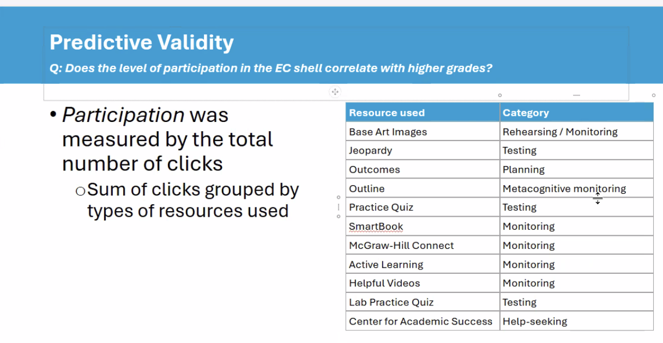

**Learning Analytics Variables Mapped to SMART Model Components**

**Search Operations (Mean: 198.37, SD: 237.45)**

|  |  |  |
| --- | --- | --- |
| **Variable** | **Description** | **Engagement Level** |
| Resource Access & Navigation | Comprehensive resource access | Mean: 41.72 (SD: 56.67) |

**Monitor Operations (Mean: 116.11, SD: 154.09)**

|  |  |  |
| --- | --- | --- |
| **Variable** | **Description** | **Engagement Level** |
| Practice Quizzes | Self-assessment activities | Mean: 91.72 (SD: 127.94) |
| JEOPARDY Games | Interactive knowledge checks | Mean: 7.74 (SD: 16.93) |
| SmartBook Usage | E-text engagement | Mean: 0.04 (SD: 0.41) |
| Active Learning | Interactive activities | Mean: 0.03 (SD: 0.27) |
| Helpful Videos | Video resource usage | Mean: 6.26 (SD: 13.97) |

**Assemble Operations (Mean: 12.80, SD: 22.81)**

|  |  |  |
| --- | --- | --- |
| **Variable** | **Description** | **Engagement Level** |
| Base Art Images | Visual information integration | Mean: 5.55 (SD: 12.85) |
| Document Organization | Content structuring | Mean: 41.72 (SD: 56.67) |
| Chapter Outlines | Content organization | Mean: 7.25 (SD: 13.59) |

**Rehearse Operations (Mean: 112.35, SD: 148.85)**

|  |  |  |
| --- | --- | --- |
| **Variable** | **Description** | **Engagement Level** |
| Quiz Practice | Knowledge reinforcement | Mean: 126.76 (SD: 165.09) |
| JEOPARDY Review | Interactive practice | Mean: 7.74 (SD: 16.93) |
| Practice Activities | Comprehensive practice | Mean: 91.72 (SD: 127.94) |

**Translate Operations (Mean: 12.80, SD: 22.81)**

|  |  |  |
| --- | --- | --- |
| **Variable** | **Description** | **Engagement Level** |
| Base Art Images | Visual-verbal translation | Mean: 5.55 (SD: 12.85) |
| Chapter Outlines | Content transformation | Mean: 7.25 (SD: 13.59) |
| Multimedia Engagement | Cross-format learning | Mean: 2.06 (SD: 11.51) |

**Key Patterns:**

1. **Search Operations** show the highest overall engagement (M=198.37, SD=237.45), indicating substantial resource-seeking behavior
2. **Monitor Operations** demonstrate the second-highest engagement (M=116.11, SD=154.09), with Practice Quizzes being the most used monitoring tool
3. **Rehearse Operations** show similar levels of engagement (M=112.35, SD=148.85), primarily driven by quiz practice
4. **Assemble and Translate Operations** show identical lower levels of engagement (M=12.80, SD=22.81)
5. **High Variability** across all components (large SDs) indicates diverse learning patterns
6. smart_mappings = {
7. 'search': {
8. 'patterns': [
9. 'Centers.for.Academic.Success',
10. 'McGraw.Hill.Connect',
11. 'Biol.223.Extended.Curriculum',
12. 'Getting.Started',
13. 'Introduction'
14. ],
15. 'full_names': [
16. 'Centers for Academic Success',
17. 'McGraw-Hill Connect',
18. 'Biol 223 Extended Curriculum 21-22',
19. 'Getting Started',
20. 'Introduction'
21. ]
22. },
23. 'monitor': {
24. 'patterns': [
25. 'SmartBook',
26. 'JEOPARDY',
27. 'Base.Art.Images',
28. 'Centers.for.Academic.Success',
29. 'McGraw.Hill.Connect',
30. 'Practice.Quiz',
31. 'Active.Learning',
32. 'Outcomes',
33. 'Outline',
34. 'Helpful.Videos'
35. ],
36. 'full_names': [
37. 'SmartBook',
38. 'JEOPARDY',
39. 'Base Art Images',
40. 'Centers for Academic Success',
41. 'McGraw-Hill Connect',
42. 'Chapter Practice Quiz',
43. 'Lab Practice Quiz',
44. 'Active Learning',
45. 'Outcomes',
46. 'Outline',
47. 'Helpful Videos'
48. ]
49. },
50. 'assemble': {
51. 'patterns': [
52. 'Base.Art.Images',
53. 'Outline'
54. ],
55. 'full_names': [
56. 'Base Art Images',
57. 'Chapter Outline'
58. ]
59. },
60. 'rehearse': {
61. 'patterns': [
62. 'SmartBook',
63. 'JEOPARDY',
64. 'Base.Art.Images',
65. 'McGraw.Hill.Connect',
66. 'Practice.Quiz',
67. 'Active.Learning',
68. 'Outline'
69. ],
70. 'full_names': [
71. 'SmartBook',
72. 'JEOPARDY',
73. 'Base Art Images',
74. 'McGraw-Hill Connect',
75. 'Chapter Practice Quiz',
76. 'Lab Practice Quiz',
77. 'Active Learning',
78. 'Outline'
79. ]
80. },
81. 'translate': {
82. 'patterns': [
83. 'Base.Art.Images',
84. 'Outline'
85. ],
86. 'full_names': [
87. 'Base Art Images',
88. 'Chapter Outline'
89. ]
90. }
91. }
92. return smart_mappings
93. smart_components = {
94. 'Search': [
95. 'Centers.for.Academic.Success',
96. 'McGraw.Hill.Connect',
97. 'Getting.Started',
98. 'Introduction'
99. ],
100. 'Monitor': [
101. 'SmartBook',
102. 'Practice.Quiz',
103. 'Quiz',
104. 'Active.Learning'
105. ],
106. 'Assemble': [
107. 'Base.Art.Images',
108. 'Outline',
109. 'Outcomes'
110. ],
111. 'Rehearse': [
112. 'JEOPARDY',
113. 'Practice.Quiz',
114. 'Lab.Practice'
115. ],
116. 'Transform': [
117. 'Lab.Practical',
118. 'Active.Learning',
119. 'Helpful.Videos'
120. ]
121. }

\# have metrics like:

search_metrics = {

'sustained': [how regularly they search],

'peak': [their highest search activity],

'spacing': [how well-timed their searches are],

'sequence': [following recommended search order],

'quality': [using good search resources]

}

# PCA might discover:

- Quality and Sequence are strongly related

- Peak activity isn't as important as consistency

- Creates a composite that emphasizes what matters most

PCA Metrics:

* Resource Diversity: How many different resources students use
* Engagement Intensity: How much they use each resource
* Temporal Distribution: How their usage is spread over time
* Composite Score = How much time spent studying
* Quality Score = How effectively that time was used

The PCA helped reveal that while interventions increased overall search behavior (composite), the quality of search behavior was what actually helped student performance.

**Table 2**

|  |  |  |  |  |
| --- | --- | --- | --- | --- |
| **Descriptive Statistics for Early Digital Trace Variables** | | |  |  |
| **Variable** | **SI**  **Mean (SD)** | **SoL**  **Mean (SD)** | **Flagged**  **Mean (SD)** | **Non_Flagged**  **Mean (SD)** |
| Active_Learning_Strategy_early | 1.06 (3.15) | 1.84 (4.47) | 0.68 (2.80) | 1.95 (4.09) |
| Gamified_Quiz_Engagement_early | 0.88 (2.62) | 1.76 (3.64) | 0.89 (2.27) | 3.14 (5.29) |
| Image_Engagement_early | 0.58 (1.37) | 0.92 (2.40) | 0.74 (2.20) | 4.95 (6.66) |
| Lab_Engagement_early | 1.06 (3.15) | 1.84 (4.47) | 0.68 (2.80) | 1.95 (4.09) |
| External_Tool_Usage_early | 2.10 (2.33) | 1.43 (1.83) | 2.02 (2.47) | 2.14 (2.49) |
| Task_Definition_early | 1.06 (2.20) | 1.59 (5.24) | 1.58 (4.30) | 6.32 (7.01) |
| Self_Quiz_Engagement_early | 47.33 (80.50) | 35.39 (56.65) | 29.21 (46.18) | 76.86 (78.76) |

**Table 3**

|  |  |  |  |  |
| --- | --- | --- | --- | --- |
| **Descriptive Statistics for Later Digital Trace Variables** | | |  |  |
| **Variable** | **SI**  **Mean (SD)** | **SoL**  **Mean (SD)** | **Flagged**  **Mean (SD)** | **Non_Flagged**  **Mean (SD)** |
| Active_Learning_Strategy_later | 9.40 (10.17) | 12.12 (16.74) | 9.53 (14.10) | 25.73 (23.26) |
| Gamified_Quiz_Engagement_later | 6.12 (14.48) | 6.35 (13.27) | 3.40 (8.41) | 14.41 (22.30) |
| Image_Engagement_later | 3.60 (6.22) | 3.41 (6.98) | 2.23 (5.62) | 12.18 (21.81) |
| Helpful_Video_Engagement_later | 3.77 (9.12) | 2.88 (7.13) | 3.09 (13.10) | 6.18 (10.76) |
| Lab_Engagement_later | 5.31 (6.93) | 6.69 (8.90) | 4.75 (6.39) | 8.14 (9.54) |
| Supplemental_Instruction_later | 2.81 (3.25) | 2.82 (3.07) | 3.28 (6.93) | 3.50 (4.42) |
| Resource_Utilization_later | 0.10 (0.31) | 0.06 (0.24) | 0.09 (0.45) | 0.14 (0.47) |
| External_Tool_Usage_later | 2.60 (2.91) | 2.31 (2.19) | 2.26 (2.23) | 3.27 (2.59) |
| Task_Definition_later | 22.42 (25.96) | 19.16 (19.32) | 16.55 (20.06) | 67.36 (36.19) |
| Self_Quiz_Engagement_later | 87.90 (103.24) | 77.51 (103.76) | 60.96 (84.45) | 158.64 (133.41) |

Note. Final group sizes were SI=48, SoL=49, Flagged Control=53, and Non-flagged Control=25.

|  |  |  |  |
| --- | --- | --- | --- |
| Category | Common Pattern | Resources | Rationale |
| 1. Assessment & Practice (Quiz Group) | - Monitor (1)  - Rehearse (1)  - Minimal Search/Assemble/Translate | - JEOPARDY  - Chapter X Practice Quiz  - Lab X Practice Quiz | Resources directly focused on practice and feedback, with strong monitoring and rehearsal components |
| 2. Active Learning | - Monitor (1)  - Assemble (1)  - Rehearse (1)  - Translate (1) | - Chapter X Active Learning  - Base Art Images  - Chapter X Outline | Resources require students to actively engage with content through multiple SMART operations, particularly assembly and translation |
| 3. Platform & Navigation Resources | - Search (1)  - Monitor (1)  - Some Rehearse (1) | - SmartBook  - McGraw-Hill Connect | Primary access points requiring navigation and offering multiple tool options |
| 4. Support & Help-Seeking Behaviors | - Search (1)  - Monitor (1) | - Centers for Academic Success  - Chapter X Helpful Videos | Important for analyzing help-seeking behaviors |
| 5. Reference & Information Resources | - Search (1)  - Minimal other operations | - Getting Started  - Introduction  - Biol 223 Extended Curriculum 21-22 | Primarily informational resources requiring search but minimal other cognitive operations |

**Figure 1**

**Examples of Immediate and Sustained Digital Traces Between Groups**

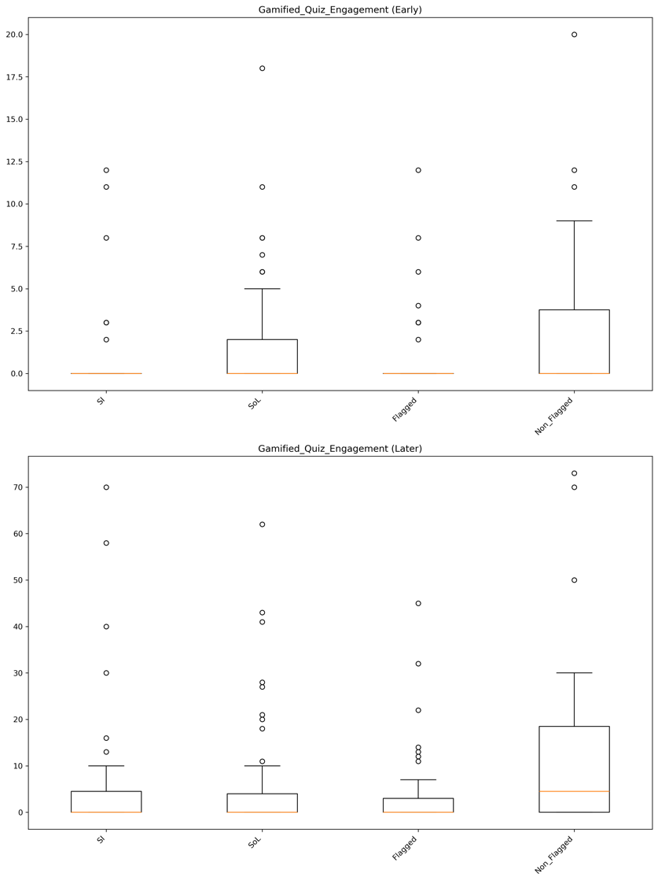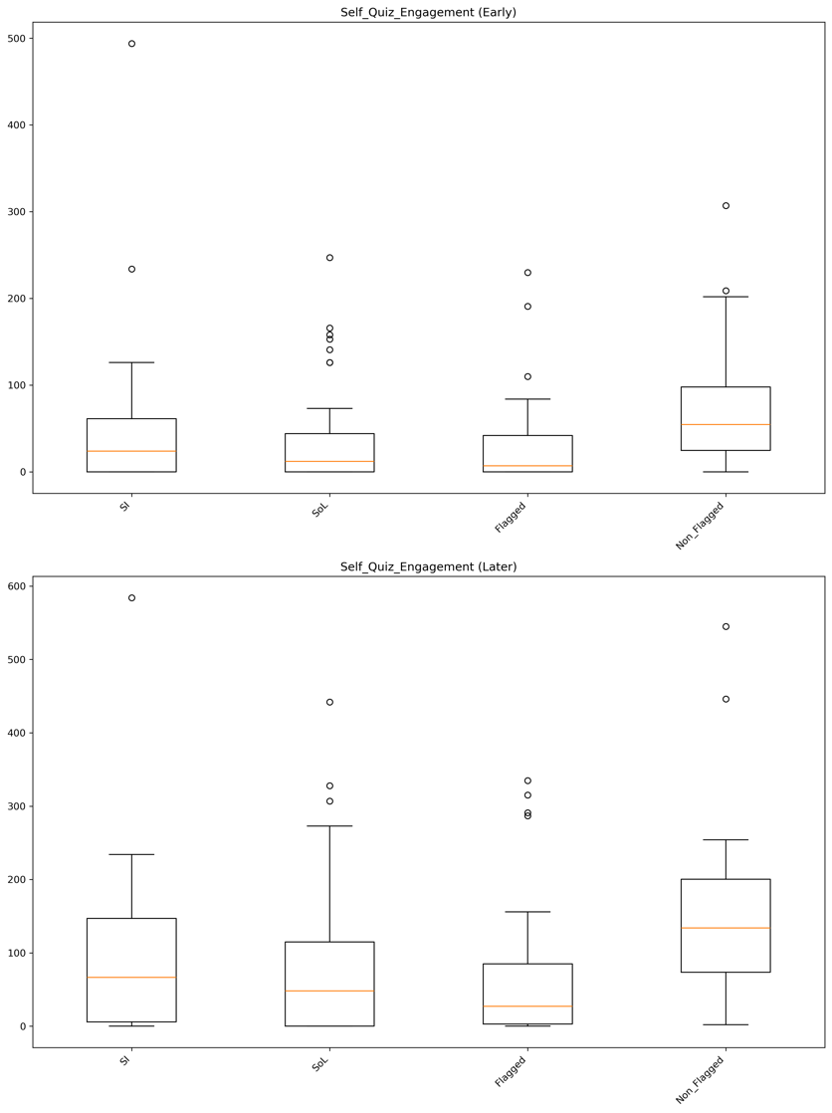

**Figure 2**

**Predictive Power of Immediate Digital Traces**

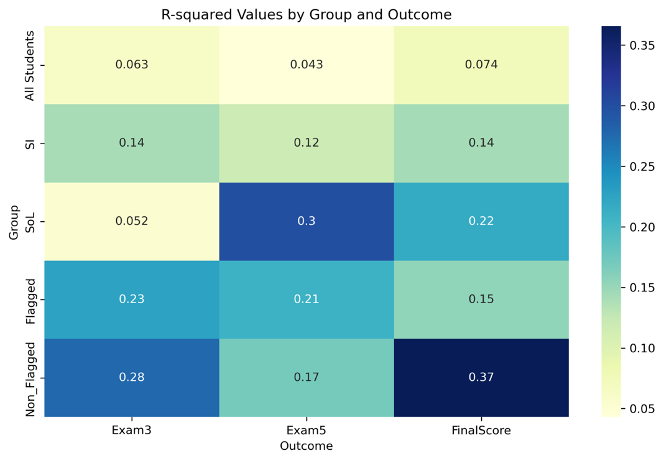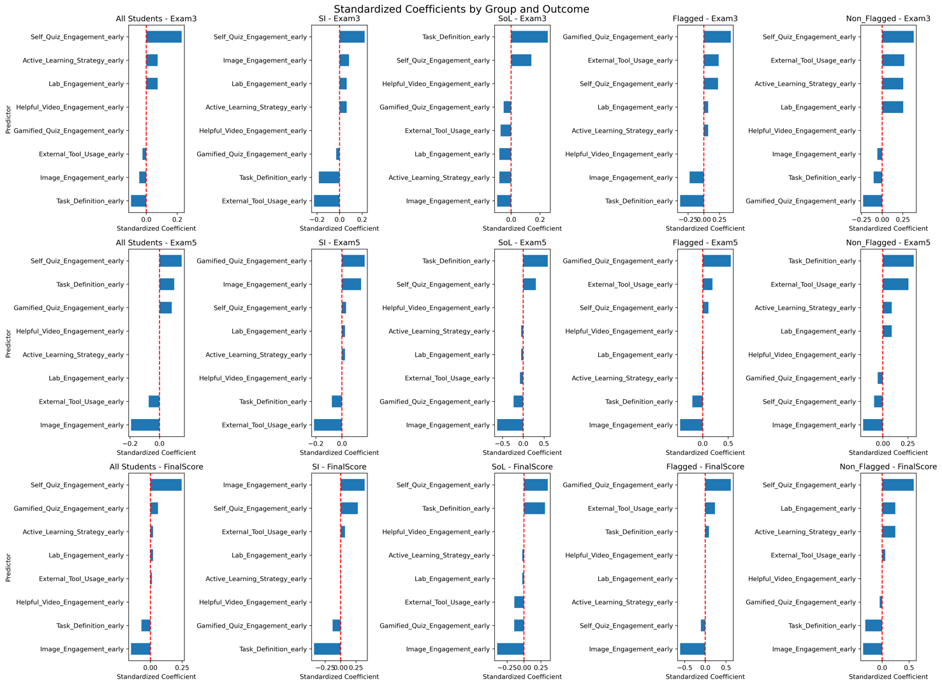

**Note.** The left panel displays a heatmap of R-squared values, indicating the predictive power of early digital traces. The right panel illustrates the standardized coefficients, visualizing the predictive strength of early digital traces.

**Figure 3**

**Predictive Power of Sustained Digital Traces**

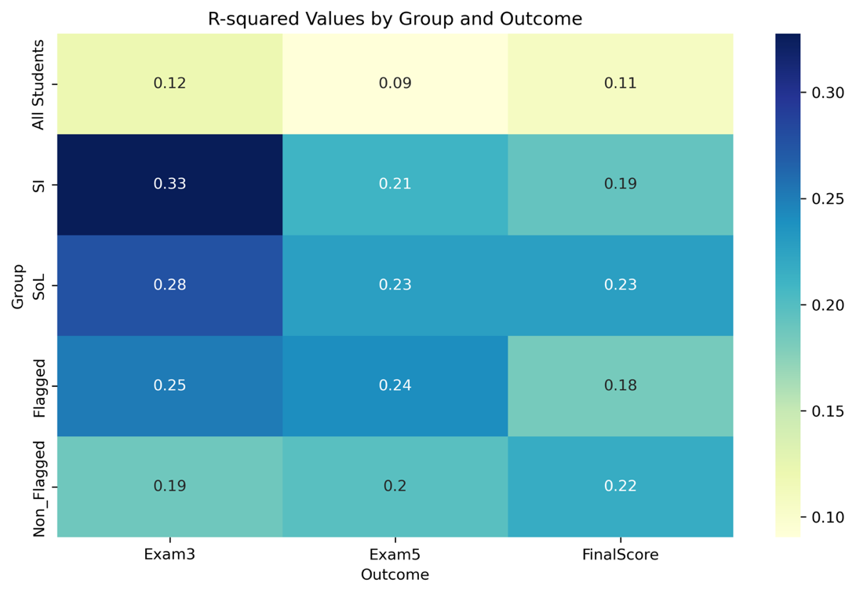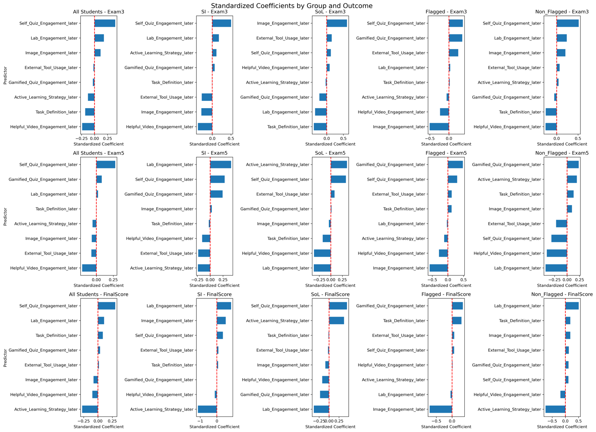

**Note.** The left panel displays a heatmap of R-squared values, indicating the predictive power of early digital traces. The right panel illustrates the standardized coefficients, visualizing the predictive strength of early digital traces.

**Figure 4**

**Proportion of Effect Mediated for Exam 3 (Early Digital Trace)**

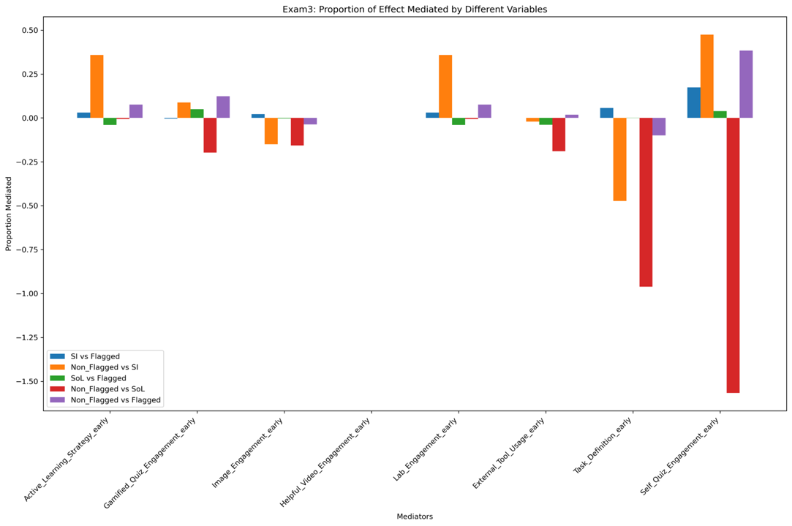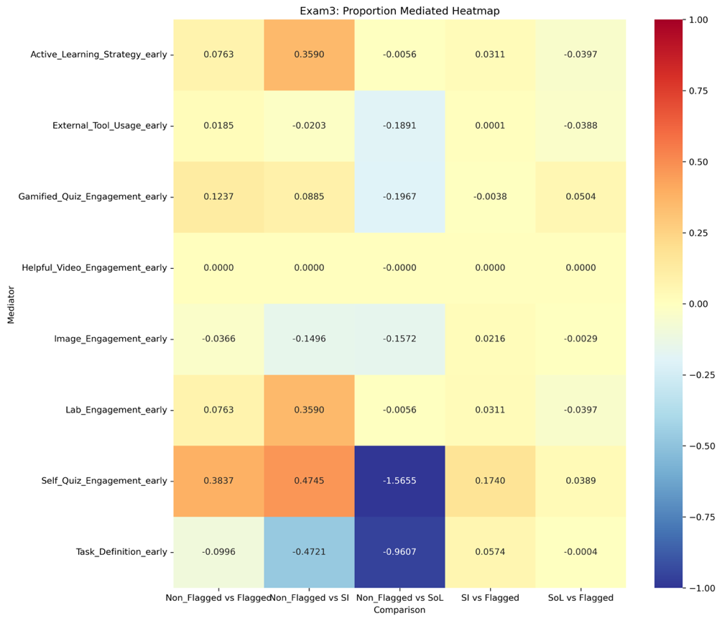

**Note**. The left panel shows the proportion of effect mediated by different variables for each comparison. Positive values indicate that the mediator explains a portion of the total effect, while negative values suggest suppression effects. The right panel presents a heatmap displaying the proportion mediated for each combination of mediator and comparison. Red colors indicate positive mediation, blue colors indicate negative mediation (suppression), and white indicates no mediation.

Figure 5

Proportion of Effect Mediated for Exam 5 (Early Digital Trace)

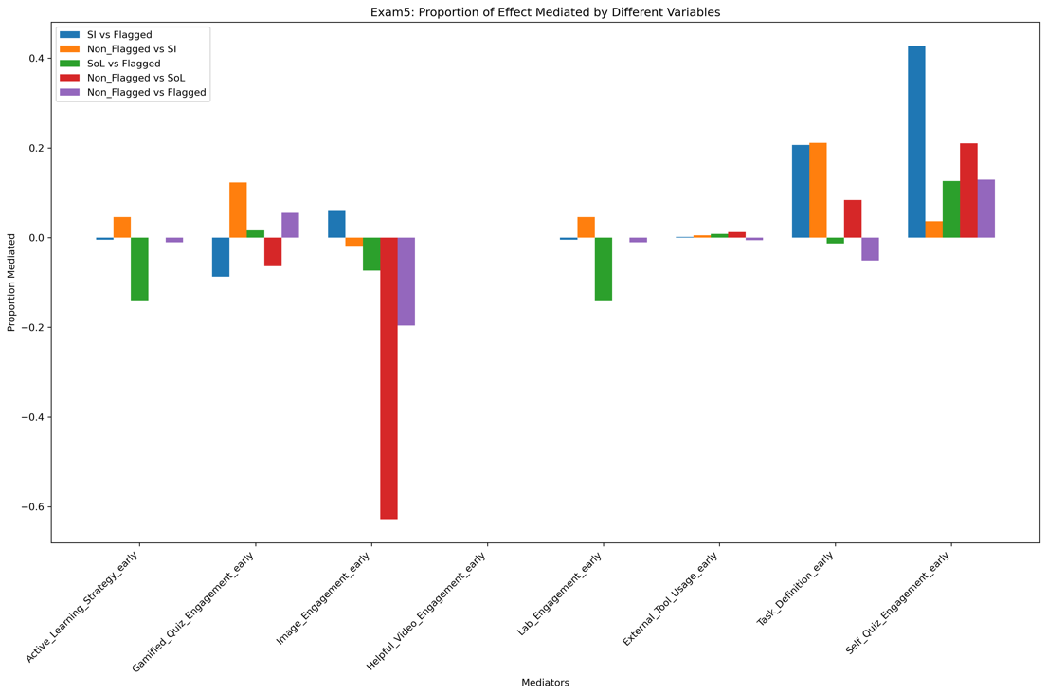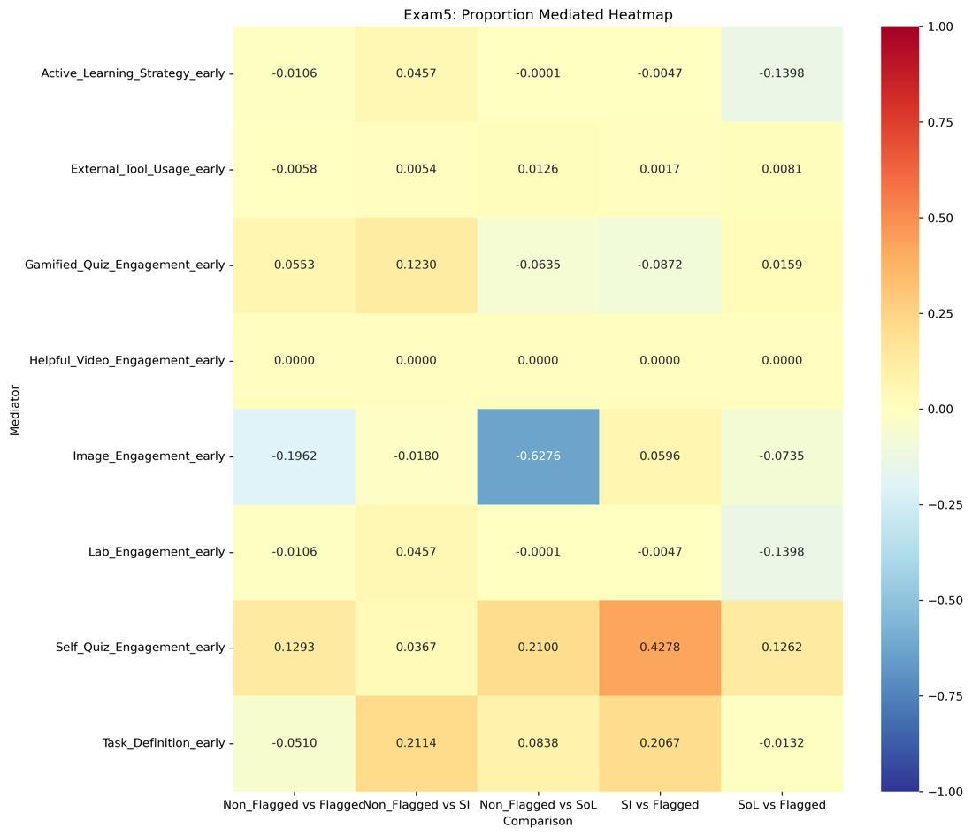

**Note**. The left panel shows the proportion of effect mediated by different variables for each comparison. Positive values indicate that the mediator explains a portion of the total effect, while negative values suggest suppression effects. The right panel presents a heatmap displaying the proportion mediated for each combination of mediator and comparison. Red colors indicate positive mediation, blue colors indicate negative mediation (suppression), and white indicates no mediation.

Figure 6

Proportion of Effect Mediated for Final Score (Early Digital Trace)

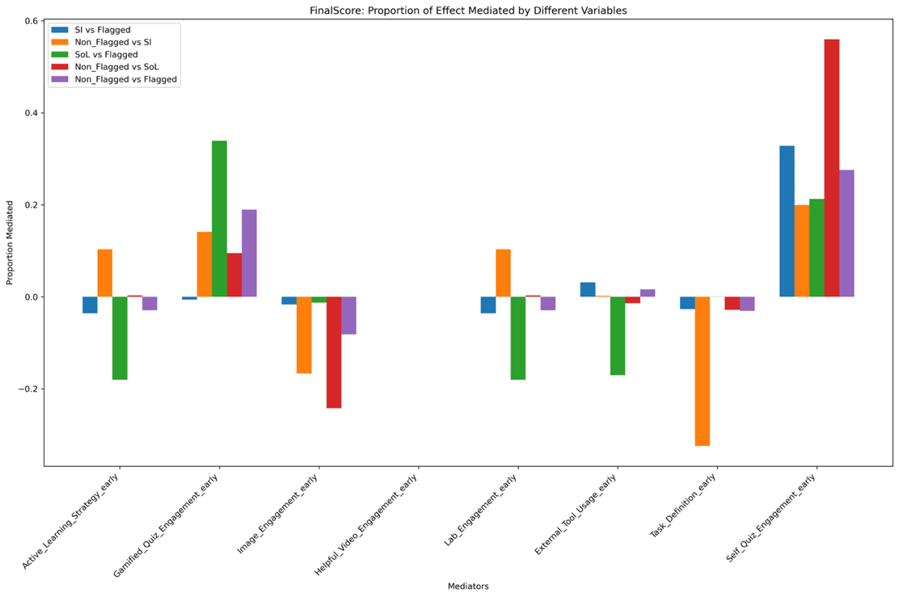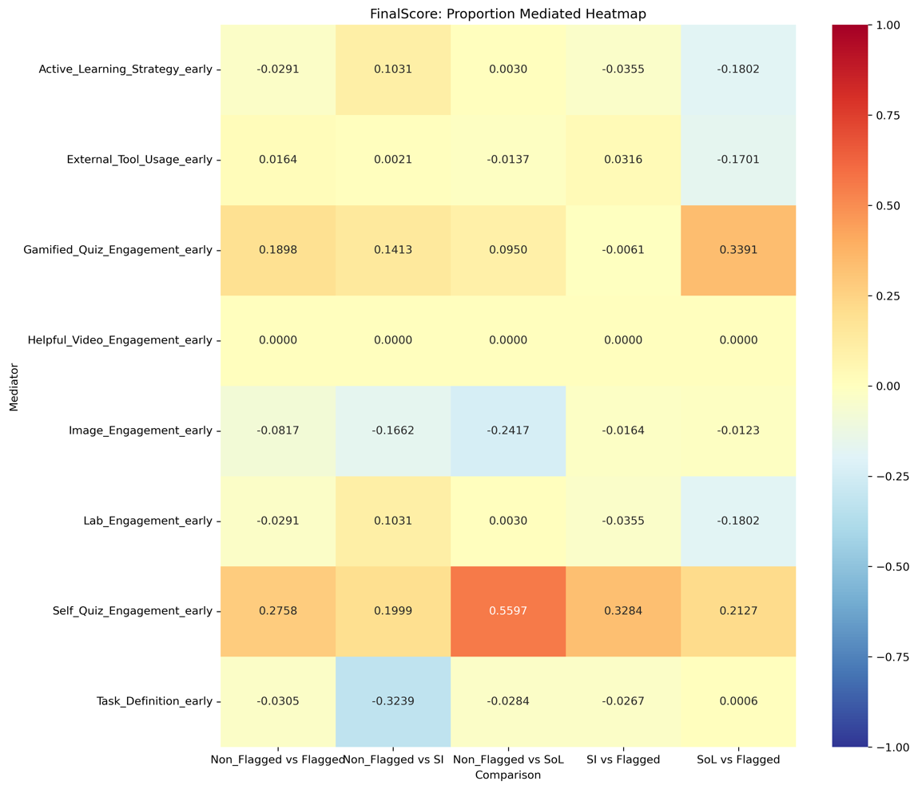

**Note**. The left panel shows the proportion of effect mediated by different variables for each comparison. Positive values indicate that the mediator explains a portion of the total effect, while negative values suggest suppression effects. The right panel presents a heatmap displaying the proportion mediated for each combination of mediator and comparison. Red colors indicate positive mediation, blue colors indicate negative mediation (suppression), and white indicates no mediation.

**Figure 7**

**Proportion of Effect Mediated for Exam 5 (Late Digital Trace)**

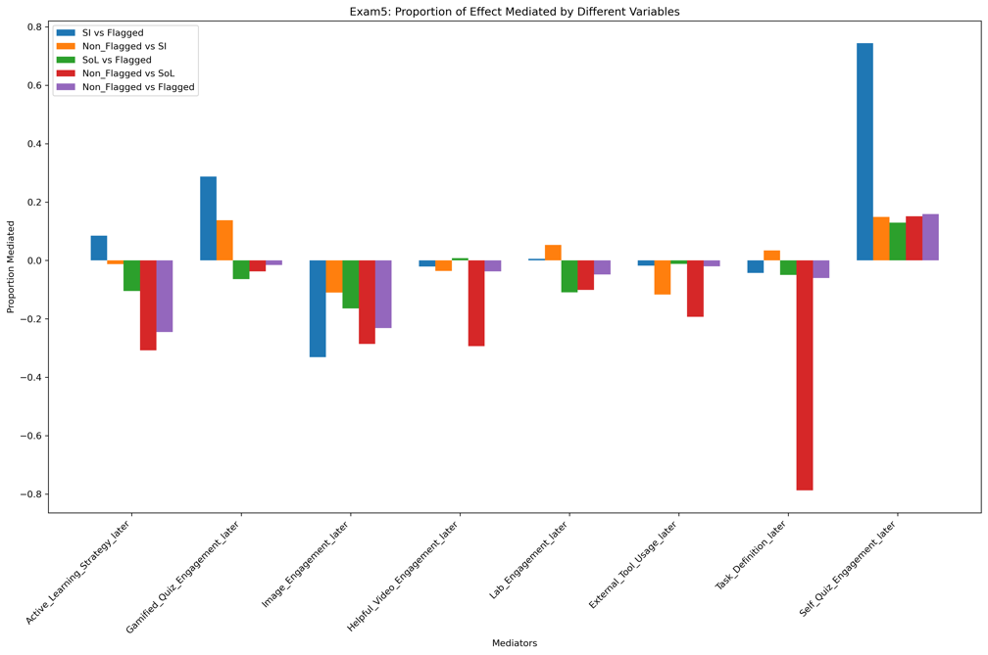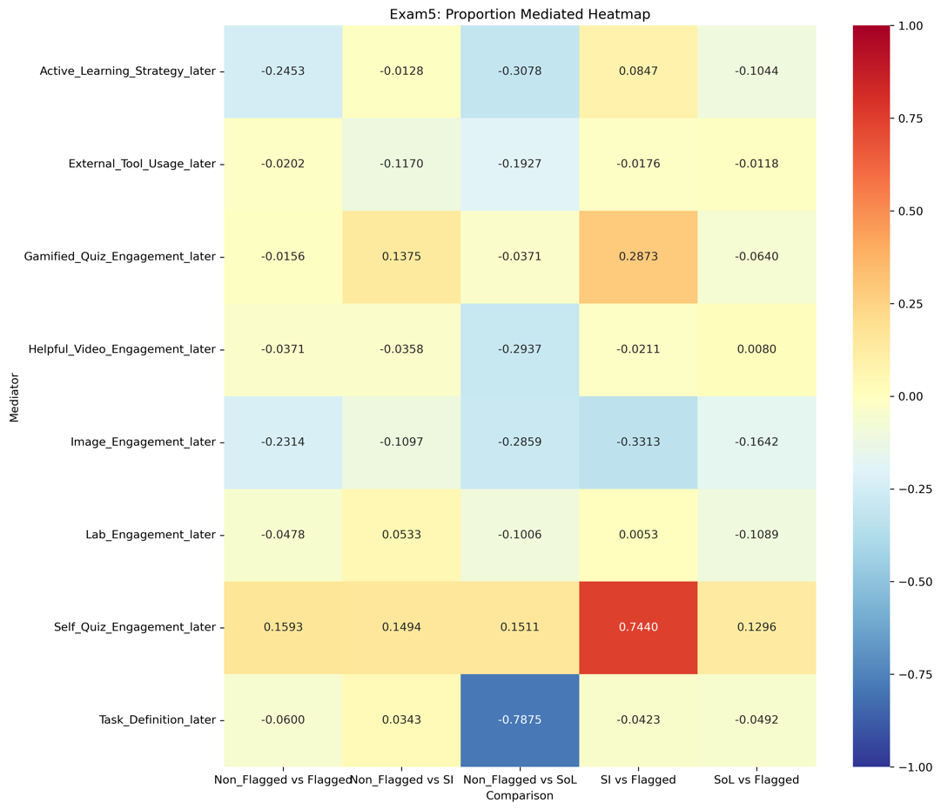

**Note**. The left panel shows the proportion of effect mediated by different variables for each comparison. Positive values indicate that the mediator explains a portion of the total effect, while negative values suggest suppression effects. The right panel presents a heatmap displaying the proportion mediated for each combination of mediator and comparison. Red colors indicate positive mediation, blue colors indicate negative mediation (suppression), and white indicates no mediation.

**Figure 8**

**Proportion of Effect Mediated for Final Score (Late Digital Trace)**

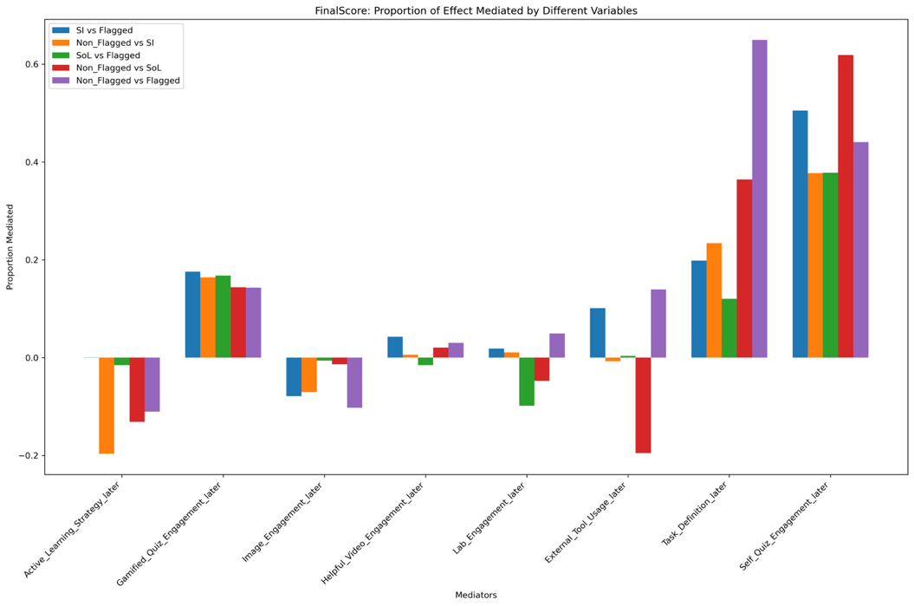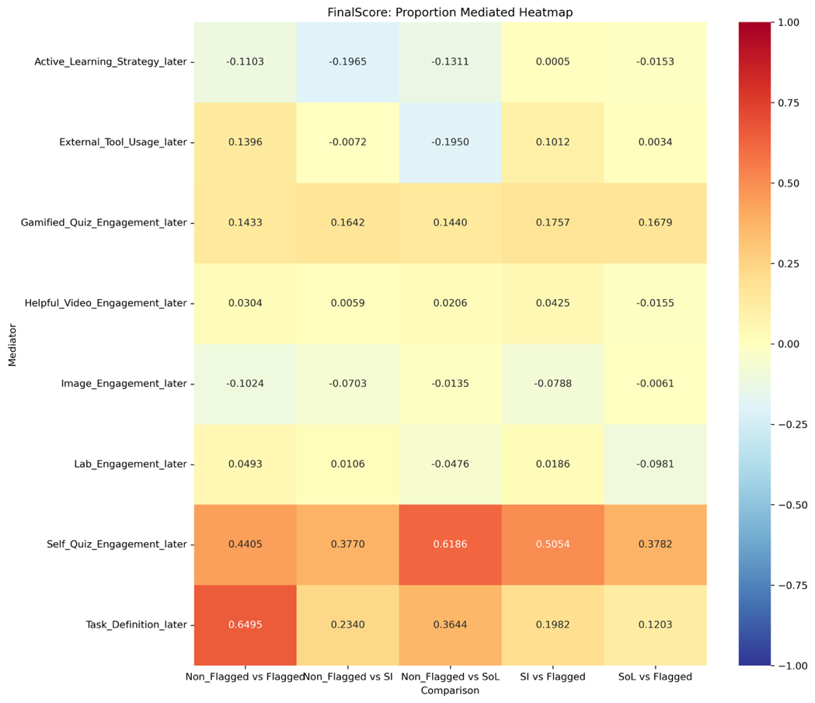

**Note**. The left panel shows the proportion of effect mediated by different variables for each comparison. Positive values indicate that the mediator explains a portion of the total effect, while negative values suggest suppression effects. The right panel presents a heatmap displaying the proportion mediated for each combination of mediator and comparison. Red colors indicate positive mediation, blue colors indicate negative mediation (suppression), and white indicates no mediation.

**Appendix A**

**Prediction Model for Identifying At-Risk (Flag) Students**

**Development of the Prediction Model**

To develop a model that could identify students who would be most likely to benefit from timely support for learning, we relied on data collected from the prior semester of 262 students enrolled in the course, including early behaviors in the Learning Management System (LMS) and the final grades they achieved in the course.

Data were extracted from a database housing different kinds of learner actions conducted in the LMS course site, including interactions with downloadable digital content and interactive tools that afforded repeated use. These resources afford opportunities for self-regulated learning (SRL; Winne & Hadwin, 1998), and when observed as a timestamped series of learning events might provide a close account of a learner's SRL process (Ben-Eliyahu & Bernacki, 2015).

Digital events were classified into types including announcements, assignments, files, tools, and other categories, as labeled by the LMS in standard metadata fields logged to the database. Students' events in the first week were aggregated to predict their final score.

**Model Selection and Performance**

The counts of all variable types were submitted as candidate features to a forward selection logistic regression with a 10-fold cross-validation process. The best model produced by this method contained nine predictors and accurately classified 74% of students based on their achievement of a C or Better or a D or Worse.

The model included an intercept that predicted that all students are more likely to earn a D or Worse than a C or Better, and that each interaction with a resource designed to support the learner incrementally increased the likelihood that the student would earn a C or Better. One additional predictor—total number of LMS events during the first week—was a positive predictor of the D or Worse outcome, with a small coefficient that slightly offset the reductions in this outcome.

The model achieved a sensitivity of 77.6%, meaning that it could accurately identify those who would earn a D-or-Worse using only event data available by the end of the first week, a full 3 weeks before the first course exam.

**Application of the Prediction Model**

On the first day of the third week of the semester, we applied the prediction model derived from the prior semester's data to the data generated by students enrolled in the course and who consented to share data and receive communication and support.

The prediction model flagged 176 students as more likely to earn a D or Worse than a C or Better, constituting our Flagged group. These students were randomly assigned into the Flagged Treatment and Flagged Control condition. Those who appeared more likely to earn a C or Better than a D or Worse were Unflagged by the algorithm.

**Model Performance in the Current Study**

The algorithm successfully identified at-risk students, as evidenced by the significant differences in Exam 1 and final grade performance between the flagged and non-flagged BioActivity groups. The non-flagged BioActivity group outperformed the flagged BioActivity group on Exam 1 (12.51 point difference, p < .001, Cohen's d = 0.66) and final grade (10.86 point difference, *p =* .014, Cohen's d = 0.66).

These results demonstrate the effectiveness of the prediction model in identifying students who may benefit from additional support early in the course, allowing for timely interventions.

**Appendix B**

Screenshots of Multimedia Skill Training of Cognitive Strategies and Self-Regulated Learning

